again

SpringBoot

**Satya Kaveti**

Written By

Latest Revision

18-June-2021

Contents

[1. Introduction 5](#_Toc75183994)

[Spring vs SpringBoot 5](#_Toc75183995)

[Creating Spring Boot Application 6](#_Toc75183996)

[1. Spring Boot using Maven 6](#_Toc75183997)

[2.Spring Initializer 7](#_Toc75183998)

[3.Spring STS IDE 7](#_Toc75183999)

[4.Spring Boot CLI Tool 8](#_Toc75184000)

[2. Spring Boot Examples 8](#_Toc75184001)

[1.Spring Boot with maven and Eclipse Example 8](#_Toc75184002)

[2.Spring Boot with Spring Initializr Example 12](#_Toc75184003)

[1.Spring Boot Starters 15](#_Toc75184004)

[2.@SpringBootApplication Annotation 16](#_Toc75184005)

[3 SpringApplication Class 18](#_Toc75184006)

[4. Embaded Servlet containers 18](#_Toc75184007)

[5.Spring Boot Profiles (@Profile Annotation) 18](#_Toc75184008)

[6. Spring Boot Actuator 19](#_Toc75184009)

[3. Spring Boot –Configurations 19](#_Toc75184010)

[How to change Spring Boot Banner Text 19](#_Toc75184011)

[application.properties 20](#_Toc75184012)

[4. Spring Boot –MVC 21](#_Toc75184013)

[Spring Boot MVC Example – Using TheamLeaf 21](#_Toc75184014)

[Static Content 25](#_Toc75184015)

[SpringBoot – MVC using Standard JSP Pages 26](#_Toc75184016)

[Spring Boot –RESTful Web Service Example 30](#_Toc75184017)

[5. Spring Boot –Database 32](#_Toc75184018)

[Spring Boot –JDBC Example 32](#_Toc75184019)

[1.Create project Structure 32](#_Toc75184020)

[Configure DataSource (application. properties) 32](#_Toc75184021)

[Model Class(model.Student.java) 32](#_Toc75184022)

[DAO Class with JdbcTemplate (StudentDAO.java) 33](#_Toc75184023)

[RowMapper Class 34](#_Toc75184024)

[SpringBootJdbcController.java 34](#_Toc75184025)

[SpringBootApp.java 35](#_Toc75184026)

[Spring Boot –JPA Example 36](#_Toc75184027)

[JPA Annotations 36](#_Toc75184028)

[Spring 4 Data 36](#_Toc75184029)

[1.Repositoy 37](#_Toc75184030)

[2.CurdRepositoy 37](#_Toc75184031)

[3.PagingAndSortingRepository 38](#_Toc75184032)

[4.JpaRepository 38](#_Toc75184033)

[5.MongoRepository 38](#_Toc75184034)

[6.Custom Repository 38](#_Toc75184035)

[7.Defining Query Methods 39](#_Toc75184036)

[JpaRepository 42](#_Toc75184037)

[Custom Queries 42](#_Toc75184038)

[Spring Boot –MongoDB REST Example 46](#_Toc75184039)

[Spring Missing/ Confusing Topics 48](#_Toc75184040)

[Diffrence between @Component & @Autowire 48](#_Toc75184041)

[Diffrence beteen @ComponentScan & @Enable AutoCOnfiguration 48](#_Toc75184042)

[References 49](#_Toc75184043)

[AngularJS with SpringBoot 50](#_Toc75184044)

[SpringBoot App UI 50](#_Toc75184045)

[Basics 51](#_Toc75184046)

[AngularJs internal working 53](#_Toc75184047)

[Few More Examples 53](#_Toc75184048)

[AngularJS Architecture Concepts 64](#_Toc75184049)

[AngularJS Routes 65](#_Toc75184050)

[AngularJS Templates 65](#_Toc75184051)

[AngularJS Controller 67](#_Toc75184052)

[AngularJs + SpringBoot Example implementation 68](#_Toc75184053)

[References 69](#_Toc75184054)

[JUNIT 69](#_Toc75184055)

[1.JUNIT Introduction 69](#_Toc75184056)

[2. JUnit Hello World! 73](#_Toc75184057)

[4. JUnit Examples 74](#_Toc75184058)

[4.1 Assert all Methods Example 74](#_Toc75184059)

[4.2 Test Suite 75](#_Toc75184060)

[4.3 Ignore Test 76](#_Toc75184061)

[4.4 Time Test 78](#_Toc75184062)

[4.5 Exceptions Test 78](#_Toc75184063)

[4.6 Parameterized Test 79](#_Toc75184064)

[4.7 JUnit List Example 80](#_Toc75184065)

[4.8 JUnit Map Example 81](#_Toc75184066)

[4.9 JUnit Tools 81](#_Toc75184067)

[References 81](#_Toc75184068)

[Mockito 82](#_Toc75184069)

[1.Creating Mock Objects 82](#_Toc75184070)

[2.Methods & Usage 82](#_Toc75184071)

[Hamcrest Matchers 84](#_Toc75184072)

[Integration Testing 86](#_Toc75184073)

[MockMvc 86](#_Toc75184074)

[Types of Authentication 88](#_Toc75184075)

[HTTP Basic Authentication 88](#_Toc75184076)

[Digest authentication 88](#_Toc75184077)

[API Keys : for Developer Quickstart 89](#_Toc75184078)

[OAuth Tokens: Great for Accessing User Data 90](#_Toc75184079)

[LDAP 91](#_Toc75184080)

[SSH – Only for LINUX Server / CommadLine(git) related Access 94](#_Toc75184081)

[Base64 – not Authentication 95](#_Toc75184082)

[Help.html 96](#_Toc75184083)

[StudentApp Document 96](#_Toc75184084)

[StudentApp + AngularJs+ CurdRepository+MockMVC References 96](#_Toc75184085)

[StudentApp MongoRepository 96](#_Toc75184086)

[Spring Boot with multiple databases 98](#_Toc75184087)

[SpringBoot Security 100](#_Toc75184088)

[SpringBoot AOP 103](#_Toc75184089)

[SpringBoot Acuator - Health check, Auditing, Metrics,Monitoring 105](#_Toc75184090)

[Spring cloud 111](#_Toc75184091)

[SpringBoot MicroServices 115](#_Toc75184092)

[Reactive JavaRx 121](#_Toc75184093)

[SpringBoot – Reactive Programming 122](#_Toc75184094)

[AngularJs(Angular 1) vs Angular (Angular 2) 124](#_Toc75184095)

[What exactly node.js is? 125](#_Toc75184096)

[How to host node.js applications? 126](#_Toc75184097)

[Npm, bower packges 126](#_Toc75184098)

[References 129](#_Toc75184099)

# 1. Introduction

Spring Boot makes it easy to create stand-alone, production-grade Spring based Applications that you can "just run".

### Spring vs SpringBoot

**Spring:** Spring started as a lightweight alternative to Java Enterprise Edition (J2EE). Spring offered a simpler approach to enterprise Java development, utilizing dependency injection and aspect-oriented programming to achieve the capabilities of EJB with plain old Java objects (POJOs).

But while spring was lightweight in terms of component code**, it was heavyweight in terms of configuration**. Initially, spring was configured with **XML** **& Spring 2.5** introduced **annotation-based component-scanning, even so, there was no escape from configuration.**

**Spring boot:** project is just a regular spring project that happens to leverage Spring Boot starters and auto-configuration. Spring Boot is not a framework, it is a way to easily create **stand-alone application with minimal or zero configurations.**

Finally, Spring Boot is just spring. Spring projects would not have any XML configurations as part of it, everything will be handled by the project Spring Boot.

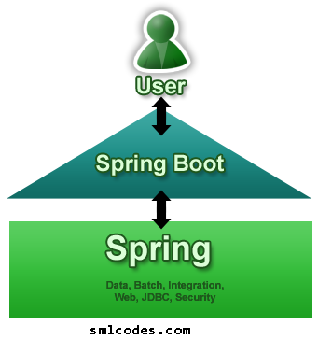

Spring Boot Features

* Create stand-alone Spring applications
* Embed **Tomcat, Jetty or Undertow directly** (no need to deploy WAR files)
* Provide opinionated **'starter' POMs to simplify your Maven configuration**
* **Automatically configure Spring whenever possible**
* Provide production-ready features such as metrics, health checks and externalized configuration
* Absolutely **no code generation and no requirement for XML configuration**

We can develop two flavors of Spring-Based Applications using Spring Boot

1. **Java-Based Applications**
2. **Groovy Application**

**Groovy** is also JVM language almost similar to Java Language. We can combine both Groovy and Java into one Project. Because like Java files, **Groovy files are finally compiled into \*.class files** only. Both **\*.groovy and \*.java files are converted to \*.class file (Same byte code format).**

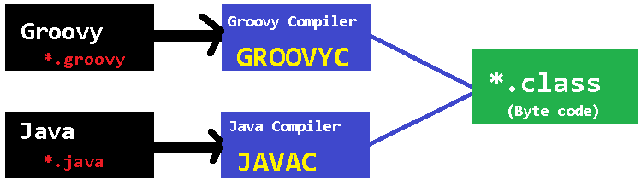

Spring Boot Framework Programming model is inspired by Groovy Programming model. Spring Boot internally uses some Groovy based techniques and tools to provide default imports and configuration.

## Creating Spring Boot Application

To create Spring Boot based applications The Spring Team (The Pivotal Team) has provided the following three approaches.

1. ***Using Maven***
2. ***Using Spring Initializer (***[***http://start.spring.io/***](http://start.spring.io/)***)***
3. ***Using Spring STS IDE***
4. ***Using Spring Boot CLI Tool***

### 1. Spring Boot using Maven

Add maven dependencies in pom.xml & do maven build

<project>

<parent>

<groupId>org.springframework.boot</groupId>

<artifactId>spring-boot-starter-parent</artifactId>

<version>1.5.6.RELEASE</version>

</parent>

<dependencies>

<dependency>

<groupId>org.springframework.boot</groupId>

<artifactId>spring-boot-starter-web</artifactId>

</dependency>

</dependencies>

<properties>

<java.version>1.8</java.version>

</properties>

</project>

### 2.Spring Initializer

Spring Initializer provides an extensible API to **generate quick start projects**. It also provides a configurable service: you can see our default instance at [**https://start.spring.io**](https://start.spring.io/)**.** It provides a simple web UI to configure the project to generate and endpoints that you can use via plain HTTP.

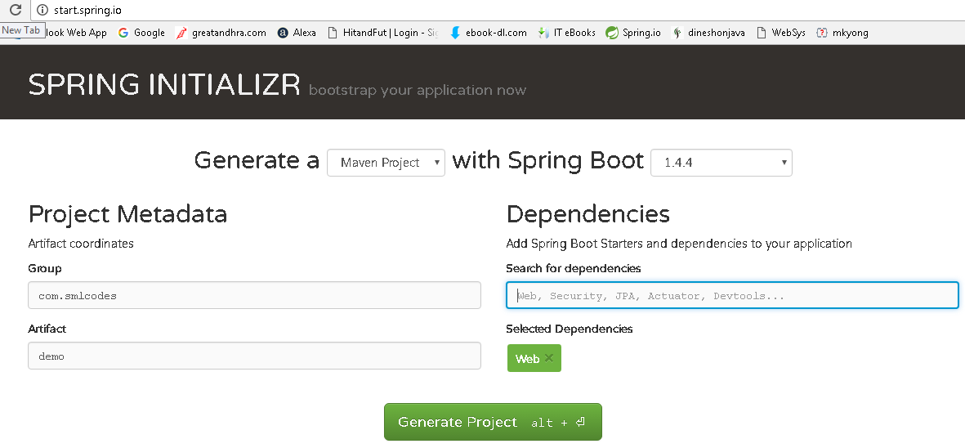

It will generate the Artifact.zip file, extract it and run maven build: **mvn clean install package**

[INFO] --- spring-boot-maven-plugin:1.4.4.RELEASE:repackage (default) @ SpringBootDemo ---

[INFO] ------------------------------------------------------------------------

[INFO] BUILD SUCCESS

[INFO] ------------------------------------------------------------------------

[INFO] Total time: 01:27 min

[INFO] Finished at: 2017-01-30T18:55:21+05:30

[INFO] Final Memory: 27M/160M

[INFO] ------------------------------------------------------------------------

### 3.Spring STS IDE

The **Spring Tool Suite** is an Eclipse-based development environment that is customized for developing **spring** applications. We can download it from [**here**](https://spring.io/tools/sts/all).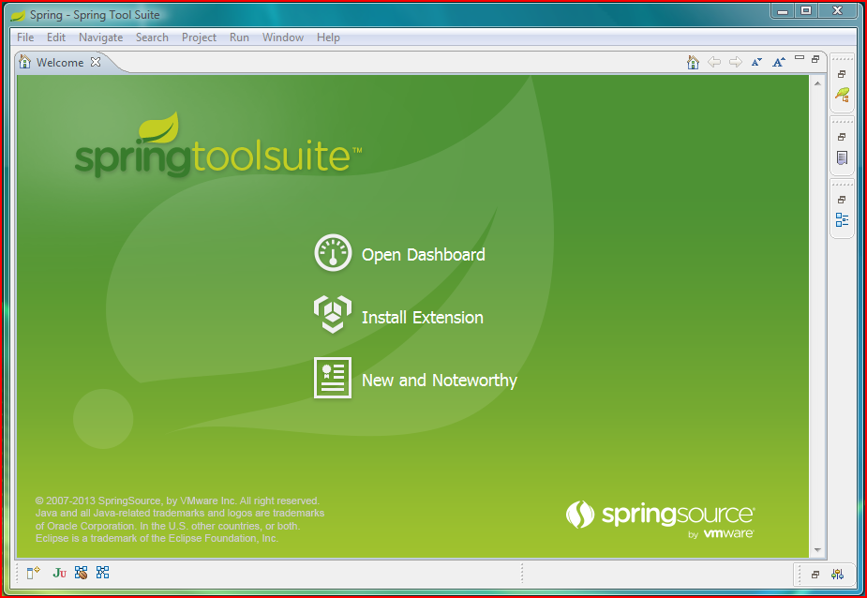

### 4.Spring Boot CLI Tool

**The Spring Boot CLI is a command line tool** that can be used if you want to quickly prototype (creates project Structure) with Spring. It allows you to run [Groovy](http://groovy.codehaus.org/) scripts, which means that you have a familiar Java-like syntax, without so much boilerplate code.

You don’t need to use the CLI to work with Spring Boot but it’s definitely the quickest way to get a spring application off the ground.

You can download the Spring CLI distribution from the Spring software repository:

* [spring-boot-cli-1.5.0.RELEASE-bin.zip](http://repo.spring.io/release/org/springframework/boot/spring-boot-cli/1.5.0.RELEASE/spring-boot-cli-1.5.0.RELEASE-bin.zip)
* [spring-boot-cli-1.5.0.RELEASE-bin.tar.gz](http://repo.spring.io/release/org/springframework/boot/spring-boot-cli/1.5.0.RELEASE/spring-boot-cli-1.5.0.RELEASE-bin.tar.gz)

**SDKMAN! (The Software Development Kit Manager)** can be used for managing multiple versions of various binary SDKs, including Groovy and the Spring Boot CLI. Get SDKMAN! from [sdkman.io](http://sdkman.io/) and install Spring Boot with

**$ sdk install springboot**

**$ spring --version**

**Spring Boot v1.5.0.RELEASE**

A simple web application that you can use to test your installation. Create a file called **app.groovy as**

**$ spring run app.groovy**

It will take some time when you first run the application as dependencies are downloaded. Subsequent runs will be much quicker.

# 2. Spring Boot Examples

## 1.Spring Boot with maven and Eclipse Example

1. Open Eclipse > File > New > Maven Project

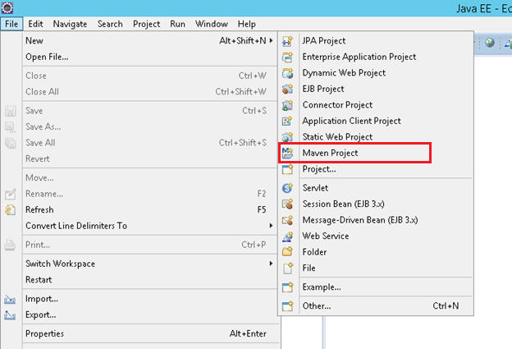

**2.Tick ‘Create a simple project (skip archetype selection) ‘ check box > click Next3. Provide Group Id (its your package), Artifact Id (project name) and click Finish**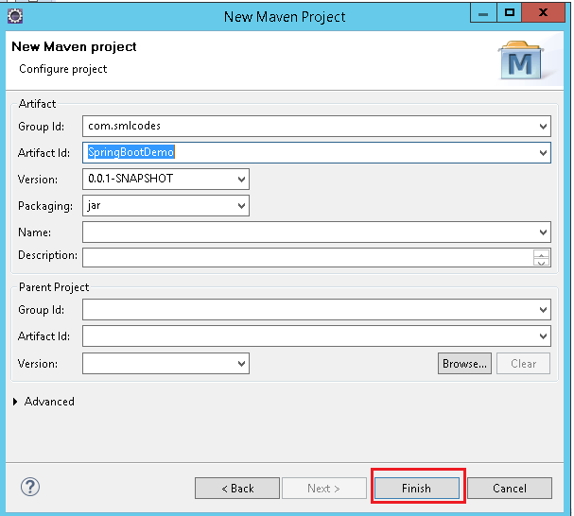

4. open pom.xml, add Spring Boot dependencies

<project>

<modelVersion>4.0.0</modelVersion>

<groupId>com.smlcodes</groupId>

<artifactId>SpringBootDemo</artifactId>

<version>0.0.1-SNAPSHOT</version>

<parent>

<groupId>org.springframework.boot</groupId>

<artifactId>**spring-boot-starter-parent**</artifactId>

<version>1.5.6.RELEASE</version>

</parent>

<dependencies>

<dependency>

<groupId>org.springframework.boot</groupId>

<artifactId>**spring-boot-starter-web**</artifactId>

</dependency>

</dependencies>

<properties>

<java.version>**1.8**</java.version>

</properties>

</project>

* **spring-boot-starter-parent:**is an existing project given by spring team which **contains Spring Boot supporting configuration data** (just configuration data, it won’t download any jars), we have added this in a **<parent>** tag means, we are instructing Maven to consider our SpringBootHelloWorld project as a child to it
* **spring-boot-starter-web**: Starter for building web, including RESTful, applications using Spring MVC. Uses Tomcat as the default embedded container

5.Now right click on the application > Maven > Update Project,

if you observe the directory structure of the project, it will create a new folder named “*Maven Dependencies*” which contains all supporting. jars to run the Spring Boot application and the Java version also changed to **1.8.**

**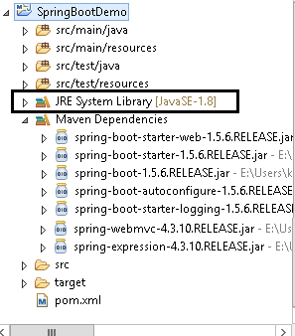**

* if you observe pom.xml, we haven’t included version number for **spring-boot-starter-web.** but maven downloaded some jar files with **some version(s) related to spring-boot-starter-web**, that’s because of Maven’s parent child relation.
* While adding spring boot parent project, we included version as 1.5.6.RELEASE, so again we no need to add version numbers for the dependencies.  As we know spring-boot-starter-parent contains configuration meta data, this means, it knows which version of dependency need to be downloaded.  So, we no need to worry about dependencies versions., it will save lot of our time.

6.create a java class with main() method, in a pakage.com.smlcodes.app.SpringBootApp.java.

**package** com.smlcodes.app;

**import** org.springframework.boot.SpringApplication;

**import** org.springframework.boot.autoconfigure.SpringBootApplication;

@SpringBootApplication

**public** **class** SpringBootApp {

**public** **static** **void** main(String[] args) {

SpringApplication.*run*(SpringBootApp.**class**, args);

System.***out***.println("\*\*\*\*\n Hello, World \n \*\*\*");

}

}

* **@SpringBootApplication** annotation, is the starting point for our Spring Boot application
* **SpringApplication.*run*(SpringBootApp.class, args);** it will bootstrapping the application

remember, for every spring boot application we have to create a main class and that need to be annotate with @SpringBootApplication and bootstrap it

8.Finally, right click on the application > Run As > Java Application

. \_\_\_\_ \_ \_\_ \_ \_

/\\ / \_\_\_'\_ \_\_ \_ \_(\_)\_ \_\_ \_\_ \_ \ \ \ \

( ( )\\_\_\_ | '\_ | '\_| | '\_ \/ \_` | \ \ \ \

\\/ \_\_\_)| |\_)| | | | | || (\_| | ) ) ) )

' |\_\_\_\_| .\_\_|\_| |\_|\_| |\_\\_\_, | / / / /

=========|\_|==============|\_\_\_/=/\_/\_/\_/

:: Spring Boot :: (v1.5.6.RELEASE)

2017-09-11 16:04:04.006 INFO 6724 --- [ main] com.smlcodes.app.SpringBootApp : Starting SpringBootApp on HYDPCMCSTS with PID 6724

2017-09-11 16:04:13.444 INFO 6724 --- [ main] com.smlcodes.app.SpringBootApp : Started SpringBootApp in 10.738 seconds (JVM running for 12.252)

\*\*\*\*\*\*\*\*\*\*\*\*

Hello, World

\*\*\*\*\*\*\*\*\*\*\*\*\*\*\*\*\*

## 2.Spring Boot with Spring Initializr Example

we are using Spring Initializer([**https://start.spring.io**](https://start.spring.io/)) to create a template for spring boot application

**1. Go to** [**https://start.spring.io**](https://start.spring.io/) **, Choose Dependencies & Generate Project. Here we are not selecting any dependencies because it is just a Hello world program**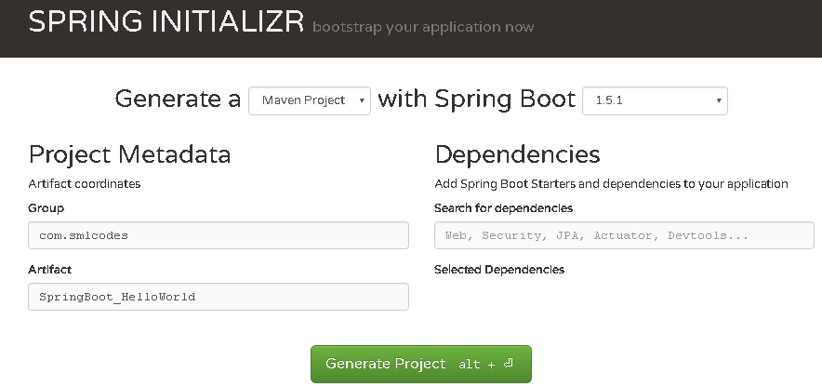

**2. Open Eclipse, import→ Maven →Existing Maven Projects → Select Project →Finish**

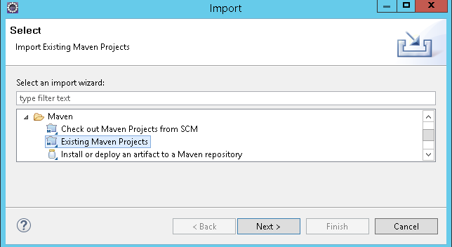

**3. The Project structure will be as follows if we open eclipse Package explorer**

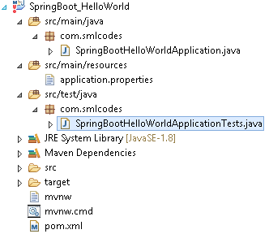

**4. If we open the pom.xml it contains only basic dependencies like spring-boot-starter which allows start spring boot application**

<dependencies>

<dependency>

<groupId>org.springframework.boot</groupId>

<artifactId>spring-boot-starter</artifactId>

</dependency>

<dependency>

<groupId>org.springframework.boot</groupId>

<artifactId>spring-boot-starter-test</artifactId>

<scope>test</scope>

</dependency>

</dependencies>

**5. Select Project, Right click Run as→ maven install to download and install the dependencies.** **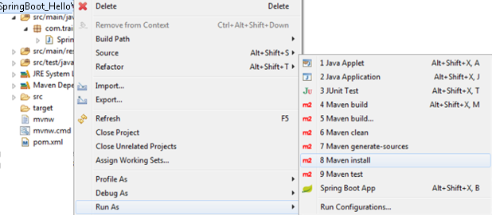**

**6.Spring boot generates the default java class which contains main() method. The main method calls the run method of SpringApplication.** SpringApplication.run(SpringBootHelloWorldApplication.class, args); **This run method bootstraps the application starting spring which will run the embedded Tomcat Server. Let’s add some helloworld message to print**

**package** com.smlcodes;

**import** org.springframework.boot.SpringApplication;

**import** org.springframework.boot.autoconfigure.SpringBootApplication;

@SpringBootApplication

**public** **class** SpringBootHelloWorldApplication {

**public** **static** **void** main(String[] args) {

SpringApplication.*run*(SpringBootHelloWorldApplication.**class**, args);

System.***out***.println("============================================");

System.***out***.println("Hello World, Spring Boot!!!!");

System.***out***.println("=============www.smlcodes.com===============");

}

}

**7.** **Select the Java file and right click RunAs → Java Application**

/\\ / \_\_\_'\_ \_\_ \_ \_(\_)\_ \_\_ \_\_ \_ \ \ \ \

( ( )\\_\_\_ | '\_ | '\_| | '\_ \/ \_` | \ \ \ \

\\/ \_\_\_)| |\_)| | | | | || (\_| | ) ) ) )

' |\_\_\_\_| .\_\_|\_| |\_|\_| |\_\\_\_, | / / / /

=========|\_|==============|\_\_\_/=/\_/\_/\_/

:: Spring Boot :: (v1.5.1.RELEASE)

2017-01-31 11:05:32.745 INFO 29596 --- [ main] s.c.a.AnnotationConfigApplicationContext : Refreshing org.springframework.context.annotation.AnnotationConfigApplicationContext@646007f4: startup date [Tue Jan 31 11:05:32 IST 2017]; root of context hierarchy

2017-01-31 11:05:43.108 INFO 29596 --- [ main] o.s.j.e.a.AnnotationMBeanExporter : Registering beans for JMX exposure on startup

2017-01-31 11:05:43.200 INFO 29596 --- [ main] c.s.SpringBootHelloWorldApplication : Started SpringBootHelloWorldApplication in 12.855 seconds (JVM running for 16.094)

**============================================**

**Hello World, Spring Boot!!!!**

**=============www.smlcodes.com===============**

8. We can also run this application from the command line using the **jar file that is generated**. To get the jar file, select **pom.xml** right click**RunAs → Maven Build (2nd one), goals=package, Apply & Run 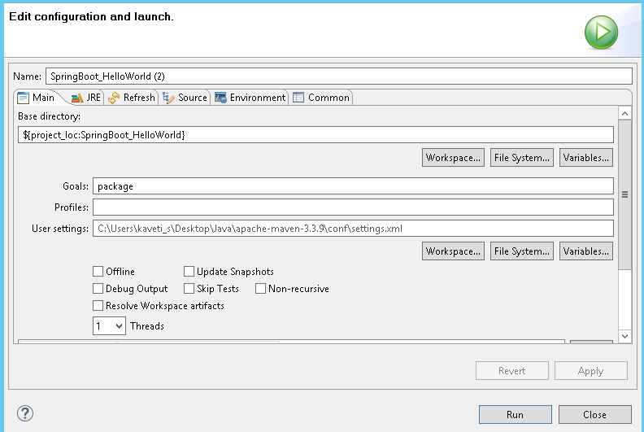**

[INFO] Scanning for projects

[INFO] --------------------------------------------------------------------

[INFO] Building SpringBoot\_HelloWorld 0.0.1-SNAPSHOT

[INFO] ----------------------------------------------------------------------

**C:\Users\kaveti\_s\Desktop\Downloads\SpringBoot\_HelloWorld\SpringBoot\_HelloWorld\target\SpringBoot\_HelloWorld-0.0.1-SNAPSHOT.jar**

[INFO] --- spring-boot-maven-plugin:1.5.1.RELEASE:repackage (default) @ SpringBoot\_HelloWorld

[INFO] -------------------------------------------------------------------

[INFO] BUILD SUCCESS

[INFO] -------------------------------------------------------------------

9. Open command line and go to the folder where your project is located. Next, move to the target folder and then type **java -jar <<filename>>.jar**.

**java -jar SpringBoot\_HelloWorld-0.0.1-SNAPSHOT.jar**

How it works internally

1. we place the all the required **Spring boot starters in pom.xml,** which are requires for implementing Spring Boot application. on loading project, the **all required starter dependencies are added automatically to the project**

2. By running Spring Boot main class, at **@SpringBootApplication** line it will do the **Auto configuration** things, it will automatically add all required annotations to Java Class ByteCode.

3.On Executing main() **SpringApplication.run()** used to bootstrap and launches Spring Boot application.

### 1.Spring Boot Starters

**Spring boot Starters** are the one-stop-shop for all the Spring and related technology that we need**. For example**, if you want to get started using **Spring and JPA for database access**, just include the **spring-boot-starter-data-jpa**dependency in your project, and you are good to go.

All **official** starters follow a similar naming pattern; **spring-boot-starter-<module>,** where **-<module>**is a particular type of application. The following are the some of the application starters are provided by Spring Boot under the **org.springframework.boot** group

| **Name** | **Description** |
| --- | --- |
| spring-boot-starter-web-services | Starter for using Spring Web Services |
| spring-boot-starter-web | Starter for building web, including RESTful, applications using Spring MVC. Uses Tomcat as the default embedded container |
| spring-boot-starter-test | Starter for testing Spring Boot applications with libraries including JUnit, Hamcrest and Mockito |
| spring-boot-starter-jdbc | Starter for using JDBC with the Tomcat JDBC connection pool |
| spring-boot-starter-jersey | Starter for building RESTful web applications using JAX-RS and Jersey. An alternative to [spring-boot-starter-web](http://docs.spring.io/autorepo/docs/spring-boot/current/reference/html/using-boot-build-systems.html#spring-boot-starter-web) |
| spring-boot-starter-aop | Aspect-oriented programming with Spring AOP and AspectJ |
| spring-boot-starter-security | Starter for using Spring Security |
| spring-boot-starter-data-jpa | Starter for using Spring Data JPA with Hibernate |
| spring-boot-starter | Core starter, including auto-configuration support, logging,YML |

In above Example we used spring-boot-starter & spring-boot-starter-test Starters which are configure in pom.xml

<dependencies>

<dependency>

<groupId>org.springframework.boot</groupId>

<artifactId>spring-boot-starter</artifactId>

</dependency>

<dependency>

<groupId>org.springframework.boot</groupId>

<artifactId>spring-boot-starter-test</artifactId>

<scope>test</scope>

</dependency>

</dependencies>

### 2.@SpringBootApplication Annotation

This annotation marks the class as a spring bean, configures the application by adding all the jars based on the dependencies and also scans the other packages for spring beans.

Spring Boot developers always have their main class annotated with **@Configuration, @EnableAutoConfiguration and @ComponentScan*.***

1. **@Configuration**  – Specifies this class as a spring bean
2. **@EnableAutoConfiguration**  –
   * This tells how you want to configure Spring, based on the jar dependencies that you have added. & also Enable / Disable auto configuration.
   * Spring Boot auto-configuration attempts to automatically configure your Spring application based on the jar dependencies that you have added.
   * For example, if HSQLDB is on your classpath, and you have not manually configured any database connection beans, then Spring Boot auto-configures an in-memory database
   * We can disble AutoConfiguration specific files by @EnableAutoConfiguration(exclude={DataSourceAutoConfiguration.class})
3. **@ComponentScan** – is to scan other packages for spring beans.
4. **@Import** - used to import additional configuration classes
5. **@ImportResource -**annotation to load XML configuration files

**import** org.springframework.boot.SpringApplication;

**import** org.springframework.boot.autoconfigure.EnableAutoConfiguration;

**import** org.springframework.context.annotation.ComponentScan;

**import** org.springframework.context.annotation.Configuration;

*@Configuration*

*@EnableAutoConfiguration*

*@ComponentScan*

**public** **class** Application {

**public** **static** **void** main(String[] args) {

SpringApplication.run(Application.**class**, args);

}

}

Since these annotations are so frequently used together Spring Boot provides a convenient **@SpringBootApplication** as an alternative. The @SpringBootApplication annotation **is equivalent to using @Configuration, @EnableAutoConfiguration and @ComponentScan** with their default attributes.

@SpringBootApplication = @Configuration + @ComponentScan + @EnableAutoConfiration.

The original @SpringBootApplication annotation class is defined as below

**package** org.springframework.boot.autoconfigure; @Target(ElementType.TYPE)

@Retention(RetentionPolicy.RUNTIME)

@Documented

@Inherited

@Configuration

@EnableAutoConfiguration

@ComponentScan

**public** **@interface** SpringBootApplication {

Class<?>[] exclude() **default** {};

String[] excludeName()**default**{};

@AliasFor(annotation = ComponentScan.**class**, attribute = "basePackages")

String[] scanBasePackages() **default** {};

@AliasFor(annotation = ComponentScan.**class**, attribute = "basePackageClasses")

Class<?>[] scanBasePackageClasses()**default**{};

}

### 3 SpringApplication Class

SpringApplication class is used to bootstrap and launch a Spring application from a Java main method.

By default, class will perform the following steps to bootstrap your application:

* Create an appropriate [ApplicationContext](http://docs.spring.io/spring-framework/docs/4.3.6.RELEASE/javadoc-api/org/springframework/context/ApplicationContext.html?is-external=true" \o "class or interface in org.springframework.context) instance (depending on your classpath)
* Register a [CommandLinePropertySource](http://docs.spring.io/spring-framework/docs/4.3.6.RELEASE/javadoc-api/org/springframework/core/env/CommandLinePropertySource.html?is-external=true" \o "class or interface in org.springframework.core.env) to expose command line arguments as Spring properties
* Refresh the application context, loading all singleton beans
* Trigger any [CommandLineRunner](http://docs.spring.io/spring-boot/docs/current/api/org/springframework/boot/CommandLineRunner.html" \o "interface in org.springframework.boot) beans.

In most circumstances the static [**run(Object, String[])**](http://docs.spring.io/spring-boot/docs/current/api/org/springframework/boot/SpringApplication.html#run-java.lang.Object-java.lang.String...-) method can be called directly from your main method to bootstrap your application:

**public** **static** **void** main(String[] args) {

SpringApplication.run(MySpringConfiguration.**class**, args);

}

4. Embaded Servlet containers

The following embedded servlet containers are supported out of the box. By default, we will get Tomcat

| **Name** | **Servlet Version** | **Java Version** |
| --- | --- | --- |
| **Tomcat 8** | 3.1 | Java 7+ |
| **Tomcat 7** | 3.0 | Java 6+ |
| **Jetty 9.3** | 3.1 | Java 8+ |
| **Jetty 9.2** | 3.1 | Java 7+ |
| **Undertow 1.3** | 3.1 | Java 7+ |

5.Spring Boot Profiles (@Profile Annotation)

Spring Profiles provide a way to segregate parts of your application configuration and make it only available in certain environments. Any **@Component or @Configuration can** be marked with **@Profile** to limit when it is loaded

@Configuration

@Profile("production")

**public** **class** ProductionConfiguration {

// ...

}

In the normal Spring way, you can use a **spring.profiles.active** Environment property to specify which profiles are active. You can specify the property in any of the usual ways, for example you could include it in your **application.properties**:**spring.profiles.active=dev,hsqldb** or specify on the command line using the **switch --spring.profiles.active=dev,hsqldb.**

### 6. Spring Boot Actuator

Spring Boot provides actuator to monitor and manage our application. Actuator is a tool which has HTTP endpoints. **when application is pushed to production, you can choose to manage and monitor your application using HTTP endpoints.**

To get production-ready features, we should use spring-boot-actuator module. We can enable this feature by adding it to the **pom.xml** file.

<dependencies>

    <dependency>

        <groupId>org.springframework.boot</groupId>

        <artifactId>spring-boot-starter-actuator</artifactId>

    </dependency>

</dependencies>

# 3. Spring Boot –Configurations

## How to change Spring Boot Banner Text

The banner that is printed on startup can be changed by adding a **banner.txt** file to **src\main\resources** folder or your classpath, or by setting **banner.location** to the location of such a file.

You can also add a **banner.gif, banner.jpg or banner.png image file to your classpath**, or set a **banner.image.location property**. Images will be converted into an ASCII art representation and printed above any text banner.

**//Default Banner**

. \_\_\_\_ \_ \_\_ \_ \_

/\\ / \_\_\_'\_ \_\_ \_ \_(\_)\_ \_\_ \_\_ \_ \ \ \ \

( ( )\\_\_\_ | '\_ | '\_| | '\_ \/ \_` | \ \ \ \

\\/ \_\_\_)| |\_)| | | | | || (\_| | ) ) ) )

' |\_\_\_\_| .\_\_|\_| |\_|\_| |\_\\_\_, | / / / /

=========|\_|==============|\_\_\_/=/\_/\_/\_/

:: Spring Boot :: (v1.5.1.RELEASE)

2017-02-01 14:07:22.957 INFO 72716 --- [ main] c.s.SpringBootHelloWorldApplication

1. Go to any ANCII Text generator [website](http://patorjk.com/) & generate your logo. for ex: [**http://patorjk.com/**](http://patorjk.com/)
2. Create banner.txt under **Proj\_Home\src\main\resources, paste the logo text**
3. **Refresh** the project & run Spring Boot Application.the banner will change as below

██████╗███╗ ███╗██╗ ██████╗ ██████╗ ██████╗ ███████╗███████╗

██╔════╝████╗ ████║██║ ██╔════╝██╔═══██╗██╔══██╗██╔════╝██╔════╝

███████╗██╔████╔██║██║ ██║ ██║ ██║██║ ██║█████╗ ███████╗

╚════██║██║╚██╔╝██║██║ ██║ ██║ ██║██║ ██║██╔══╝ ╚════██║

███████║██║ ╚═╝ ██║███████╗╚██████╗╚██████╔╝██████╔╝███████╗███████║

╚══════╝╚═╝ ╚═╝╚══════╝ ╚═════╝ ╚═════╝ ╚═════╝ ╚══════╝╚══════╝

2017-02-01 14:07:22.957 INFO 72716 --- [ main] c.s.SpringBootHelloWorldApplication

## application.properties

Spring Boot provides a very neat way to load properties for an application. we can define properties in **application.properties** (**PROJ\_HOME\src\main\resources\application.properties)** file the following way

db.name=smlcodesdb

db.username=smlcodes

db.password=wEB20R1XPJtg9

In traditional Spring application would have loaded up the properties in the following way

public class SmlcodesPropTest {

@Value("${db.name}") //dbname is KEY here

private String dbname;

@Value("${db. username }")

private String server\_port;

In Spring boot, it takes application.properties file to define a bean - that can hold all the related properties in following way

@ConfigurationProperties(prefix = "db")

@Component

**public** **class** DBConfig {

**public** String dbname;

**public** String username;

**public** String password;

**public** String getDbname() {

**return** dbname;

}

**public** **void** setDbname(String dbname) {

**this**.dbname = dbname;

}

**public** String getUsername() {

**return** username;

}

**public** **void** setUsername(String username) {

**this**.username = username;

}

**public** String getPassword() {

**return** password;

}

**public** **void** setPassword(String password) {

**this**.password = password;

}

}

**@ConfigurationProperties** is used to bind and validate some external Properties. If we want to validate before going to use, we have to place **@Validated** & place type of validation on the filed

@ConfigurationProperties(prefix="foo")

@Validated

**public** **class** FooProperties {

@NotNull

**private** InetAddress remoteAddress;

// ... getters and setters

}

# 4. Spring Boot –MVC

In old Spring MVC lets you create special **@Controller** or **@RestController** beans to handle incoming HTTP requests. Methods in your controller are mapped to HTTP using **@RequestMapping** annotations.

SpringMVC example **@RestController** to serve JSON data

@RestController

@RequestMapping(value="/users")

**public** **class** SmlCodesRestController {

@RequestMapping(value="/{user}", method=RequestMethod.GET)

**public** User getUser(@PathVariable Long user) {

// ...

}

@RequestMapping(value="/{user}/customers", method=RequestMethod.GET)

List<Customer> getUserCustomers(@PathVariable Long user) {

// ...

}

@RequestMapping(value="/{user}", method=RequestMethod.DELETE)

**public** User deleteUser(@PathVariable Long user) {

// ...

}

}

## Spring Boot MVC Example – Using TheamLeaf

**Thymeleaf Quick Tutorial**

**Thymeleaf** is a modern server-side Java template engine for both web and standalone environments.

We can use Thymeleaf directly in .html files. By just placing below line to activate Thymeleaf in our HTML.

<html lang="en" xmlns:th="http://www.thymeleaf.org">

If you want to use Thymleaf elements in our program, we have use th:<element> Tag in our HTML Tags

<table>

<thead>

<tr>

<th th:text="#{msgs.headers.name}">Name</th>

<th th:text="#{msgs.headers.price}">Price</th>

</tr>

</thead>

<tbody>

<tr th:each="prod: ${allProducts}">

<td th:text="${prod.name}">Oranges</td>

<td th:text="${#numbers.formatDecimal(prod.price, 1, 2)}">0.99</td>

</tr>

</tbody>

</table>

We need add **spring-boot-starter-thymeleaf** dependency in our application's pom.xml file to use Thymeleaf in our Application

<dependency>

<groupId>org.springframework.boot</groupId>

<artifactId>**spring-boot-starter-thymeleaf**</artifactId>

</dependency>

Example – Employee CURD operations

Create Project : [Ref](https://github.com/RameshMF/springboot-thymeleaf-crud-pagination-sorting-webapp) :

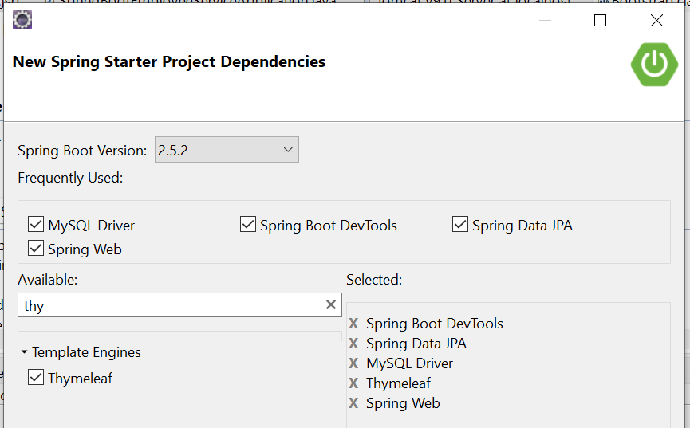

Build with maven & Open Elcipse. If we see the Folder Structre

* **All static content like CSS, JS files will** be placed unter **→resources\static\**
* **all the result pages** must be placed under**→resources\templates\**

This type of floder structure we will use in TheamLeaf based UI.

#### Static Content

By default, Spring Boot serves static content from a directory called /static. You can also customize the static resource locations by using the spring.web.resources.static-locations property in applications.proerties file.

#### Template Content (Template Engines)

Spring MVC supports a variety of templating technologies, including **Thymeleaf, FreeMarker, and JSPs**. If you use one of these templating engines with the default configuration, your templates are picked up automatically from src/main/resources/templates

1. application.properties (DB Properties)

spring.datasource.url=jdbc:mysql://localhost:3306/webapp?useSSL=false

spring.datasource.username=root

spring.datasource.password=root

spring.jpa.properties.hibernate.dialect = org.hibernate.dialect.MySQL5InnoDBDialect

spring.jpa.hibernate.ddl-auto = update

2. Employee.java entity class to map with Employee Table

**package** springboot;

**import** javax.persistence.Column;

**import** javax.persistence.Entity;

**import** javax.persistence.GeneratedValue;

**import** javax.persistence.GenerationType;

**import** javax.persistence.Id;

**import** javax.persistence.Table;

@Entity

@Table(name = "employee")

**public** **class** Employee {

@Id

@GeneratedValue(strategy = GenerationType.***IDENTITY***)

**private** Long id;

@Column

**private** String name;

@Column

**private** String address;

@Column

**private** Double salary;

**//Setters & Getters**

}

3. EmployeeRepository.java – for performing CURD Operations on DB

**package** springboot.repository;

@Repository

**public** **interface** EmployeeRepository **extends** JpaRepository<Employee, Long> {

}

4. EmployeeService.java – Service Layer

**package** springboot.service;

**import** java.util.List;

**import** springboot.model.Employee;

**public** **interface** EmployeeService {

List<Employee> getAllEmployees();

**void** saveEmployee(Employee employee);

Employee getEmployeeById(**long** id);

**void** deleteEmployeeById(**long** id);

}

EmployeeServiceImpl.java – Service Layer Implenetation

**package** springboot.service;

**import** springboot.model.Employee;

**import** springboot.repository.EmployeeRepository;

@Service

**public** **class** EmployeeServiceImpl **implements** EmployeeService {

@Autowired

EmployeeRepository repository;

@Override

**public** List<Employee> getAllEmployees() {

// **TODO** Auto-generated method stub

**return** repository.findAll();

}

@Override

**public** **void** saveEmployee(Employee employee) {

// **TODO** Auto-generated method stub

Employee e = repository.save(employee);

System.***out***.println(" Employee Data Saved : " + e);

}

@Override

**public** Employee getEmployeeById(**long** id) {

Employee e = repository.getById(id);

System.***out***.println("Employee getEmployeeById : " + e);

**return** e;

}

@Override

**public** **void** deleteEmployeeById(**long** id) {

Employee e = repository.getById(id);

repository.delete(e);

System.***out***.println("Employee Deleted : ");

}

}

So far Good. Now come to actual Thymeleaf changes

Display Homepage

1.Create *index.html* thymeleaf template under "resources/templates" folder and add below code.

<html lang=*"en"* xmlns:th=*"http://www.thymeleaf.org"*>

<head>

<link rel=*"stylesheet"* href=[*https://stackpath.bootstrapcdn.com/bootstrap/4.1.3/css/bootstrap.min.css*](https://stackpath.bootstrapcdn.com/bootstrap/4.1.3/css/bootstrap.min.css)*>*

</head>

<body>

<div class=*"container my-2"*>

<h1>ThemeLeaf - EmployeeApp&trade;</h1>

<div class=*"list-group"*>

<a href=*"#"* class=*"list-group-item list-group-item-action"*>All Employees</a>

<a href=*"#"* class=*"list-group-item list-group-item-action"*>Add Employee</a>

</div>

</div>

</body>

</html>

2. Create a *EmployeeServiceImpl* class, and add method to display homepage

@Controller

**public** **class** EmployeeController {

@Autowired

**private** EmployeeService employeeService;

@GetMapping("/")

**public** String viewHomePage(Model model) {

System.***out***.println("Calling Home Page....");

**return** "index";

}

}

Now Run mian class & open Browser

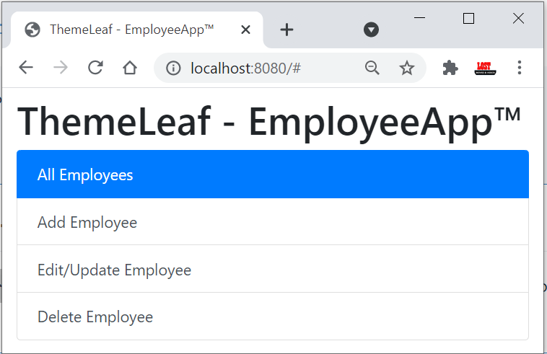

To make our application more stylish, add **CSS** and **JS** files in **src/main/resources/static** folder.

You can see Complete code [**Example here**](https://github.com/smlcodes/Books-Sync-Gitlab/tree/main/Codes/SpringBoot-Thymeleaf) **(**[**Code Ref**](https://github.com/RameshMF/springboot-thymeleaf-crud-pagination-sorting-webapp)**.)**

<https://github.com/smlcodes/Books-Sync-Gitlab/tree/main/Codes/SpringBoot-Thymeleaf>

If you got this Error: Whitelabel Error page (type=Not Found, status=404)

Move your SpringBoot main class from sub package to Root package, example from **spring.app** package to **spring** package

## SpringBoot – MVC using Standard JSP Pages

Add this extra dependency in pom.xml to work with jsp pages

<!-- JSTL -->

<dependency>

<groupId>javax.servlet</groupId>

<artifactId>jstl</artifactId>

</dependency>

<!-- Tomcat Embed -->

<dependency>

<groupId>org.springframework.boot</groupId>

<artifactId>spring-boot-starter-tomcat</artifactId>

</dependency>

<dependency>

<groupId>org.apache.tomcat.embed</groupId>

<artifactId>tomcat-embed-jasper</artifactId>

</dependency>

<!-- Optional, test for static content, bootstrap CSS-->

<dependency>

<groupId>org.webjars</groupId>

<artifactId>bootstrap</artifactId>

<version>3.3.7</version>

</dependency>

**Few Points to note,**

#### CSS, JS , assets related files

In old Spring, to use static files, we need configure those folders paths in SpringConfig.xml file

<!-- OLD Spring - These for Static images, css calls in jsp pages -->

<mvc:annotation-driven />

<mvc:resources mapping=*"/assets/\*"* location=*"/assets/"* />

<mvc:resources mapping=*"/js/\*"* location=*"/js/"* />

<mvc:resources mapping=*"/css/\*"* location=*"/css/"* />

But in Spring Boot, no need to declare the resource mapping like above. The resource mapping will handle automatically. We need to place CSS or Javascript, in /src/main/resources/static/ folder.

#### JSP Files

JSP view files would be created inside **src/main/webapp/WEB-INF/jsp.** If you want use css, js files which are placed in static folder, just link into JSP view via

<link href="/css/main.css" rel="stylesheet">

To resolve **JSP** files location, you can have two approaches.

1. Using application.properties
2. Using Java configuration

**1.Using** application.properties (Recommnded)

To Tell Spring, where JSP files located - we need to place those details in application.properties

spring.mvc.view.prefix: /WEB-INF/jsp/

spring.mvc.view.suffix: .jsp

**2. Using** Java configuration

Configure InternalResourceViewResolver to serve JSP pages using WebMvcConfigurerAdapter

package springboot.controller;

@Configuration

@EnableWebMvc

@ComponentScan

public class MVCConfiguration extends ~~WebMvcConfigurerAdapter~~ {

@Override

public void configureViewResolvers(ViewResolverRegistry registry) {

InternalResourceViewResolver resolver = new InternalResourceViewResolver();

resolver.setPrefix("/WEB-INF/view/");

resolver.setSuffix(".jsp");

resolver.setViewClass(JstlView.class);

registry.viewResolver(resolver);

}

}

#### Spring Boot Application Initializer

So far we used .jar file to run our SpringBoot application. But for Web Applications recommended way is .war file Deployment. To Achive the .war file related stuff in SpringBoot we need to use SpringBootServletInitializer

Our SpringBoot main class need to **extend** SpringBootServletInitializer & override configure() method to produce .war file. This makes use of Spring Framework’s Servlet 3.0 support and allows you to configure your application when it’s launched by the servlet container.

@SpringBootApplication

public class SpringBootAppApplication extends SpringBootServletInitializer {

@Override

protected SpringApplicationBuilder configure(SpringApplicationBuilder application) {

return application.sources(SpringBootAppApplication.class);

}

public static void main(String[] args) {

SpringApplication.*run*(SpringBootAppApplication.class, args);

System.*out*.println(" Hello, Again");

}

}

[**So finally,**](https://howtodoinjava.com/spring-boot/spring-boot-jsp-view-example/)

* **Controller** classes created inside src/main/java
* **JSP pages** created inside src/main/webapp/WEB-INF/view
* **CSS and JS** files created inside src/main/resources/static
* **application.properties** created inside src/main/resources
* **Application.java** is a launch file for Spring Boot created inside src/main/java

**Example**

pom.xml

<dependencies>

<dependency>

<groupId>org.springframework.boot</groupId>

<artifactId>spring-boot-starter-jersey</artifactId>

</dependency>

<dependency>

<groupId>org.springframework.boot</groupId>

<artifactId>spring-boot-starter-web</artifactId>

</dependency>

<dependency>

<groupId>org.springframework.boot</groupId>

<artifactId>spring-boot-starter-web-services</artifactId>

</dependency>

<dependency>

<groupId>org.springframework.boot</groupId>

<artifactId>spring-boot-starter-test</artifactId>

<scope>test</scope>

</dependency>

<dependency>

<groupId>org.springframework.boot</groupId>

<artifactId>spring-boot-starter-thymeleaf</artifactId>

</dependency>

<!-- JSTL -->

<dependency>

<groupId>javax.servlet</groupId>

<artifactId>jstl</artifactId>

</dependency>

<!-- Tomcat Embed -->

<dependency>

<groupId>org.springframework.boot</groupId>

<artifactId>spring-boot-starter-tomcat</artifactId>

</dependency>

<dependency>

<groupId>org.apache.tomcat.embed</groupId>

<artifactId>tomcat-embed-jasper</artifactId>

</dependency>

<!-- Optional, test for static content, bootstrap CSS-->

<dependency>

<groupId>org.webjars</groupId>

<artifactId>bootstrap</artifactId>

<version>3.3.7</version>

</dependency>

</dependencies>

**JSP’s -** src\main\webapp\WEB-INF\views

//index.jsp

<%@ taglib prefix="spring" uri="http://www.springframework.org/tags"%>

<form action="getUser" method="post">

Username :<input type="text" name="username" > <br>

Email :<input type="email" name="email" > <br>

Password :<input type="password" name="password"> <br>

<button type="submit">Sign in</button>

</form>

//user.jsp

<%@ taglib prefix="spring" uri="http://www.springframework.org/tags"%>

<h1>User Data is</h1>

<h4>${user.username}</h4>

<h4>${user.password}</h4>

<h4>${user.email}</h4>

Add entries in application.properties

# for SpringMVC - JSP related Config

spring.mvc.view.prefix:/WEB-INF/views/

spring.mvc.view.suffix:.jsp

#For detailed logging during development

logging.level.org.springframework=TRACE

logging.level.com=TRACE

HomeController.java

package springboot.controller;

import org.springframework.stereotype.Controller;

import org.springframework.web.bind.annotation.ModelAttribute;

import org.springframework.web.bind.annotation.RequestMapping;

import org.springframework.web.servlet.ModelAndView;

import springboot.bo.UserBo;

@Controller

public class HomeController {

@RequestMapping("/")

public ModelAndView homePage() {

ModelAndView view = new ModelAndView();

view.setViewName("index");

return view;

}

@RequestMapping("/getUser")

public ModelAndView getUser(@ModelAttribute UserBo user) {

ModelAndView view = new ModelAndView();

view.addObject("user", user);

view.setViewName("user");

return view;

}

}

UserBo.java to store input data

public class UserBo {

private int id;

private String username;

private String email;

private String password;

//Setters & Getters

}

SpringBootAppApplication.java

package springboot;

@SpringBootApplication

public class SpringBootAppApplication extends SpringBootServletInitializer {

@Override

protected SpringApplicationBuilder configure(SpringApplicationBuilder application) {

return application.sources(SpringBootAppApplication.class);

}

public static void main(String[] args) {

SpringApplication.*run*(SpringBootAppApplication.class, args);

}

}

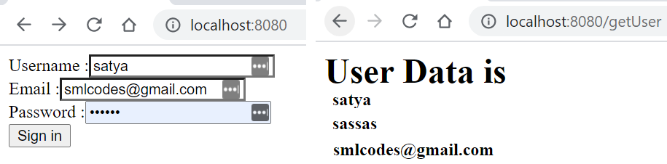

## Spring Boot –RESTful Web Service Example

To work with webservices, in SpringBoot we have to use two annotations

* @RestController: tells Spring Boot to consider this class as REST controller
* @RequestMapping: used to register paths inside it to respond to the HTTP requests.

The @RestController is a stereotype annotation. It adds @Controller and @ResponseBody annotations to the class.

@RestController = @Controller + @ResponseBody

Note - The @RestController and @RequestMapping annotations are Spring MVC annotations. They are not specific to Spring Boot.

app.controller.SpringBootRestController.java

**package** app.controller;

@RestController

**public** **class** SpringBootRestController {

@RequestMapping("/")

**public** String welcome() {

**return** "Spring Boot Home Page";

}

@RequestMapping("/hello")

**public** String myData() {

**return** "Smalcodes : Hello Spring Boot";

}

}

app.SpringBootApp.java

**package** app;

**import** org.springframework.boot.SpringApplication;

**import** org.springframework.boot.autoconfigure.SpringBootApplication;

@SpringBootApplication

**public** **class** SpringBootApp {

**public** **static** **void** main(String[] args) {

SpringApplication.*run*(SpringBootApp.**class**, args);

}

}

Create pom.xml same as first example.

**Test the Application**

Right click on project > Run as >Java Application >**select SpringBootApp**

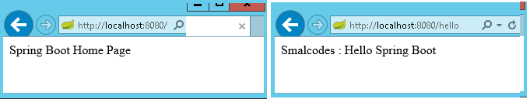

* In above Spring Boot main application class in ***app*** package and controller class **in *app.controller****.*
* While starting our application, SpringBootApp class will scan all the components under that package. we have created our controller class in **app.controller** which is inside app package, our controller was registered by spring boot.
* If you create the controller class outside of the main package, lets say com.smlcodes.controller*,*If you run the application it gives 404 error.To resolve this,  we have to add ***@ComponentScan*** annotation in our Spring Boot main class, as below

@SpringBootApplication

@ComponentScan(basePackages="smlcodes.controller")

**public** **class** SpringBootApp {

**public** **static** **void** main(String[] args) {

SpringApplication.*run*(SpringBootApp.**class**, args);

}

}

# 5. Spring Boot –Database

## Spring Boot –JDBC Example

Spring Boot provides starter and libraries for connecting to our application with JDBC. Spring JDBC dependencies can be resolved by using either spring-boot-starter-jdbc or spring-boot-starter-data-jpa spring boot starters.

### 1.Create project Structure

To create project go to <https://start.spring.io/> and add JDBC,MySQL,JPA dependencies to the Project. 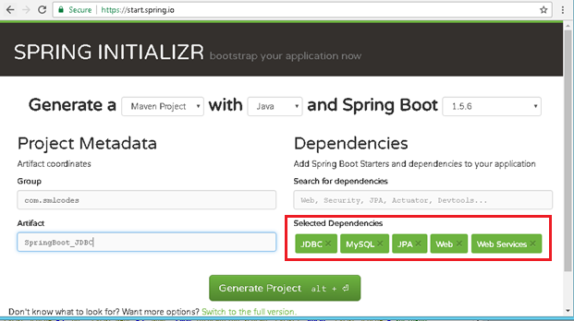

### Configure DataSource (application. properties)

DataSource and Connection Pool are configured in application.properties file using prefix spring.datasource. Spring boot uses javax.sql.DataSource interface to configure DataSource.

spring.datasource.url=jdbc:mysql://localhost:3306/springdb?useSSL=false

spring.datasource.username=root

spring.datasource.password=root

spring.datasource.driver-class-name=com.mysql.jdbc.Driver

### Model Class(model.Student.java)

Find the MySQL table used in our example.

**CREATE** **TABLE** `student` (

`sno` **INT**(11) **NOT** **NULL**,

`name` **VARCHAR**(50) **NULL** **DEFAULT** **NULL**,

`address` **VARCHAR**(50) **NULL** **DEFAULT** **NULL**,

**PRIMARY** **KEY** (`sno`)

)

**COLLATE**='latin1\_swedish\_ci'

**ENGINE**=**InnoDB**;

Create Student class with table properties

**package** app.model;

**public** **class** Student {

**private** **int** sno;

**private** String name;

**private** String address;

**public** Student() {

**super**();

}

**public** Student(**int** sno, String name, String address) {

**super**();

**this**.sno = sno;

**this**.name = name;

**this**.address = address;

}

//Setters & Getters

}

### DAO Class with JdbcTemplate (StudentDAO.java)

* JdbcTemplate is the central class to handle JDBC. It executes SQL queries and fetches their results. To use JdbcTemplate.
* JdbcTemplate dependency injection using @Autowired with constructor.

**package** app.dao;

**import** org.springframework.beans.factory.annotation.Autowired;

**import** org.springframework.jdbc.core.JdbcTemplate;

**import** org.springframework.stereotype.Repository;

**import** app.model.Student;

@Repository

**public** **class** StudentDAO {

@Autowired

**private** JdbcTemplate template;

**public** List<Student> findAll() {

List<Student> result = template.query("SELECT sno,name, address FROM Student", **new** StudentRowMapper());

**return** result;

}

**public** **void** addStudent(**int** sno, String name, String address) {

template.update("INSERT INTO Student(sno,name, address) VALUES (?,?,?)", sno, name, address);

}

}

### RowMapper Class

Spring JDBC provides RowMapper interface that is used to map row with a java object. We need to create our own class implementing RowMapper interface to map row with java object. Find the sample code to implement RowMapperinterface.

It is a Functional interface we have only one method mapRow(ResultSet rs, int rowno)

**package** app.dao;

**public** **class** StudentRowMapper **implements** RowMapper<Student> {

@Override

**public** Student mapRow(ResultSet rs, **int** rowno) **throws** SQLException {

// **TODO** Auto-generated method stub

Student s = **new** Student();

s.setSno(rs.getInt("sno"));

s.setName(rs.getString("name"));

s.setAddress(rs.getString("address"));

**return** s;

}

}

### SpringBootJdbcController.java

**package** app.controller;

@RestController

**public** **class** SpringBootJDBCController {

@Autowired

**private** StudentDAO dao;

@RequestMapping("/jdbc")

**public** String welcome() {

**return** "Spring Boot Home Page";

}

@RequestMapping("/insert")

**public** String insert(@RequestParam("sno") **int** sno, @RequestParam("name") String name,

@RequestParam("address") String adr) {

System.***out***.println(" \*\*\*\*\*\*\*\*\*\*\*\*\*\* Inside Method \*\*\*\*\*\*\*\*\*\*\*\*");

dao.addStudent(sno, name, adr);

**return** "Data Inserted";

}

@RequestMapping("/select")

**public** String select() {

String result="";

List<Student> list = dao.findAll();

Iterator<Student> itr = list.iterator();

**while** (itr.hasNext()) {

Student s = (Student) itr.next();

result = result+ s.getSno()+", ";

result = result+ s.getName()+", ";

result = result+ s.getAddress()+" <br>";

}

System.***out***.println("Result : "+result);

**return** result;

}

}

### SpringBootApp.java

**package** app;

@SpringBootApplication

**public** **class** SpringBootApp {

**public** **static** **void** main(String[] args) {

SpringApplication.*run*(SpringBootApp.**class**, args);

}

}

**Static/index.jsp**

<a href=*"/select"*>SELECT</a><br />

<h1>Insert Form</h1>

<form action=*"/insert"*>

Sno: <input name=*"sno"* type=*"text"* /> <br>

Name: <input name=*"name"* type=*"text"* /> <br>

Address: <input name=*"address"* type=*"text"* /> <br>

<input type=*"submit"* value=*"INSERT"* /> <br>

</form>

</body>

</html>

**Rightclikc on Project> Runas> Java Application** 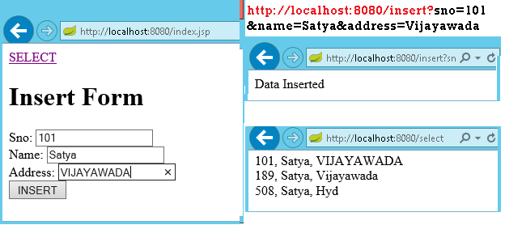

We can discard RowMapper class if we write following code in StudentDAO class it self.

@Repository

**public** **class** StudentDAO {

@Autowired

**private** JdbcTemplate template;

**public** List<Student> findAll() {

List<Student> result = template.query("SELECT sno,name, address FROM Student",

(rs, rowNum) -> **new** Student(rs.getInt("sno"),

rs.getString("name"), rs.getString("address")));

**return** result;

}

**public** **void** addStudent(**int** sno, String name, String address) {

template.update("INSERT INTO Student(sno,name, address) VALUES (?,?,?)",

sno, name, address);

}

}

## Spring Boot –JPA Example

Spring Boot provides **spring-boot-starter-data-jpa** starter to connect Spring application with relational database efficiently. You can use it into project POM (Project Object Model) file.

### JPA Annotations

By default, each field is mapped to a column with the name of the field. You can change the default name via **@Column (name="newColumnName").**

The following annotations can be used.

|  |  |
| --- | --- |
| @Entity | Marks java class to a Table name |
| @Table(name="tabname") | Provides table name, when table name & class names are different . |
| @Id | Identifies the unique ID of the database entry |
| @GeneratedValue | Together with an ID this annotation defines that value is generated automatically. |
| @Transient | Field will not be saved in database |

The central interface in Spring Data repository abstraction is **Repository** (probably not that much of a surprise). It takes the domain class to manage as well as the id type of the domain class as type arguments.

### Spring 4 Data

Spring Data Commons provides all the common abstractions that enable you to connect with different data stores. It provides classes & methods, which are common for all the SQL, NoSQL, BigData databases

* Execute CRUD (create, read, update, delete) operations
* Sorting
* Page-wise reading (pagination)

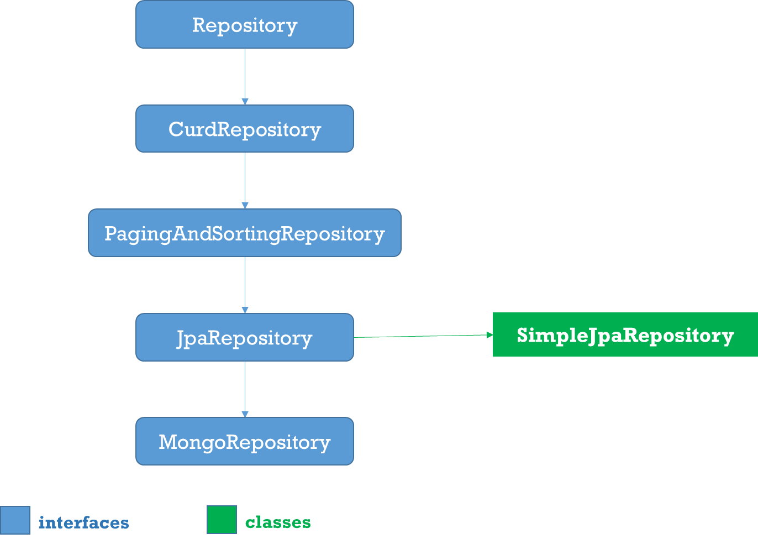

1.Repositoy

Root interface for all Repositoty classes. It is a **marker interface (no methods).**

2.CurdRepositoy

It provides generic **CRUD** operations irrespective of the underlying database. It extends **Repository** interface.

public interface CrudRepository<T, ID> extends Repository<T, ID> {

save(S entity);

saveAll(Iterable<S> entities);

Optional<T> findById(ID id);

Iterable<T> findAll();

Iterable<T> findAllById(Iterable<ID> ids);

void deleteById(ID id);

void delete(T entity);

void deleteAll(Iterable<? extends T> entities);

void deleteAll();

boolean existsById(ID id);

long count();

}

3.PagingAndSortingRepository

PagingAndSortingRepository provides options to

* **Sort** your data using **Sort interface**
* **Paginate** your data using **Pageable interface**, which provides methods for pagination - getPageNumber(), getPageSize(), next(), previousOrFirst() etc

public abstract interface PagingAndSortingRepository extends CrudRepository {

public Iterable findAll(Sort sort);

public Page findAll(Pageable pageable);

}

4.JpaRepository

JPA specific extension of [Repository](https://docs.spring.io/spring-data/commons/docs/current/api/org/springframework/data/repository/Repository.html?is-external=true)

public interface JpaRepository<T, ID extends Serializable> extends

PagingAndSortingRepository<T, ID> {

List<T> findAll();

List<T> findAll(Sort sort);

List<T> save(Iterable<? extends T> entities);

void flush();

T saveAndFlush(T entity);

void deleteInBatch(Iterable<T> entities);

}

5.MongoRepository

Mongo specific [Repository](https://docs.spring.io/spring-data/commons/docs/current/api/org/springframework/data/repository/Repository.html?is-external=true) interface.

public interface MongoRepository<T, ID> extends PagingAndSortingRepository {

List<T> findAll()

List<T> findAll(Sort sort)

List<S> saveAll(Iterable<S> entities)

List<S> insert(Iterable<S> entities)

S insert(S entity)

}

6.Custom Repository

* You can create a custom repository extending any of the repository classes - Repository, PagingAndSortingRepository or CrudRepository. For example,

interface PersonRepository extends CrudRepository<User, Long> {

}

* Spring Data also provides the feature of query creation from interface method names.

interface PersonRepository extends Repository<User, Long> {

List<Person> findByEmailAddressAndLastname(EmailAddress emailAddress, String lastname);

// Enables the distinct flag for the query

List<Person> find**Distinc**tPeopleByLastnameOrFirstname(String lastname, String firstname);

List<Person> findPeople**Distinct**ByLastnameOrFirstname(String lastname, String firstname);

// Enabling ignoring case for an individual property

List<Person> findByLastname**IgnoreCase**(String lastname);

// Enabling ignoring case for all suitable properties

List<Person> findByLastnameAndFirstnameAllIgnoreCase(String lastname, String firstname);

// Enabling static ORDER BY for a query

List<Person> findByLastnameOrderByFirstnameAsc(String lastname);

List<Person> findByLastnameOrderByFirstnameDesc(String lastname);

}

7.Defining Query Methods

The repository proxy has two ways to derive a store-specific query from the method name:

* By deriving the query from the method name directly.

List<Person> **findByEmailAddressAndLastname**(EmailAddress emailAddress, String lastname);

* By using a manually defined query.

@Query("select u from User u")

List<User> **findAllByCustomQueryAndStream**();

* Limiting the result size of a query with Top and First

User findFirstByOrderByLastnameAsc();

User findTopByOrderByAgeDesc();

Page<User> query**First10By**Lastname(String lastname, Pageable pageable);

Slice<User> find**Top3By**Lastname(String lastname, Pageable pageable);

List<User> find**First10**ByLastname(String lastname, Sort sort);

List<User> findTop10ByLastname(String lastname, Pageable pageable);

1.Entity class : Student.java

1.  create an entity class that contains the information of a single Student entry

**package** app.entity;

@Entity

@Table(name = "student")

**public** **class** Student {

@Id

@GeneratedValue(strategy = GenerationType.***AUTO***)

**private** **int** sno;

@Column(name = "name")

**private** String name;

@Column(name = "address")

**private** String address;

**public** Student() {

**super**();

}

**public** Student(**int** sno, String name, String address) {

**super**();

**this**.sno = sno;

**this**.name = name;

**this**.address = address;

}

**//Setters & getters**

}

StudentRepository.java

We can create the repository that provides CRUD operations for ***Student*** objects by using one of the following methods:

1. Create an interface that extends the ***CrudRepository*** interface.
2. Create an interface that extends the ***Repository*** interface and add the required methods to the created interface.

**package** app.repository;

**import** org.springframework.data.repository.CrudRepository;

**import** app.entity.Student;

**public** **interface** StudentRepository **extends** CrudRepository<Student, String>{

}

StudentService.java

**package** app.service;

@Service

**public** **class** StudentService {

@Autowired

**private** StudentRepository repository;

**public** List<Student> getAllStudents() {

List<Student> studentRecords = **new** ArrayList<>();

repository.findAll().forEach(studentRecords::add);

**return** studentRecords;

}

**public** Student getStudent(String id) {

**return** repository.findOne(id);

}

**public** **void** addStudent(Student studentRecord) {

repository.save(studentRecord);

}

**public** **void** delete(String id) {

repository.delete(id);

}

}

StudentController.java

**package** app.controller;

@RestController

**public** **class** StudentController {

@Autowired

**private** StudentService studentService;

@RequestMapping("/")

**public** List<Student> getAllStudent() {

**return** studentService.getAllStudents();

}

@RequestMapping(value = "/add", method = RequestMethod.***POST***)

**public** **void** addStudent(@RequestBody Student student) {

studentService.addStudent(student);

}

@RequestMapping(value = "/get/{id}", method = RequestMethod.***GET***)

**public** Student getStudent(@PathVariable String id) {

**return** studentService.getStudent(id);

}

}

SpringBootApp.java

@SpringBootApplication

**public** **class** SpringBootApp {

**public** **static** **void** main(String[] args) {

SpringApplication.*run*(SpringBootApp.**class**, args);

}

}

[**http://localhost:8080/**](http://localhost:8080/) -get All Srudents

[

{

"sno": 189,

"name": "Satya",

"address": "Vijayawada"

},

{

"sno": 508,

"name": "Satya",

"address": "Hyd"

}

]

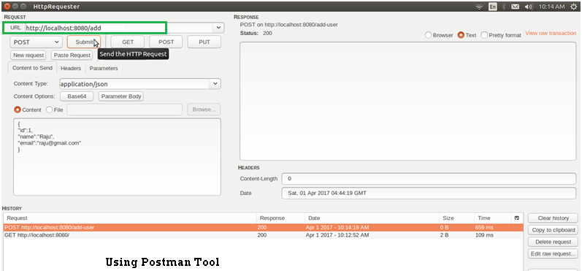

## JpaRepository

**JpaRepository** provides some JPA related method such as flushing the persistence context and delete record in a batch. [JpaRepository](http://static.springsource.org/spring-data/data-jpa/docs/current/api/org/springframework/data/jpa/repository/JpaRepository.html) extends [PagingAndSortingRepository](http://static.springsource.org/spring-data/data-commons/docs/current/api/org/springframework/data/repository/PagingAndSortingRepository.html) which in turn extends [CrudRepository](http://static.springsource.org/spring-data/data-commons/docs/current/api/org/springframework/data/repository/CrudRepository.html).

Their main functions are:

* [**CrudRepository**](http://static.springsource.org/spring-data/data-commons/docs/current/api/org/springframework/data/repository/CrudRepository.html) mainly provides CRUD functions.
* [**PagingAndSortingRepository**](http://static.springsource.org/spring-data/data-commons/docs/current/api/org/springframework/data/repository/PagingAndSortingRepository.html) provide methods to do pagination and sorting records.
* [**JpaRepository**](http://static.springsource.org/spring-data/data-jpa/docs/current/api/org/springframework/data/jpa/repository/JpaRepository.html) provides some JPA related method such as flushing the persistence context and delete record in a batch.

Because of the inheritance mentioned above, **JpaRepository** will have all the functions of **CrudRepository** and **PagingAndSortingRepository**.

### Custom Queries

Spring Data JPA provides **three different approaches for creating custom queries** with query methods. Each of these approaches is described in following.

#### Using Method Name

* Spring Data JPA has a built-in query creation mechanism which can be used for parsing queries straight from the method name of a query method.
* the method names of your repository interface are created **by combining the property names of an entity object and the supported keywords.**

**public** **interface** PersonRepository **extends** Repository<User, Long> {

List<Person> findByEmailAddressAndLastname(EmailAddress emailAddress, String lastname);

// Enables the distinct flag for the query

List<Person> findDistinctPeopleByLastnameOrFirstname(String lastname, String firstname);

List<Person> findPeopleDistinctByLastnameOrFirstname(String lastname, String firstname);

// Enabling ignoring case for an individual property

List<Person> findByLastnameIgnoreCase(String lastname);

// Enabling ignoring case for all suitable properties

List<Person> findByLastnameAndFirstnameAllIgnoreCase(String lastname, String firstname);

// Enabling static ORDER BY for a query

List<Person> findByLastnameOrderByFirstnameAsc(String lastname);

List<Person> findByLastnameOrderByFirstnameDesc(String lastname);

}

#### JPA Named Queries

Spring Data JPA provides also support for the JPA Named Queries. You have got following alternatives for declaring the named queries:

* You can use either ***named-query* XML** element or ***@NamedQuery*** annotation to create named queries with the JPA query language.
* You can use either ***named-native-query*** XML element **or *@NamedNative*** query annotation to create queries with SQL if you are ready to tie your application with a specific database platform.

The only thing you have to do to use the created named queries is to name the query method of your repository interface to match with the name of your named query. See below Example code

@Entity

@NamedQuery(name = "Person.findByName", query = "SELECT p FROM Person p WHERE LOWER(p.lastName) = LOWER(?1)")

@Table(name = "persons")

**public** **class** Person {

@Id

@GeneratedValue(strategy = GenerationType.AUTO)

**private** Long id;

@Column(name = "creation\_time", nullable = **false**)

**private** Date creationTime;

@Column(name = "first\_name", nullable = **false**)

**private** String firstName;

}

The relevant part of my ***PersonRepository*** interface looks following

**public** **interface** PersonRepository **extends** JpaRepository<Person, Long> {

//A list of persons whose last name is an exact match with the given last name.

**public** List<Person> findByName(String lastName);

}

#### @Query Annotation

* The ***@Query***annotation can be used to create queries by using the JPA query language and to **bind these queries directly to the methods of your repository interface**.
* When the query method is called, Spring Data **JPA will execute the query specified by the *@Query* annotation**
* If there is a collision between the *@Query* annotation and the named queries, the query specified by using *@Query* annotation will be executed

public interface ProductRepository

extends CrudRepository<Product, Long> {

@Query("FROM Product")

List<Product> findAllProducts();

}

You may use positional parameters instead of named parameters in queries. Positional parameters are prefixed with a question mark **(?)** followed the numeric position of the parameter in the query. The Query.setParameter(integer position, Object value) method is used to set the parameter values.

public List findWithName(String name) {

return em.createQuery(

“SELECT c FROM Customer c WHERE c.name LIKE ?1”)

.setParameter(1, name)

.getResultList();

}

**Automatic Query Generation**

The **<jpa:repositories/>** has an option query-lookup-strategy which defaults to “**create-if-not-found” which will generate queries for us.**The default is “create-if-not-found“. Other options are “create” or “use-declared-query“.

<jpa:repositories base-package="com.gordondickens.myapp.repository"

query-lookup-strategy="create-if-not-found"/>

To create a find method that effectively does @Query("FROM Product p where p.productId =:productId")

public interface ProductRepository extends CrudRepository<Product, Long> {

...

@Query

Product findByProductId(String productId);

...

Example

**Student.java**

**package** app.entity;

@Entity

@Table(name = "student")

**public** **class** Student {

@Id

@GeneratedValue(strategy = GenerationType.***AUTO***)

**private** **int** sno;

@Column(name = "name")

**private** String name;

@Column(name = "address")

**private** String address;

@Override

**public** String toString() {

String str = "Student[" + "Sno: " + getSno() + ", Name:" + getName() + ", " + "Address : " + getAddress() + "]";

**return** str;

}

**//Setters & getters**

}

**StudentRepository.java**

**public** **interface** StudentRepository **extends** CrudRepository<Student, Long> {

List<Student> findBySno(**int** sno);

List<Student> findByName(String name);

// custom query example and return a stream

@Query("select c from Student c where c.address = :address")

Stream<Student> findByAddress(@Param("address") String address);

}

**Application.java**

package app;

@SpringBootApplication

public class Application implements CommandLineRunner {

@Autowired

DataSource dataSource;

@Autowired

StudentRepository repository;

public static void main(String[] args) throws Exception {

SpringApplication.*run*(Application.class, args);

}

@Transactional(readOnly = true)

@Override

public void run(String... args) throws Exception {

System.*out*.println("DATASOURCE = " + dataSource);

System.*out*.println("\n1.findAll()...");

for (Student student : repository.findAll()) {

System.*out*.println(student);

}

System.*out*.println("\n2.findByName(String name)...");

for (Student student : repository.findByName("Satya")) {

System.*out*.println(student);

}

System.*out*.println("\n3.findByAddress(@Param(\"name\"))...");

try (Stream<Student> s =repository.findByAddress("Vijayawada")) {

s.forEach(x -> System.*out*.println(x));

System.*out*.println("Done!");

*exit*(0);

}

}

}

1.findAll()...

Student[Sno: 0, Name:null, Address : null]

Student[Sno: 101, Name:Satya, Address : VIJAYAWADA]

Student[Sno: 102, Name:Satya, Address : Vijayawada]

Student[Sno: 147, Name:kumar, Address : Hyderabad]

Student[Sno: 189, Name:Satya, Address : Vijayawada]

Student[Sno: 508, Name:Satya, Address : Hyd]

2.findByName(String name)...

Student[Sno: 101, Name:Satya, Address : VIJAYAWADA]

Student[Sno: 102, Name:Satya, Address : Vijayawada]

Student[Sno: 189, Name:Satya, Address : Vijayawada]

Student[Sno: 508, Name:Satya, Address : Hyd]

4.findByAddress(@Param("name") String name)...

Student[Sno: 101, Name:Satya, Address : VIJAYAWADA]

Student[Sno: 102, Name:Satya, Address : Vijayawada]

Student[Sno: 189, Name:Satya, Address : Vijayawada]

## Spring Boot –MongoDB REST Example

Configuration file application.properties

# Create new database : ‘smlcodes’

spring.data.mongodb.database=smlcodes

spring.data.mongodb.host=localhost

spring.data.mongodb.port=27017

we need to model our documents. Let’s call ours ‘**Booking**’ and give it a make, model, and description. Here is our Java class to accomplish this

**package** smlcodes.repository;

**import** org.springframework.data.annotation.Id;

**import** org.springframework.data.mongodb.core.mapping.Document;

@Document

**public** **class** Student{

@Id

String sno;

String name;

String address;

//Setters & getters

* **@Id-**id provided by Mongo for a document.
* **@Document-** provides a collection name.

***BookingRepository.java***

The **MongoRepository** provides basic CRUD operation methods and also an API to find all documents in the collection.

@Transactional

**public** **interface** StudentRepository **extends** MongoRepository<Student, String> {

**public** Student findBySno(**int** sno);

}

***BookingController.java***

**package** smlcodes.controller;

@RestController

@RequestMapping("/student")

**public** **class** StudentController {

@Autowired

StudentRepository studentRepository;

@RequestMapping("/create")

**public** Map<String, Object> create(Student student) {

student = studentRepository.save(student);

Map<String, Object> dataMap = **new** HashMap<String, Object>();

dataMap.put("message", "Student created successfully");

dataMap.put("status", "1");

dataMap.put("student", student);

**return** dataMap;

}

@RequestMapping("/read")

**public** Map<String, Object> read(@RequestParam **int** sno) {

Student student = studentRepository.findBySno(sno);

Map<String, Object> dataMap = **new** HashMap<String, Object>();

dataMap.put("message", "Student found successfully");

dataMap.put("status", "1");

dataMap.put("student", student);

**return** dataMap;

}

@RequestMapping("/readall")

**public** Map<String, Object> readAll() {

List<Student> students = studentRepository.findAll();

Map<String, Object> dataMap = **new** HashMap<String, Object>();

dataMap.put("message", "Student found successfully");

dataMap.put("totalStudent", students.size());

dataMap.put("status", "1");

dataMap.put("students", students);

**return** dataMap;

}

}

SpringBootMongoDbApplication.java

@SpringBootApplication

**public** **class** SpringBootMongoDbApplication {

**public** **static** **void** main(String[] args) {

SpringApplication.*run*(SpringBootMongoDbApplication.**class**, args);

}

}

Test

[**http://localhost:8080/student/create?sno=101&name=Satya&address=HYDERABAD**](http://localhost:8080/student/create?sno=101&name=Satya&address=HYDERABAD) **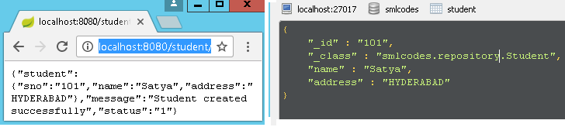**

# 6. Spring Boot – Advanced

## Spring Boot – Logging

Spring boot’s provide default logging mecahnisum, which is written with *Apache Commons Logging*

SpringBoot supports  ERROR, WARN, INFO, DEBUG, or TRACE as logging level. By default, logging level is set to **INFO**. It means that code>DEBUG and TRACE messages are not visible.

To enable debug or trace logging, we can set the logging level in application.properties file. Also, we can pass the –debug or –trace arguments on the command line while starting the application.

**# In Console**

**-Dlogging.level.org.springframework=ERROR**

**-Dlogging.level.com.howtodoinjava=TRACE**

**# In properties file**

**logging.level.org.springframework=ERROR**

**logging.level.com.howtodoinjava=TRACE**

Example

**import** org.slf4j.Logger;

**import** org.slf4j.LoggerFactory;

@SpringBootApplication

**public** **class** Application

{

**private** **static** **final** Logger ***LOGGER***=LoggerFactory.*getLogger*(Application.**class**);

**public** **static** **void** main(String[] args) {

SpringApplication.*run*(Application.**class**, args);

***LOGGER***.info("Simple log statement with inputs {}, {} and {}", 1,2,3);

}

}

## Spring Boot - Devtools

If you have worked on latest UI development frameworks e.g. Node, [angular](https://howtodoinjava.com/angularjs/angularjs-tutorial-helloworld-example/), gulp etc. then you must have appreciated the auto-reload of UI in browser whenever there is change in some code. Its pretty useful and saves a lot of time.

To enable dev tools in spring boot application is very easy. Just add the spring-boot-devtools dependency in your build file.

<dependencies>

    <dependency>

        <groupId>org.springframework.boot</groupId>

        <artifactId>**spring-boot-devtools**</artifactId>

        <optional>true</optional>

    </dependency>

</dependencies>

**Static Resource Caching**

To improve the performance, dev tools cache the static content/template files to serve them faster to browser/client.

There are many such UI template libraries that support this feature. e.g. thymeleaf, freemarker, groovy, mustache etc.

#spring.freemarker.cache = true //set true in production environment

spring.freemarker.cache = false //set false in development environment; It is false by default.

//Other such properties

spring.thymeleaf.cache = false

spring.mustache.cache = false

spring.groovy.template.cache = false

**Automatic UI refresh**

The **spring-boot-devtools** module includes an embedded LiveReload server that can be used to trigger a browser refresh when a resource is changed

spring.devtools.livereload.enabled  = false #Set false to disable live reload

## SpringBoot Acuator - Health check, Auditing, Metrics,Monitoring

Actuator brings production-ready features to our application.

**Monitoring our app, gathering metrics, understanding traffic or the state of our database becomes trivial with this dependency.**

<dependency>

    <groupId>org.springframework.boot</groupId>

    <artifactId>spring-boot-starter-actuator</artifactId>

</dependency>

Once above maven dependency is included in the POM file, **16 different actuator REST endpoints**, such as actuator, beans, dump, info, loggers, and metrics are exposed

Some of important and widely used actuator endpoints are given below:

|  |  |
| --- | --- |
| **ENDPOINT** | **USAGE** |
| /env | Returns list of properties in current environment |
| /health | Returns application health information. |
| /auditevents | Returns all auto-configuration candidates and the reason why they ‘were’ or ‘were not’ applied. |
| /beans | Returns a complete list of all the Spring beans in your application. |
| /trace | Returns trace logs (by default the last 100 HTTP requests). |
| /dump | It performs a thread dump. |
| /metrics | It shows metrics information like JVM memory used, system CPU usage, open files, and much more. |

You can access all avaible endpoint by this URL: [**http://localhost:8080/actuator**](http://localhost:8080/actuator)

{

"\_links": {

"self": {

"href": *"http://localhost:8080/actuator"*,

"templated": false

},

"health": {

"href": *"http://localhost:8080/actuator/health"*,

"templated": false

},

"health-component-instance": {

"href": *"http://localhost:8080/actuator/health/{component}/{instance}"*,

"templated": true

},

"health-component": {

"href": *"http://localhost:8080/actuator/health/{component}"*,

"templated": true

},

"info": {

"href": *"http://localhost:8080/actuator/info"*,

"templated": false

}

}

}

If you see we have only 2 endpoints showing (health, info) out of 16 endpoints

By default, all the actuator endpoints are exposed over **JMX** but only the health and info endpoints are exposed over **HTTP**.

Here is how you can expose actuator endpoints over HTTP and JMX using application properties -

**Exposing Actuator endpoints over HTTP**

# Use "\*" to expose all endpoints, or a comma-separated list to expose selected ones

management.endpoints.web.exposure.include=\*

management.endpoints.web.exposure.exclude=

**Exposing Actuator endpoints over JMX**

# Use "\*" to expose all endpoints, or a comma-separated list to expose selected ones

management.endpoints.jmx.exposure.include=\*

management.endpoints.jmx.exposure.exclude=

#### Securing Actuator Endpoints with Spring Security

Actuator endpoints are sensitive and must be secured from unauthorized access. you can add spring security to your application using the following dependency -

<dependency>

<groupId>org.springframework.boot</groupId>

<artifactId>spring-boot-starter-security</artifactId>

</dependency>

we can override the default spring security configuration and define our own access rules.

#### Creating a Custom Actuator Endpoint

To customize the endpoint and define your own endpoint, simply Create a classs annotate with @Endpoint URL :

**import** org.springframework.boot.actuate.endpoint.annotation.Endpoint;

**import** org.springframework.boot.actuate.endpoint.annotation.ReadOperation;

**import** org.springframework.stereotype.Component;

@Endpoint(id="helloEndpoint")

@Component

**public** **class** ListEndPoints {

@ReadOperation

**public** String mypoint(){

**return** "Hello" ;

}

}

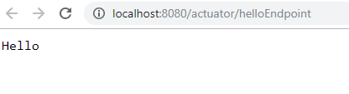

Few more Endpoints

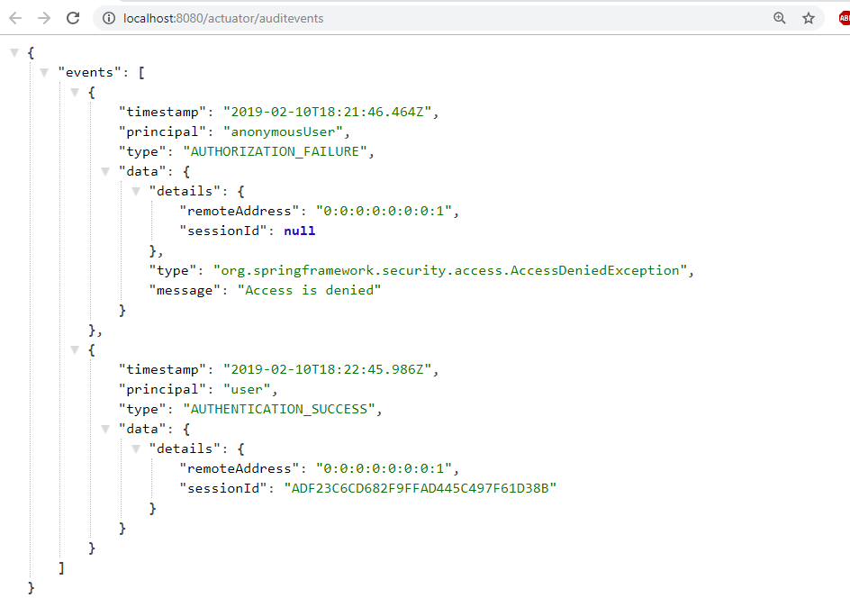

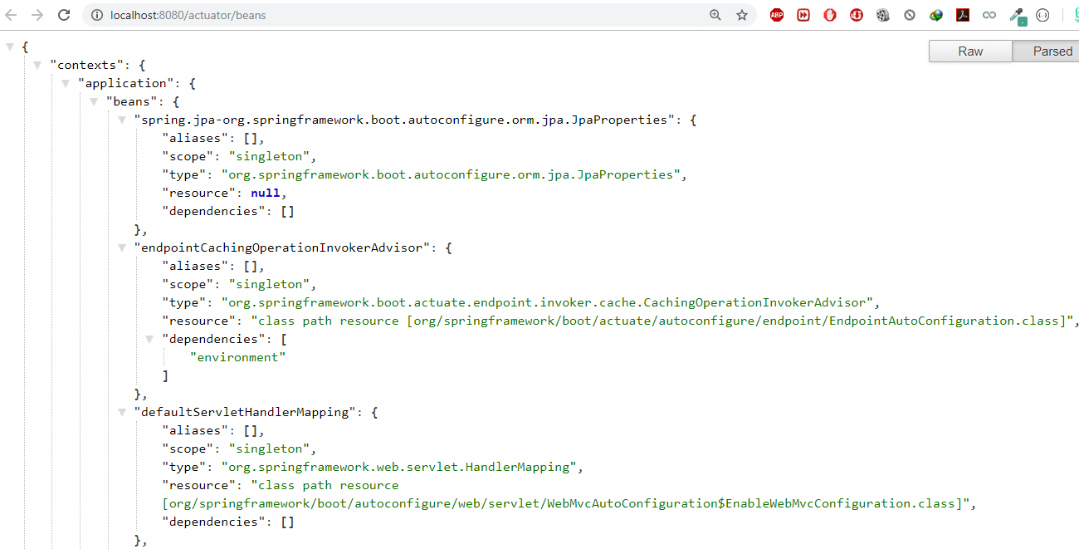

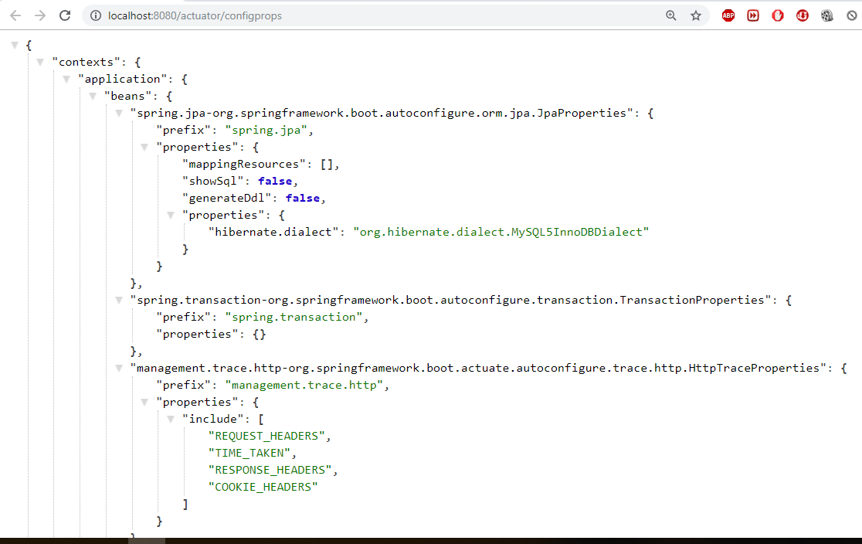

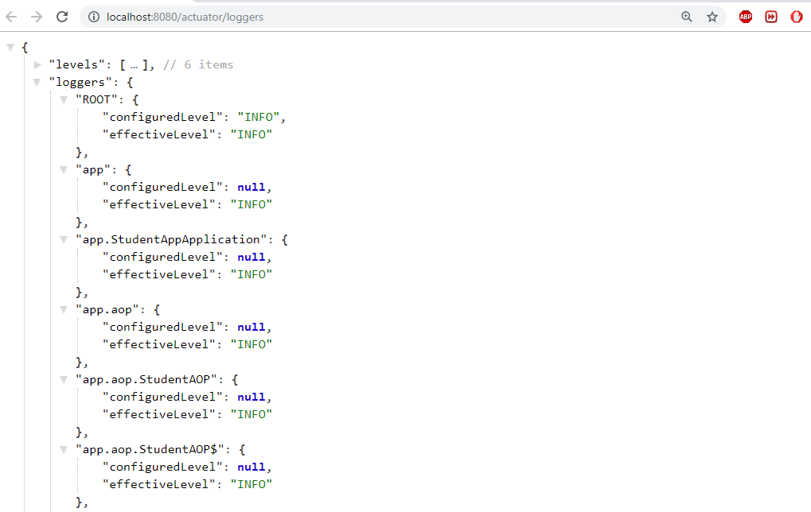

## SpringBoot – Project Lombok

Project Lombok is a Java library tool that generates code for minimizing boilerplate code. The library replaces boilerplate code with easy-to-use annotations.

For example, by adding a couple of annotations, you can get rid of code clutters, such as getters and setters methods, constructors, hashcode, equals, and toString methods, and so on.

* [**val**](https://projectlombok.org/features/val) :Finally! Hassle-free final local variables.
* [**var**](https://projectlombok.org/features/var) :Mutably! Hassle-free local variables.
* [**@Data**](https://projectlombok.org/features/Data):All together now: A shortcut for @ToString, @EqualsAndHashCode, @Getter on all fields, and @Setter on all non-final fields, and @RequiredArgsConstructor!
* [**@NonNull**](https://projectlombok.org/features/NonNull) :or: How I learned to stop worrying and love the NullPointerException.
* [**@Cleanup**](https://projectlombok.org/features/Cleanup) :Automatic resource management: Call your close() methods safely
* [**@Getter/@Setter**](https://projectlombok.org/features/GetterSetter) :Never write public int getFoo() {return foo;} again.
* [**@ToString**](https://projectlombok.org/features/ToString) : generate a toString for you!
* [**@EqualsAndHashCode**](https://projectlombok.org/features/EqualsAndHashCode) : Generates hashCode and equals implementations from the fields of your object.
* [**@NoArgsConstructor, @RequiredArgsConstructor and @AllArgsConstructor**](https://projectlombok.org/features/constructor)

Constructors made to order: Generates constructors that take no arguments, one argument per final / non-nullfield, or one argument for every field.

* [**@Value**](https://projectlombok.org/features/Value) :Immutable classes made very easy.
* [**@Builder**](https://projectlombok.org/features/Builder) No-hassle fancy-pants APIs for object creation!
* [**@SneakyThrows**](https://projectlombok.org/features/SneakyThrows) :To boldly throw checked exceptions where no one has thrown them before!
* [**@Synchronized**](https://projectlombok.org/features/Synchronized):synchronized done right: Don't expose your locks.
* [**@With**](https://projectlombok.org/features/With):Immutable 'setters' - methods that create a clone but with one changed field.
* [**@Getter(lazy=true)**](https://projectlombok.org/features/GetterLazy):Laziness is a virtue!
* [**@Log**](https://projectlombok.org/features/log) :Captain's Log, stardate 24435.7: "What was that line again?"
* [**experimental**](https://projectlombok.org/features/experimental/all) :Head to the lab: The new stuff we're working on.

Maven dependency

<dependency>

<groupId>org.projectlombok</groupId>

<artifactId>lombok</artifactId>

<optional>true</optional>

</dependency>

## SpringBoot Security

spring-boot-starter-security: take care of all the required dependencies related to spring security.

<dependency>

<groupId>org.springframework.boot</groupId>

<artifactId>spring-boot-starter-security</artifactId>

</dependency>

This will include the *SecurityAutoConfiguration*class – containing the initial/default security configuration.

Just Run the project & see the magic

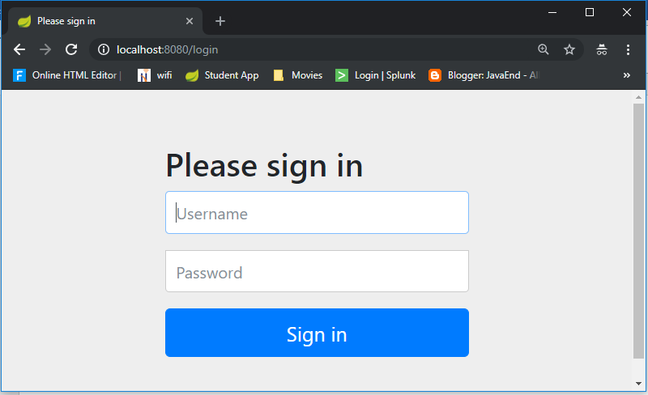

**We never created this login form, but from where it came from?**

SpringSecurity default comes with login page & you can login with generated password which is already printed in the console

Using generated security password: **8b4667a4-cc3a-47fd-b51f-b6f5e83745df**

Def.user name is : **user**

You can change the password by providing a security.user.password. This and other useful properties are externalized via [SecurityProperties](https://github.com/spring-projects/spring-boot/tree/v1.4.0.RELEASE/spring-boot-autoconfigure/src/main/java/org/springframework/boot/autoconfigure/security/SecurityProperties.java" \t "_top) (properties prefix "security").

security.user.name=user

security.user.name=password

security.basic.enabled=true

To discard the security auto-configuration and add our own configuration, we need to exclude the ***SecurityAutoConfiguration*** class.

**@SpringBootApplication(exclude = { SecurityAutoConfiguration.class })**

public class SpringBootSecurityApplication {

    public static void main(String[] args) {

        SpringApplication.run(SpringBootSecurityApplication.class, args);

    }

}

Or by adding some configuration into the *application.properties* file:

spring.autoconfigure.exclude=org.springframework.boot.autoconfigure.security.SecurityAutoConfiguration

If we disabling security auto-configuration, we need to provide our own configuration, by extends WebSecurityConfigurerAdapter

@Configuration

@EnableWebSecurity

**public** **class** SecurityConfig **extends** WebSecurityConfigurerAdapter {

@Override

**public** **void** configure(HttpSecurity http) **throws** Exception {

// It allows configuring web based security for specific http requests

http

.authorizeRequests()

.anyRequest().authenticated()

.and()

.formLogin()

.and()

.httpBasic();

/\* ============ Custom login Page URL ==========

http

.authorizeRequests()

.antMatchers("/admin/\*\*").hasRole("ADMIN")

.antMatchers("/anonymous\*").anonymous()

.antMatchers("/login\*").permitAll()

.anyRequest().authenticated()

.and()

.formLogin()

.loginPage("/login.html")

.loginProcessingUrl("/perform\_login")

.defaultSuccessUrl("/homepage.html", true)

//.failureUrl("/login.html?error=true")

.failureHandler(authenticationFailureHandler())

.and()

.logout()

.logoutUrl("/perform\_logout")

.deleteCookies("JSESSIONID")

.logoutSuccessHandler(logoutSuccessHandler());

\*/

}

@Bean

@Override

**public** UserDetailsService userDetailsService() {

UserDetails user =

User.~~withDefaultPasswordEncoder~~()

.username("user")

.password("user")

.roles("USER")

.build();

**return** **new** InMemoryUserDetailsManager(user);

}

}

Let’s summarize what we did in order to add Spring Boot Security to his web app. To secure his web app,

* we added Spring Boot Security to the classpath.
* Once it was in the classpath, Spring Boot Security was enabled by default.
* Then customized the security by extending  WebSecurityConfigurerAdapter and added his own configure and userDetailsServiceimplementation.
* <http://localhost:8080/login?logout>
* <https://docs.spring.io/spring-security/site/docs/current/guides/html5/form-javaconfig.html>
* <https://examples.javacodegeeks.com/enterprise-java/spring/boot/spring-boot-security-example/>

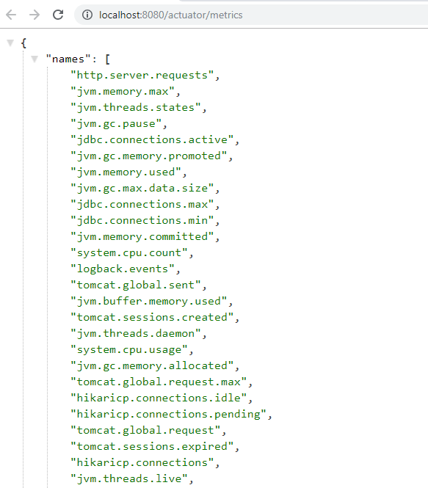

<https://dzone.com/articles/spring-boot-actuator-a-complete-guide>

<https://www.callicoder.com/spring-boot-actuator/>

# 7. Spring Cloud – MicroServices

The major use-case for Spring Cloud is the ready-to-use solution that it provides to common problems observed in distributed environments like load balancing, service discovery, circuit breaking, etc., which can easily be integrated in an existing Spring project.

Before we look at Spring Cloud, let’s have a brief overview on Microservice Architecture and the role of Spring Boot in creating microservices.

<https://github.com/sivaprasadreddy/spring-boot-microservices-series>

Microservices

#### Monoliths

Traditionally we are building large enterprise applications in modularised fashion, but finally deploy them together as a single deployment unit (EAR or WAR). These are called Monolithic applications.

There are some issues with the monolithic architecture such as:

* Large codebases become mess over the time
* Multiple teams working on single codebase become tedious
* It is not possible to scale up only certain parts of the application
* Technology updates/rewrites become complex and expensive tasks

#### MicroServices

Microservice architecture is a style of application development where the application is broken down into small services and these services have loose coupling among them. Following are the major advantages of using microservice architecture −

**Advantages of MicroServices**

* Comprehending smaller codebase is easy
* Can independently scale up highly used services
* Each team can focus on one (or few) MicroService(s)
* Technology updates/rewrites become simpler

SpringBoot and SpringCloud are a good choice for MicroServices

Spring Cloud

Spring Cloud provides a collection of components which are useful in building distributed applications in cloud. We can develop these components on our own, however that would waste time in developing and maintaining this boilerplate code.

That is where Spring Cloud comes into picture. It provides ready-to-use cloud patterns for common problems which are observed in a distributed environment. Some of the patterns which it attempts to address are −

* Distributed Messaging
* Load Balancing
* Circuit Breakers
* Routing
* Distributed Logging
* Service Registration
* Distributed Lock
* Centralized Configuration

#### Spring Cloud Components

Let us now take a look at the various components which Spring Cloud provides and the problems these components solve

|  |  |
| --- | --- |
| **Problem** | **Components** |
| **Distributed Cloud Configuration** | Spring Cloud Configuration, Spring Cloud Zookeeper, Spring Consul Config |
| **Distributed Messaging** | Spring Stream with Kafka, Spring Stream with RabbitMQ |
| **Service Discovery** | Spring Cloud Eureka, Spring Cloud Consul, Spring Cloud Zookeeper |
| **Logging** | Spring Cloud Zipkin, Spring Cloud Sleuth |
| **Spring Service Communication** | Spring Hystrix, Spring Ribbon, Spring Feign, Spring Zuul |

#### Projects Of Spring Cloud

**Spring Cloud Config Server:** Confiuring application properties, environment detsils etc. We can use Spring Cloud Config Server with git or Consul or ZooKeeper as config repository.

**Service Registry and Discovery:** As there could be many services and we need the ability to scale up or down dynamically, we need Service Registry and Discovery mechanism so that service-to-service communication should not depend on hard-coded hostnames and port numbers. Spring Cloud provides Netflix Eureka-based Service Registry and Discovery support with just minimal configuration. We can also use Consul or ZooKeeper for Service Registry and Discovery. 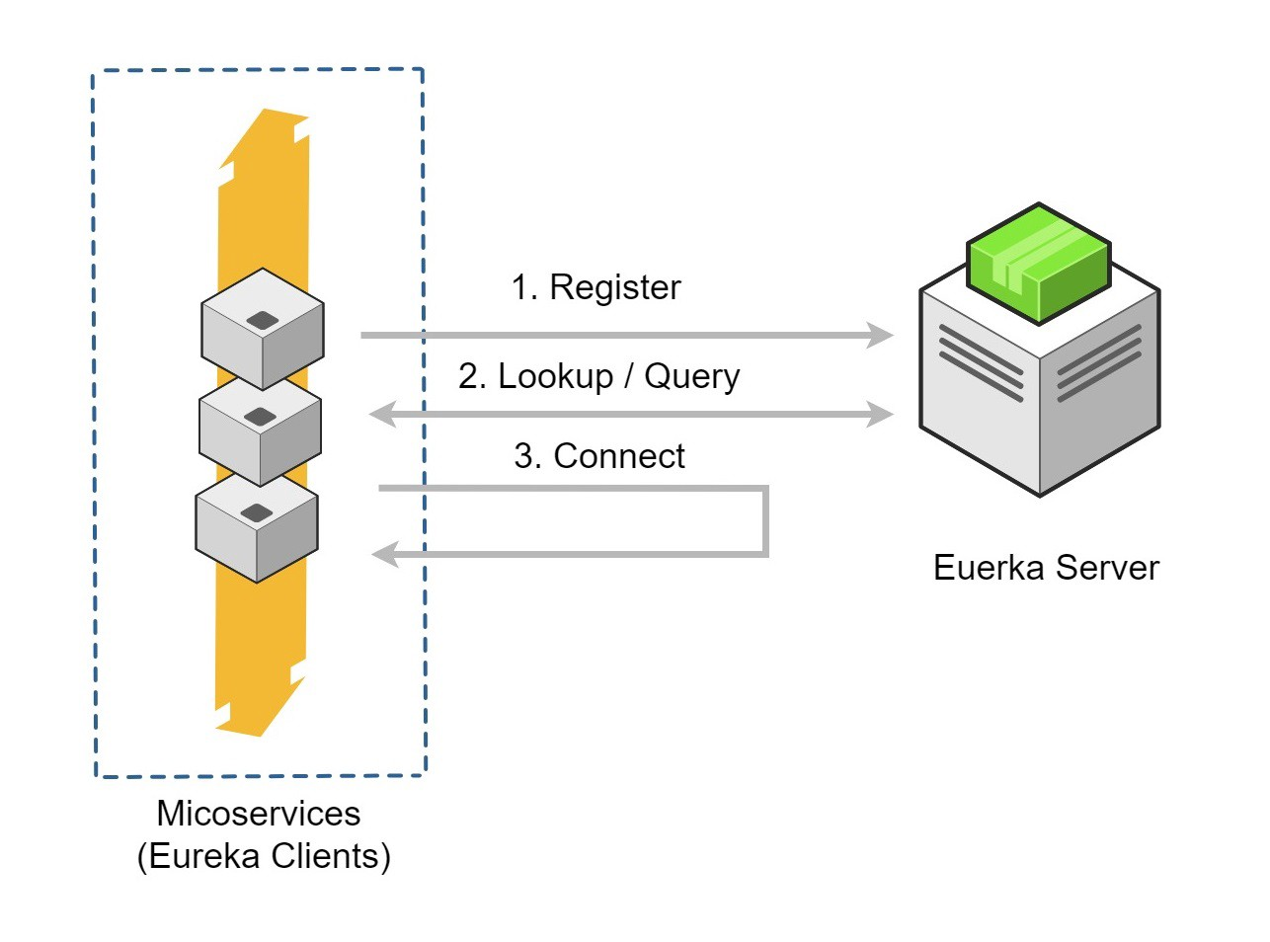

**Circuit Breaker:** In microservices based architecture, one service might depend on another service and if one service goes down then failures may cascade to other services as well. Spring Cloud provides Netflix Hystrix based Circuit Breaker to handle these kinds of issues.

**Spring Cloud Data Streams:** These days we may need to work with huge volumes of data streams using Kafka or Spark etc. Spring Cloud Data Streams provides higher-level abstractions to use those frameworks in an easier manner.

**Spring Cloud Security:** Some of the microservices needs to be accessible to authenticated users only and most likely we might want a **Single Sign-On** feature to propagate the authentication context across services. Spring Cloud Security provides authentication services using **OAuth2**.

**Distributed Tracing:** simple end-user action might trigger a chain of microservice calls, there should be a mechanism to trace the related call chains. We can use Spring Cloud Sleuth with Zipkin to trace the cross-service invocations.

**Spring Cloud Contract:** There is a high chance that separate teams work on different microservices. There should be a mechanism for teams to agree upon API endpoint contracts so that each team can develop their APIs independently. Spring Cloud Contract helps to create such contracts and validate them by both service provider and consumer.

#### 1. Spring Cloud Config Server

SpringBoot provides lot of flexibility in externalizing configuration properties via properties or YAML files. We can also configure properties for each environment (dev, qa, prod etc) separately using profile specific configuration files such as **application.properties**, **application-dev.properties**, **application-prod.properties** etc. But once the application is started we can not update the properties at runtime. If we change the properties we need to restart the application to use the updated configuration properties.

We can create a Spring Cloud Config Server which provides the configuration values for all of our microservices. We can use **git**, **svn**, **database** or **Consul** as a backend to store the configuration parameters.

Spring Cloud Config Server is nothing but a SpringBoot application with a configured configuration properties source. The configuration source can be a **git** repository, **svn** repository or Consul service (<https://www.consul.io/>).

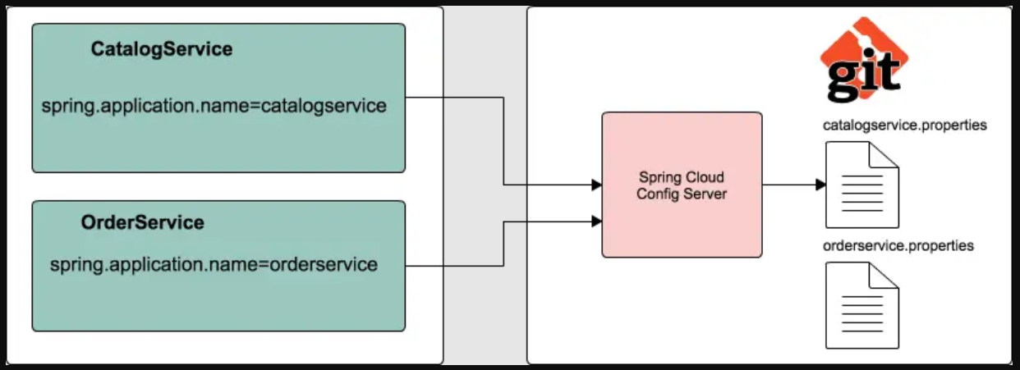

Then we can configure the location of Spring Cloud Config server in our microservice so that it will load all the properties when we start the application. In addition to that, whenever we update the properties we can invoke **/refresh** REST endpoint in our microservice so that it will reload the configuration changes without requiring to restart the application.

## 1. SpringCloud – Example

We are going to build a simple shopping cart application and assume we are going to start with the following microservices:

1. **catalog-service:** It provides REST API to provide catalog information like products.
2. **inventory-service:** It provides REST API to manage product inventory.
3. **cart-service:** It provides REST API to hold the customer cart details.
4. **order-service:** It provides REST API to manage orders.
5. **customer-service:** It provides REST API to manage customer information.
6. **shoppingcart-ui:** It is customer facing front-end web application.

We are going to build various services and REST endpoints as we go through various microservice concepts.

a.Catalog-Service

Create a SpringBoot app with **Web, JPA, MySQL, Actuator, DevTools, Lombok** starters

#### Database : MySQL as Docker Container

We are going to use Docker and run MySQL as a Docker container.

**docker-compose.yml**

version: '3'

services:

mysqldb:

image: 'mysql:5.7'

container\_name: mysqldb

ports:

- '3306:3306'

environment:

MYSQL\_ROOT\_PASSWORD: passw0rd

MYSQL\_DATABASE: catalog

Download & Start MySQL Docker container

docker-compose up

Open any MySQL Editor & provide login details

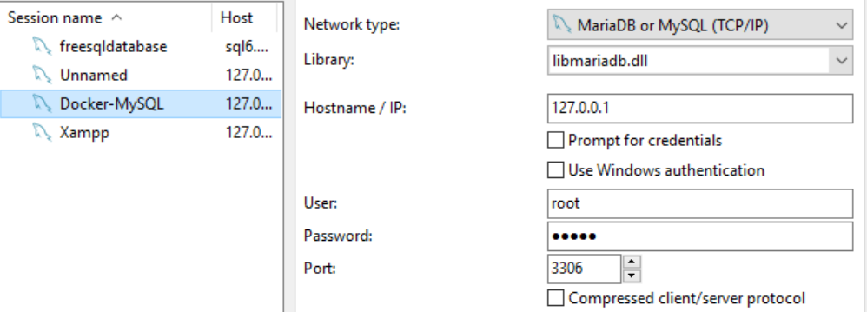

**CREATE** **TABLE** `products` (

`id` **BIGINT**(20) **NOT** **NULL**,

`code` **VARCHAR**(255) **NOT** **NULL** **COLLATE** 'latin1\_swedish\_ci',

`description` **VARCHAR**(255) **NULL** **DEFAULT** **NULL** **COLLATE** 'latin1\_swedish\_ci',

`name` **VARCHAR**(255) **NOT** **NULL** **COLLATE** 'latin1\_swedish\_ci',

`price` **DOUBLE** **NOT** **NULL**,

**PRIMARY** **KEY** (`id`) **USING** **BTREE**,

**UNIQUE** **INDEX** `UK\_57ivhy5aj3qfmdvl6vxdfjs4p` (`code`) **USING** **BTREE**

)

**COLLATE**='latin1\_swedish\_ci'

**ENGINE**=**InnoDB**

;

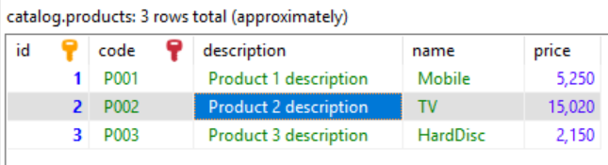

application.properties

server.port=8181

logging.level.catalog=debug

spring.datasource.driver-class-name=com.mysql.jdbc.Driver

spring.datasource.url=jdbc:mysql://localhost:3306/catalog?useSSL=false

spring.datasource.username=root

spring.datasource.password=passw0rd

spring.datasource.initialization-mode=always

spring.jpa.hibernate.ddl-auto=update

spring.jpa.show-sql=true

//expose all the Actuator endpoints

management.endpoints.web.exposure.include=\*

Java Code

**Pom.xml**

<?xml version=*"1.0"* encoding=*"UTF-8"*?>

<project xmlns=*"http://maven.apache.org/POM/4.0.0"* xmlns:xsi=*"http://www.w3.org/2001/XMLSchema-instance"*

xsi:schemaLocation=*"http://maven.apache.org/POM/4.0.0 https://maven.apache.org/xsd/maven-4.0.0.xsd"*>

<modelVersion>4.0.0</modelVersion>

<parent>

<groupId>org.springframework.boot</groupId>

<artifactId>spring-boot-starter-parent</artifactId>

<version>2.5.3</version>

<relativePath/> <!-- lookup parent from repository -->

</parent>

<groupId>catalog</groupId>

<artifactId>catalog-service</artifactId>

<version>0.0.1-SNAPSHOT</version>

<name>catalog-service</name>

<description>Demo project for Spring Boot</description>

<properties>

<java.version>11</java.version>

</properties>

<dependencies>

<dependency>

<groupId>org.springframework.boot</groupId>

<artifactId>spring-boot-starter-actuator</artifactId>

</dependency>

<dependency>

<groupId>org.springframework.boot</groupId>

<artifactId>spring-boot-starter-data-jpa</artifactId>

</dependency>

<dependency>

<groupId>org.springframework.boot</groupId>

<artifactId>spring-boot-starter-web</artifactId>

</dependency>

<dependency>

<groupId>org.springframework.boot</groupId>

<artifactId>spring-boot-devtools</artifactId>

<scope>runtime</scope>

<optional>true</optional>

</dependency>

<dependency>

<groupId>mysql</groupId>

<artifactId>mysql-connector-java</artifactId>

<scope>runtime</scope>

</dependency>

<dependency>

<groupId>org.projectlombok</groupId>

<artifactId>lombok</artifactId>

<optional>true</optional>

</dependency>

<dependency>

<groupId>org.springframework.boot</groupId>

<artifactId>spring-boot-starter-test</artifactId>

<scope>test</scope>

</dependency>

</dependencies>

<build>

<plugins>

<plugin>

<groupId>org.springframework.boot</groupId>

<artifactId>spring-boot-maven-plugin</artifactId>

<configuration>

<excludes>

<exclude>

<groupId>org.projectlombok</groupId>

<artifactId>lombok</artifactId>

</exclude>

</excludes>

</configuration>

</plugin>

</plugins>

</build>

</project>

**package** catalog.entity;

**import** lombok.Data;

**import** javax.persistence.\*;

@Data

@Entity

@Table(name = "products")

**public** **class** Product {

@Id

@GeneratedValue(strategy = GenerationType.***AUTO***)

**private** Long id;

@Column(nullable = **false**, unique = **true**)

**private** String code;

@Column(nullable = **false**)

**private** String name;

**private** String description;

**private** **double** price;

**//Getters & Setters**

}

**package** catalog.repository;

**public** **interface** ProductRepository **extends** JpaRepository<Product, Long> {

Optional<Product> findByCode(String code);

}

@Service

@Transactional

@Slf4j

**public** **class** ProductService {

**private** **final** ProductRepository productRepository;

@Autowired

**public** ProductService(ProductRepository productRepository) {

**this**.productRepository = productRepository;

}

**public** List<Product> findAllProducts() {

List<Product> list = productRepository.findAll();

**for**(Product p : list) {

System.***out***.println(p.getName());

}

**return** list;

}

**public** Optional<Product> findProductByCode(String code) {

**return** productRepository.findByCode(code);

}

}

@RestController

@RequestMapping("/api/products")

@Slf4j

**public** **class** ProductController {

**private** **final** ProductService productService;

@Autowired

**public** ProductController(ProductService productService) {

**this**.productService = productService;

}

@GetMapping("")

**public** List<Product> allProducts() {

**return** productService.findAllProducts();

}

@GetMapping("/{code}")

**public** Product productByCode(@PathVariable String code) {

**return** productService.findProductByCode(code).orElseThrow(() -> **new** ProductNotFoundException("Product with code [" + code + "] doesn't exist"));

}

}

Okay, now we can start our SpringBoot application and hit <http://localhost:8181/api/products>

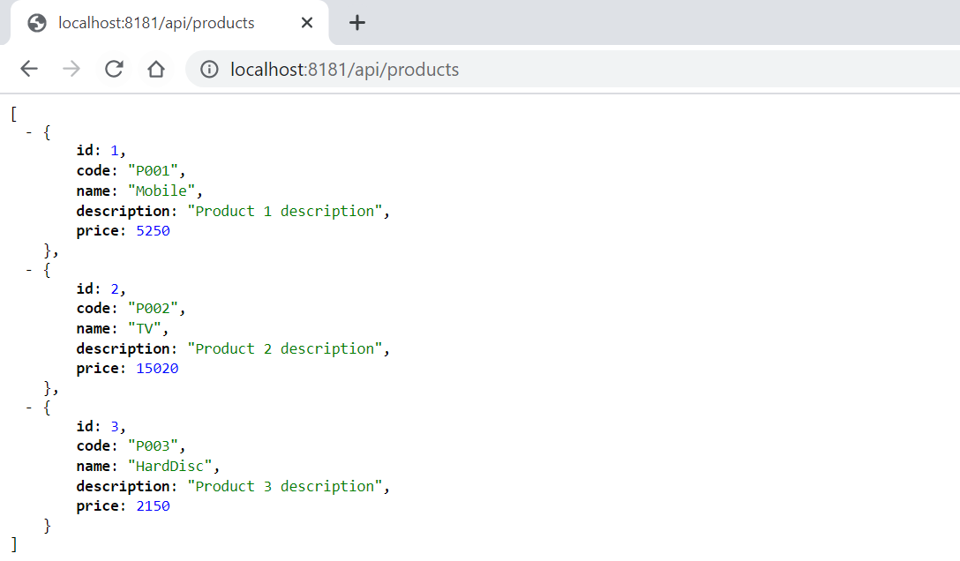

## 2. Spring Cloud Config Server – to Store our Properties

SpringBoot provides lot of flexibility in externalizing configuration properties via properties or YAML files. We can also configure properties for each environment (dev, qa, prod etc) separately using profile specific configuration files such as **application.properties**, **application-dev.properties**, **application-prod.properties** etc. But once the application is started we can not update the properties at runtime. If we change the properties we need to restart the application to use the updated configuration properties.

To Solve this, We can use **Spring Cloud Config Server** to centralize all the applications configuration and use **Spring Cloud Config Client** module from the applications to consume configuration properties from Config Server. We can also update the configuration properties at runtime without requiring to restart the application.

Spring Cloud Config Server is nothing but a SpringBoot application with a configured configuration properties source. The configuration source can be a **git** , **svn**  or any repository.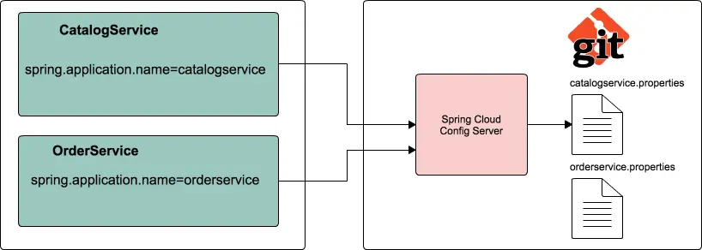

Steps to configure Spring Cloud Config Server

1.Create a git repo to store our **properties** with different envromnets.

<https://github.com/smlcodes/SpringConfigServer>

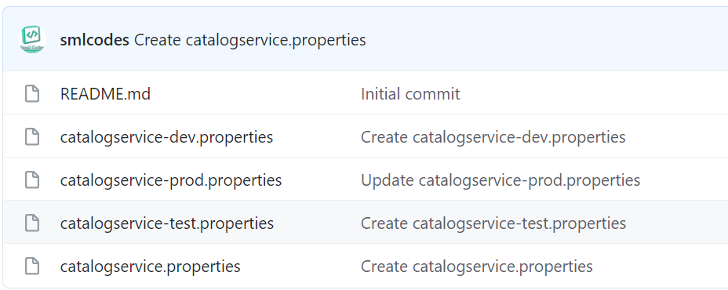

2.Let us create a SpringBoot application **spring-cloud-config-server** from [http://start.spring.io](http://start.spring.io/) by selecting the starters **Config Server** and **Actuator**.

3.To make our SpringBoot application as a SpringCloud Config Server, we just need to add **@EnableConfigServer** annotation to the main entry point class

@SpringBootApplication

@EnableConfigServer

**public** **class** SpringCloudConfigServerApplication {

**public** **static** **void** main(String[] args) {

SpringApplication.*run*(SpringCloudConfigServerApplication.**class**, args);

}

}

4.configure **git url** property pointing to the git repository in application.propertis

spring.config.name=configserver

server.port=8182

spring.cloud.config.server.git.uri=https://github.com/smlcodes/SpringConfigServer.git

spring.cloud.config.server.git.default-label=main

management.security.enabled=false

5.Start the application. Spring Cloud Config Server exposes the **following REST endpoints** to get application specific configuration properties:

/{application}/{profile}[/{label}]

/{application}-{profile}.yml

/{label}/{application}-{profile}.yml

/{application}-{profile}.properties

/{label}/{application}-{profile}.properties

Here **{application}** refers to value of **spring.config.name** property, **{profile}** is an active profile and **{label}** is an optional git label (defaults to “master”).

Now if you access the URL **http://localhost:8182/catalogservice/default** then you will get the following response with catalogservice **default** configuration details: 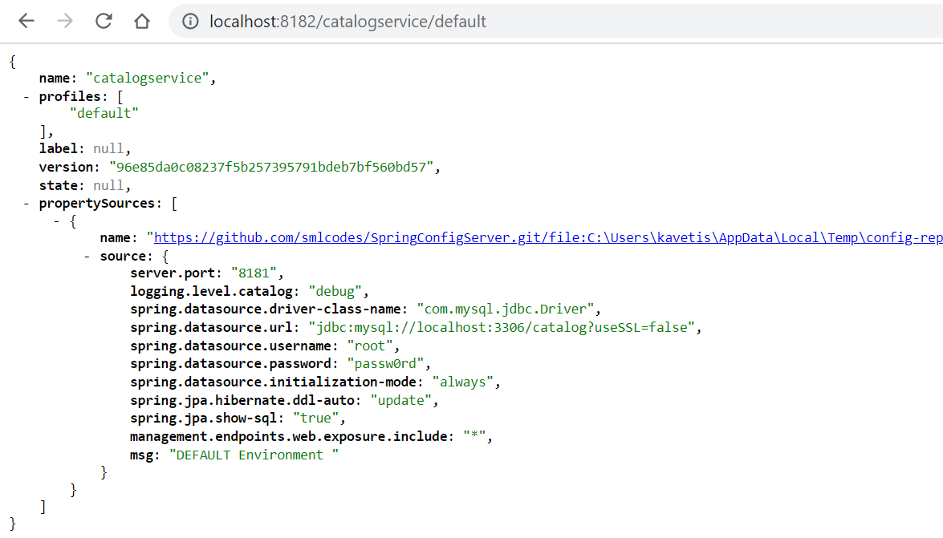

Similary we can enviroment propertils like

* <http://localhost:8182/catalogservice/default>
* <http://localhost:8182/catalogservice/dev>
* <http://localhost:8182/catalogservice/test>
* <http://localhost:8182/catalogservice/prod>

Spring Cloud Config Client Example

Let us see how we can create a SpringBoot application and use configuration properties from Config Server instead of putting them inside the application.

1.Update **catalog-service** with **Config Client,** **Web** and **Actuator** starters.

<dependency>

<groupId>org.springframework.boot</groupId>

<artifactId>spring-boot-starter-actuator</artifactId>

</dependency>

<dependency>

<groupId>org.springframework.cloud</groupId>

<artifactId>spring-cloud-starter-config</artifactId>

</dependency>

<dependency>

<groupId>org.springframework.cloud</groupId>

<artifactId>spring-cloud-starter-bootstrap</artifactId>

</dependency>

**2.Create REST Resource**

Add one RestController to view the Server side property values in the response. And add a method to request/response the perticalur value from Repository values.

@RefreshScope

@RestController

**class** SpringCloudConfigClinet{

@Value("${msg:Config Server is not working. Please check...}")

**private** String msg;

@GetMapping("/msg")

**public** String getMsg() {

**return** **this**.msg;

}

}

Usually in SpringBoot application we configure properties in application.properties. But while using Spring Cloud Config Server we use bootstrap.properties or bootstrap.yml file to configure the URL of Config Server.

Configure the following properties in src/main/resources/bootstrap.properties:

server.port=8181

spring.application.name=catalogservice

spring.cloud.config.uri=http://localhost:8182

management.security.enabled=false

*Note that the value of****spring.application.name****property should match with base filename (catalogservice) in config-repo*

Now run the following catalog-service main entry point class. We can access the actuator endpoint http://localhost:8181/env to see all the configuration properties.

You open <http://localhost:8181/msg> you get property value of msg 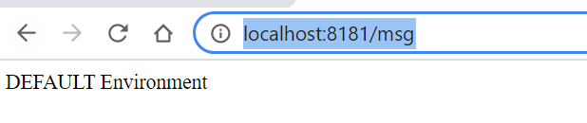

Ref. <https://www.sivalabs.in/2017/08/spring-cloud-tutorials-introduction-to-spring-cloud-config-server/>

Now if we delete the application.properties file, the application will works normally.

## 3. Spring Cloud Service Registry and Discovery

In the microservices world, **Service Registry and Discovery** plays an important role because we most likely run multiple instances of services and we need a mechanism to call other services without hardcoding their hostnames or port numbers.

* Think of it as a lookup service where microservices (clients) can register themselves and discover other registered microservices.
* When a client microservice registers with Eureka it provides metadata such as host, port, and health indicator thus allowing for other microservices to discover it.
* The discovery server expects a regular heartbeat message from each microservice instance. If an instance begins to consistently fail to send a heartbeat, the discovery server will remove the instance from his registry.

|  |  |
| --- | --- |
| **Netflix Component Name** | **Functionality** |
| Eureka | Service Registration and Discovery |
| Ribbon | Dynamic Routing and Load Balancer |
| Hystrix | Circuit Breaker |
| Zuul | Edge Server |

Steps to create Netflix Eureka based Service Registry

add **Eureka Server** starter.

<dependency>

<groupId>org.springframework.cloud</groupId>

<artifactId>spring-cloud-starter-netflix-eureka-server</artifactId>

</dependency>

We need to add **@EnableEurekaServer** annotation on main class to make our SpringBoot application a Eureka Server based Service Registry.

@SpringBootApplication

@EnableEurekaServer

**public** **class** SpringCloudEurekaServerApplication {

**public** **static** **void** main(String[] args) {

SpringApplication.*run*(SpringCloudEurekaServerApplication.**class**, args);

}

}

By default, each Eureka Server is also a Eureka client and needs at least one service URL to locate a peer. As we are going to have a single Eureka Server node (Standalone Mode), we are going to disable this client-side behavior by configuring the following properties in application.properties file.

spring.application.name=service-registry

server.port=8761

eureka.instance.hostname=localhost

eureka.instance.client.registerWithEureka=false

eureka.instance.client.fetchRegistry=false

eureka.instance.client.serviceUrl.defaultZone=http://${eureka.instance.hostname}:${server.port}/eureka/

Netflix Eureka Service provides UI where we can see all the details about registered services.Now run the main class, check url <http://localhost:8761/>

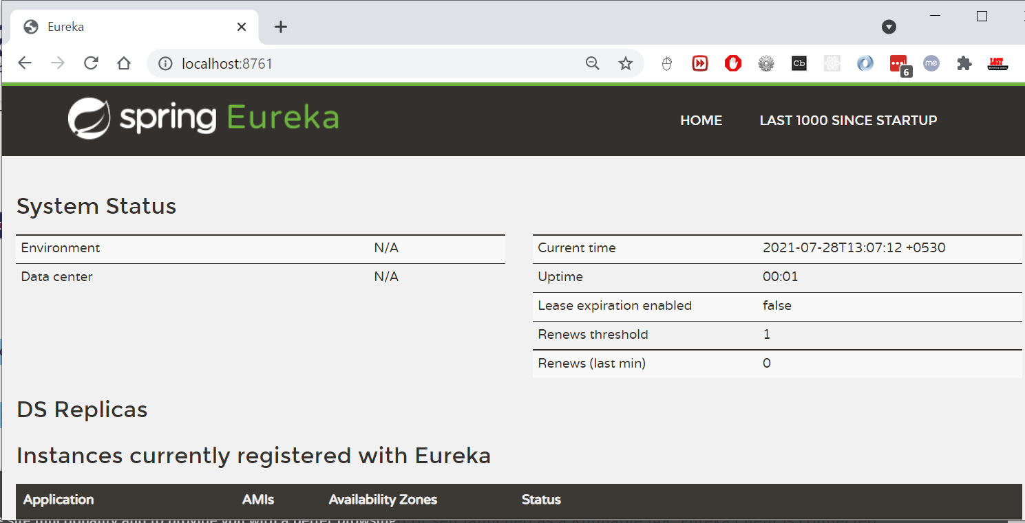

Register Catalog-Service to Eureka

Add the **Eureka Discovery** starter to **catalog-service** which will add the following dependency.

<dependency>

<groupId>org.springframework.cloud</groupId>

<artifactId>spring-cloud-starter-netflix-eureka-client</artifactId>

</dependency>

we just need to configure **eureka.client.service-url.defaultZone** property in **application.properties** to automatically register with the Eureka Server.

eureka.client.service-url.defaultZone=http://localhost:8761/eureka/

With this configuration in place, start catalog-service and visit http://localhost:8761. You should see catalog-service is registered with **SERVICE ID** as **CATALOG-SERVICE**. 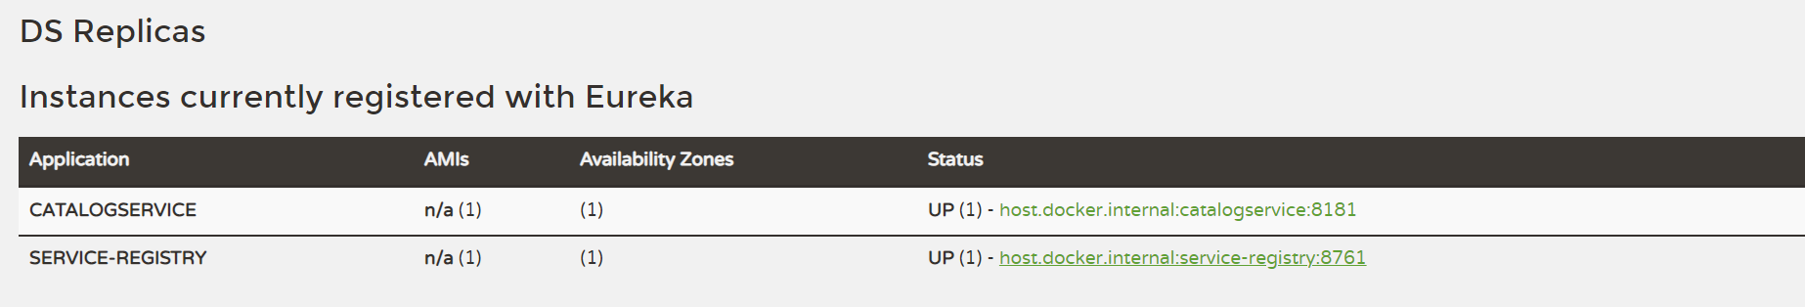

b.Inventory-service

Create **inventory-service** SpringBoot application with **Web, JPA, H2/MySQL, Actuator, Config Client and Eureka Discovery** starters.

**CREATE** **TABLE** `inventory` (

`id` **BIGINT**(20) **NOT** **NULL**,

`quantity` **INT**(11) **NULL** **DEFAULT** **NULL**,

`product\_code` **VARCHAR**(255) **NOT** **NULL** **COLLATE** 'latin1\_swedish\_ci',

**PRIMARY** **KEY** (`id`) **USING** **BTREE**,

**UNIQUE** **INDEX** `UK\_40r5uxke3xlbf7qeqfhklx0uc` (`product\_code`) **USING** **BTREE**

)

**COLLATE**='latin1\_swedish\_ci'

**ENGINE**=**InnoDB**

;

Java Code

**Model class**

@Data

@Entity

@Table(name = "inventory")

**public** **class** InventoryItem {

@Id

@GeneratedValue(strategy = GenerationType.***AUTO***)

**private** Long id;

@Column(name = "product\_code", nullable = **false**, unique = **true**)

**private** String productCode;

@Column(name = "quantity")

**private** Integer availableQuantity = 0;

}

**InventoryItemRepository**

**public** **interface** InventoryItemRepository **extends** JpaRepository<InventoryItem, Long> {

Optional<InventoryItem> findByProductCode(String productCode);

}

**InventoryController**

@RestController

@Slf4j

**public** **class** InventoryController {

**private** **final** InventoryItemRepository inventoryItemRepository;

@Autowired

**public** InventoryController(InventoryItemRepository inventoryItemRepository) {

**this**.inventoryItemRepository = inventoryItemRepository;

}

@GetMapping("/api/inventory/{productCode}")

**public** ResponseEntity<InventoryItem> findInventoryByProductCode(@PathVariable("productCode") String productCode) {

***log***.info("Finding inventory for product code :" + productCode);

Optional<InventoryItem> inventoryItem = inventoryItemRepository.findByProductCode(productCode);

**if** (inventoryItem.isPresent()) {

**return** **new** ResponseEntity(inventoryItem, HttpStatus.***OK***);

} **else** {

**return** **new** ResponseEntity(HttpStatus.***NOT\_FOUND***);

}

}

@GetMapping("/api/inventory")

**public** List<InventoryItem> getInventory() {

***log***.info("Finding inventory for all products ");

**return** inventoryItemRepository.findAll();

}

}

**InventoryServiceApplication**

@SpringBootApplication

**public** **class** InventoryServiceApplication {

**public** **static** **void** main(String[] args) {

SpringApplication.*run*(InventoryServiceApplication.**class**, args);

System.***out***.println(" ");

System.***out***.println("InventoryService ® ™ ");

System.***out***.println(" ");

System.***out***.println(" ===============================================");

System.***out***.println("http://localhost:9992/api/inventory/");

System.***out***.println(" ===============================================");

}

}

**bootstrap.properties**

server.port=9992

spring.application.name=inventoryservice

spring.cloud.config.uri=http://localhost:501

management.security.enabled=false

eureka.client.service-url.defaultZone=http://localhost:8761/eureka/

Test API : <http://localhost:9992/api/inventory/>

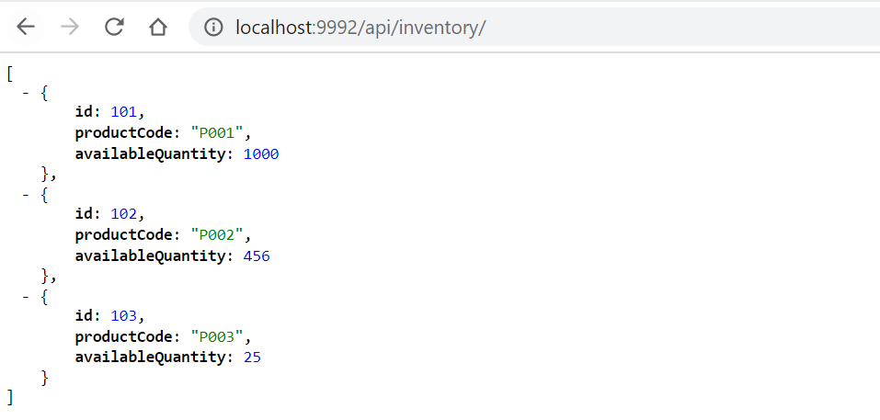

Now we can see Invetory Service in Eureka Server 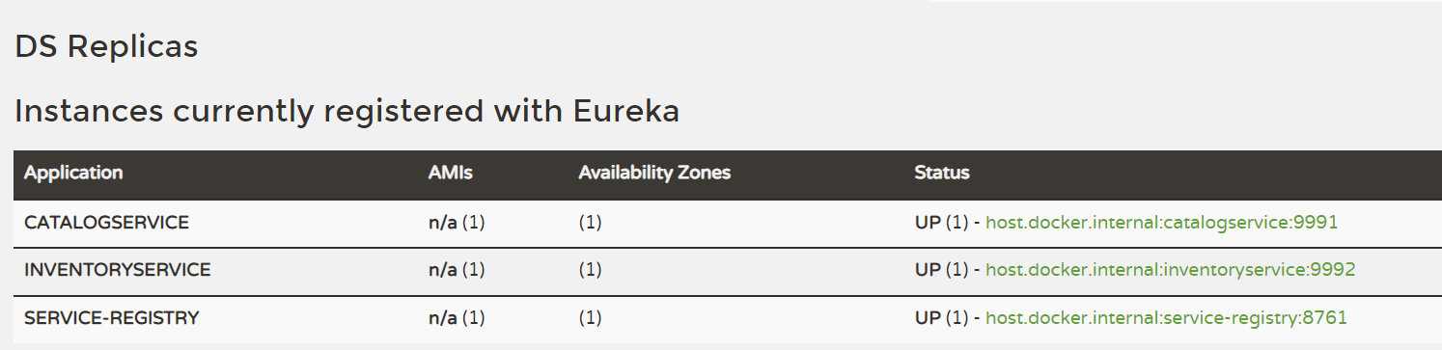

Ref. <https://www.sivalabs.in/2018/03/microservices-springcloud-eureka/>

## 4. Spring Cloud Load balancing

Lets remove server.port=9992 from both boostrap & git property file. And start 2 Inventoy instance manullay.

java -jar -Dserver.port=9898 inventory-service-0.0.1-SNAPSHOT.jar

java -jar -Dserver.port=9899 inventory-service-0.0.1-SNAPSHOT.jar

Now you can visit Eureka Dashboard **http://localhost:8761/** and see 3 instances of inventory-service registered.

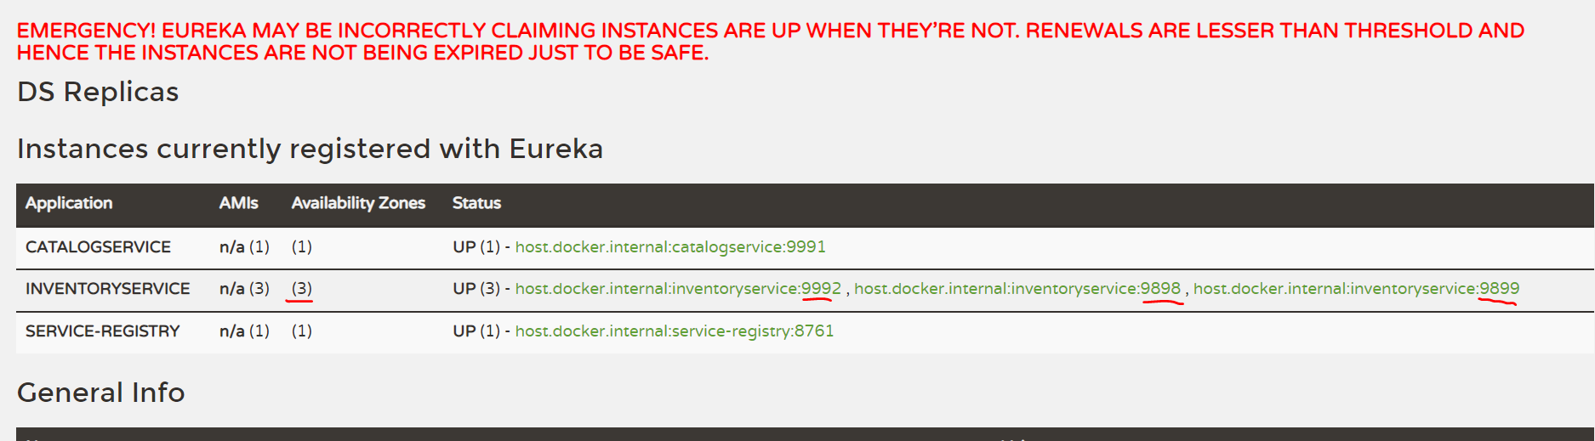

Suppoce we if want to call Inventory Service from Catalog Srervice, which of above 3 instance will call ?

Suppose we want to invoke inventory-service REST endpoint from catalog-service. We can use **RestTemplate** to invoke REST endpoint but there are 2 instances running.

We can register **RestTemplate** as a Spring bean with **@LoadBalanced** annotation. The RestTemplate with **@LoadBalanced** annotation will internally use **Ribbon LoadBalancer** to resolve the **ServiceID** and invoke REST endpoint using one of the available servers.

**Catalog-service/ CatalogServiceApplication.java**

@SpringBootApplication

**public** **class** CatalogServiceApplication {

@Bean

@LoadBalanced

**public** RestTemplate restTemplate() {

**return** **new** RestTemplate();

}

**public** **static** **void** main(String[] args) {

SpringApplication.run(CatalogServiceApplication.**class**, args);

}

}

Use RestTemplate to invoke **inventory-service** endpoint from catalog-service/ProductService.java

@Service

@Transactional

@Slf4j

**public** **class** ProductService {

**private** **final** ProductRepository productRepository;

**private** **final** RestTemplate restTemplate;

@Autowired

**public** ProductService(ProductRepository productRepository, RestTemplate restTemplate) {

**this**.productRepository = productRepository;

**this**.restTemplate = restTemplate;

}

**public** Optional<Product> findProductByCode(String code) {

Optional<Product> productOptional = productRepository.findByCode(code);

**if**(productOptional.isPresent()) {

***log***.info("Fetching inventory level for product\_code: "+code);

ResponseEntity<ProductInventoryResponse> itemResponseEntity =

restTemplate.getForEntity("http://inventory-service/api/inventory/{code}",

ProductInventoryResponse.**class**,

code);

**if**(itemResponseEntity.getStatusCode() == HttpStatus.***OK***) {

Integer quantity = itemResponseEntity.getBody().getAvailableQuantity();

***log***.info("Available quantity: "+quantity);

} **else** {

***log***.error("Unable to get inventory level for product\_code: "+code +

", StatusCode: "+itemResponseEntity.getStatusCode());

}

}

**return** productOptional;

}

}

Note that we have used **http://inventory-service/api/inventory/{code}** instead of http://localhost:9898/api/inventory/{code} or http://localhost:9999/api/inventory/{code}

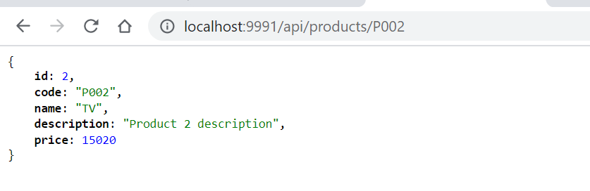

With this kind of automatic Service Registration and Discovery mechanism, we no need to worry about how many instances are running and what are their hostnames and ports etc.

## 5. Spring Cloud Circuit Breaker using Netflix Hystrix

In the microservices world, to fulfill a client request one microservice may need to talk to other microservices. We should minimize this kind of direct dependencies on other microservices but in some cases it is unavoidable. If a microservice is down or not functioning properly then the issue may cascade up to the upstream services.

Netflix created Hystrix library implementing [Circuit Breaker](https://martinfowler.com/bliki/CircuitBreaker.html) pattern to address these kinds of issues. We can use **Spring Cloud Netflix Hystrix Circuit Breaker** to protect microservices from cascading failures.

Steps to Spring Cloud Circuit Breaker using Netflix Hystrix

From **catalog-service** we are invoking REST endpoint on **inventory-service** to get the inventory level of a product. What if inventory-service is down? What if inventory-service is taking too long to respond thereby slowing down all the services depending on it? We would like to have some **timeouts** and implement some **fallback mechanism**.

Add **Hystrix** starter to catalog-service.

<dependency>

<groupId>org.springframework.cloud</groupId>

<artifactId>spring-cloud-starter-netflix-hystrix</artifactId>

</dependency>

To enable Circuit Breaker add **@EnableCircuitBreaker** annotation on catalog-service entry-point class.

@SpringBootApplication

@~~EnableCircuitBreaker~~

**public** **class** CatalogServiceApplication {

@Bean

@LoadBalanced

**public** RestTemplate restTemplate() {

**return** **new** RestTemplate();

}

**public** **static** **void** main(String[] args) {

SpringApplication.*run*(CatalogServiceApplication.**class**, args);

}

}

@Service

@Slf4j

**public** **class** InventoryServiceClient {

**private** **final** RestTemplate restTemplate;

@Autowired

**public** InventoryServiceClient(RestTemplate restTemplate) {

**this**.restTemplate = restTemplate;

}

@HystrixCommand(fallbackMethod = "getDefaultProductInventoryByCode")

**public** Optional<ProductInventoryResponse> getProductInventoryByCode(String productCode)

{

ResponseEntity<ProductInventoryResponse> itemResponseEntity =

restTemplate.getForEntity("http://inventory-service/api/inventory/{code}",

ProductInventoryResponse.**class**,

productCode);

**if** (itemResponseEntity.getStatusCode() == HttpStatus.***OK***) {

**return** Optional.*ofNullable*(itemResponseEntity.getBody());

} **else** {

***log***.error("Unable to get inventory level for product\_code: " + productCode + ", StatusCode: " + itemResponseEntity.getStatusCode());

**return** Optional.*empty*();

}

}

@SuppressWarnings("unused")

Optional<ProductInventoryResponse> getDefaultProductInventoryByCode(String productCode) {

***log***.info("Returning default ProductInventoryByCode for productCode: "+productCode);

ProductInventoryResponse response = **new** ProductInventoryResponse();

response.setProductCode(productCode);

response.setAvailableQuantity(50);

**return** Optional.*ofNullable*(response);

}

}

We have annotated the method from where we are making a REST call with **@HystrixCommand(fallbackMethod = “getDefaultProductInventoryByCode”)** so that if it doesn’t receive the response within the certain time limit the call gets timed out and invoke the configured fallback method. The fallback method should be defined in the same class and should have the same signature. In the fallback method **getDefaultProductInventoryByCode()** we are setting the **availableQuantity** to 50, obviously, this behavior depends on what business wants.

Spring Cloud also provides a nice dashboard to monitor the status of Hystrix commands. Create a Spring Boot application with **Hystrix Dashboard** starter and annotate the main entry-point class with **@EnableHystrixDashboard**.

<dependency>

<groupId>org.springframework.cloud</groupId>

<artifactId>spring-cloud-starter-netflix-hystrix-dashboard</artifactId>

</dependency>

Now in Hystrix Dashboard home page enter **http://localhost:8181/actuator/hystrix.stream** as stream URL and give Catalog Service as Title and click on Monitor Stream button.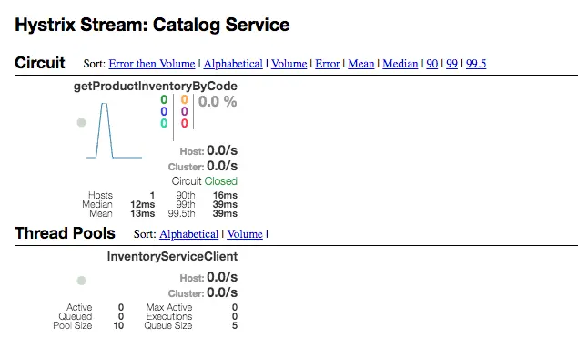

## 6. Spring Cloud Zuul Proxy as API Gateway

Spring Cloud provides Zuul proxy, similar to **Nginx**, that can be used to create API Gateway.

API Gateway, aka Edge Service, provides a unified interface for a set of microservices so that clients no need to know about all the details of microservices internals. However, there are some pros and cons of using API Gateway pattern in microservices architecture.

**Pros:**

* Provides easier interface to clients
* Can be used to prevent exposing the internal microservices structure to clients
* Allows to refactor microservices without forcing the clients to refactor consuming logic
* Can centralize cross-cutting concerns like security, monitoring, rate limiting etc

**Cons:**

* It could become a single point of failure if proper measures are not taken to make it highly available
* Knowledge of various microservice API may creep into API Gateway

## 7. Distributed Tracing with Spring Cloud Sleuth and Zipkin

One of the challenges in microservices architecture is the ability to debug issues. A simple user action might trigger a chain of downstream microservice calls. It would be tedious to trace the logs related to a particular user action across microservices.

 We can use [Spring Cloud Sleuth](http://cloud.spring.io/spring-cloud-static/Finchley.M7/single/spring-cloud.html#_spring_cloud_sleuth) to handle these kinds of issues. Spring Cloud Sleuth provides the distributed tracing capabilities and we can also export these trace information to [Zipkin](https://zipkin.io/) to visualize the call traces.

### Ref.

<https://www.sivalabs.in/2018/03/microservices-using-springboot-spring-cloud-part-1-overview/>

<https://github.com/sivaprasadreddy/spring-boot-microservices-series>

# 8. Spring Missing/ Confusing Topics

## Diffrence between @Component & @Autowire

**@Compoent** is just creating bean object of that class at Auto Scanning time.

**@Autowire** is, after creating bean object in @Componet time, it will autowires/ injecets the Dependent classes.

## Diffrence beteen @ComponentScan & @Enable AutoCOnfiguration

One of the main advantages of Spring Boot is its annotation driven versus traditional xml-based configurations, **@EnableAutoConfiguration** automatically configures the Spring application based on its included jar files, it sets up defaults or helper based on dependencies in pom.xml.

Auto-configuration is usually applied based on the classpath and the defined beans. Therefore, we donot need to define any of the DataSource, EntityManagerFactory, TransactionManager etc and magically based on the classpath, Spring Boot automatically creates proper beans and registers them for us.

For example when there is a tomcat-embedded.jar on your classpath you likely need a TomcatEmbeddedServletContainerFactory (unless you have defined your own EmbeddedServletContainerFactory bean).

**@EnableAutoConfiguration** has a exclude attribute to disable an auto-configuration explicitly otherwise we can simply exclude it from the pom.xml, for example if we donot want Spring to configure the tomcat then exclude spring-bootstarter-tomcat from spring-boot-starter-web.

**@ComponentScan** provides scope for spring component scan, it simply goes though *the provided base package* and picks up dependencies required by **@Bean or @Autowired** etc, In a typical Spring application, @ComponentScan is used in a configuration classes, the ones annotated with @Configuration.

Configuration classes contains methods annotated with @Bean. These @Bean annotated methods generate beans managed by Spring container. Those beans will be auto-detected by @ComponentScan annotation. There are some annotations which make beans auto-detectable like @Repository, @Service, @Controller, @Configuration, @Component. In below code Spring starts scanning from the package including BeanA class.

# **9. Types of Authentication**

A servlet-based web application can choose from the following types of authentication, from least secure to most:

* Basic authentication
* Form-based authentication
* Digest authentication
* SSL and client certificate authentication

“Authentication” and “Authorization”. Authentication can be defined as the process of verifying someone’s identity by using pre-required details (Commonly username and password). Authorization is the process of allowing an authenticated user to access a specified resource (eg:-right to access a file).

## HTTP Basic Authentication

* One solution is that of **HTTP Basic Authentication**. In this approach, an HTTP user agent simply provides a **username**and **password** to prove their authentication.
* This approach does not require cookies, session IDs, login pages, and other such specialty solutions, and because it uses the **HTTP header** itself, there’s no need to handshakes or other complex response systems.
* HTTP is not [encrypted](https://nordicapis.com/securing-your-datastream-with-p2p-encryption/) in any way. It is encapsulated in base64, and is often erroneously proclaimed as encrypted due to this

## Digest authentication

The difference between digest authentication and basic authentication is that in digest authentication, the username and password are never sent over the wire. Instead, a hash is created made up of the following pieces of information:

* The username
* The password
* The URL
* The randomly generated string (the nonce)
* The HTTP method being used

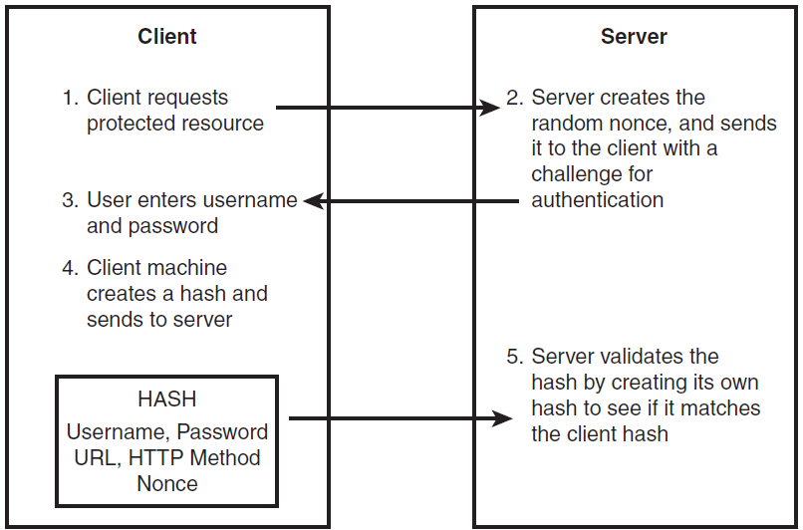

## API Keys : for Developer Quickstart

* To access Bitbucket in Hygieia, we will generate API key, and we will place that key in properties file.
* API Keys can be used as Basic HTTP Authentication credentials and provide a substitute for the account's actual username and password.
* The best thing about an API key is its simplicity. You merely log in to a service, find your API key (often in the settings screen), and copy it to use in an application, test in the browser, or use with one of these [API request tools](https://zapier.com/engineering/api-request-tools/).
* Typically, an API key gives full access to every operation an API can perform, including writing new data or deleting existing data. If you use the same API key in multiple apps, a broken app could destroy your users' data without an easy way to stop just that one app.
* Many API keys are sent in the query string as part of the URL, which makes it easier to discover for someone who should not have access to it. A better option is to put the API key in the Authorization header. In fact, that’s the [proposed standard](https://tools.ietf.org/html/rfc7235?utm_source=zapier.com&utm_medium=referral&utm_campaign=zapier):  
  Authorization: Apikey 1234567890abcdef

## OAuth Tokens: Great for Accessing User Data

* OAuth is the answer to accessing user data with APIs.
* users simply click a button to allow an application to access their accounts.

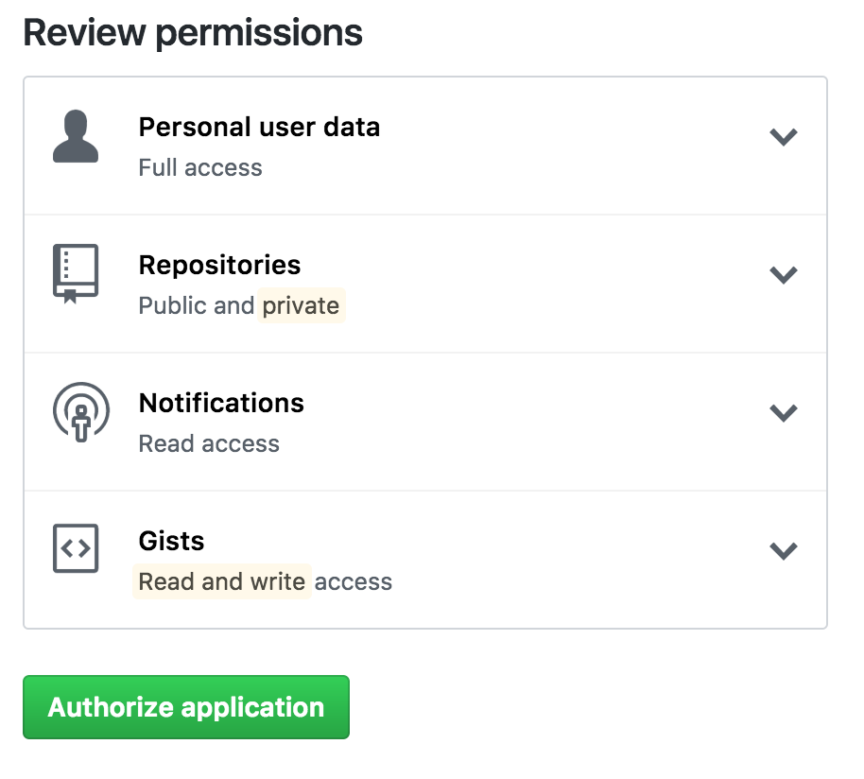

## LDAP

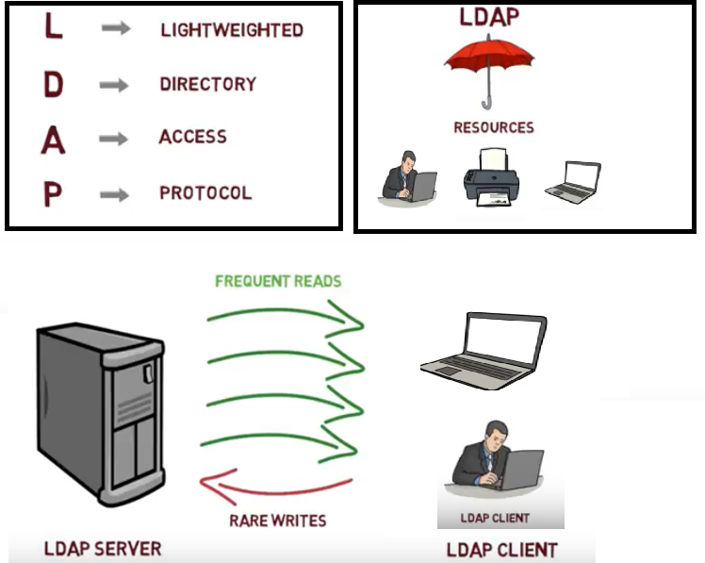

<https://www.youtube.com/watch?v=lp5z8HQGAH8>

import javax.naming.\*;

import javax.naming.directory.\*;

import java.util.Hashtable;

class Simple {

public static void main(String[] args) {

Hashtable authEnv = new Hashtable(11);

String userName = "johnlennon";

String passWord = "sushi974";

String base = "ou=People,dc=example,dc=com";

String dn = "uid=" + userName + "," + base;

String ldapURL = "ldap://ldap.example.com:389";

authEnv.put(Context.INITIAL\_CONTEXT\_FACTORY,"com.sun.jndi.ldap.LdapCtxFactory");

authEnv.put(Context.PROVIDER\_URL, ldapURL);

authEnv.put(Context.SECURITY\_AUTHENTICATION, "simple");

authEnv.put(Context.SECURITY\_PRINCIPAL, dn);

authEnv.put(Context.SECURITY\_CREDENTIALS, passWord);

try {

DirContext authContext = new InitialDirContext(authEnv);

System.out.println("Authentication Success!");

} catch (AuthenticationException authEx) {

System.out.println("Authentication failed!");

} catch (NamingException namEx) {

System.out.println("Something went wrong!");

namEx.printStackTrace();

}

}

}

## SSH – Only for LINUX Server / CommadLine(git) related Access

* SSH, or secure shell, is an encrypted protocol used to administer and communicate with servers. When working with a Linux server, chances are, you will spend most of your time in a terminal session connected to your server through SSH.
* An SSH server can authenticate clients using a variety of different methods. The most basic of these is password authentication, which is easy to use, but not the most secure.
* SSH key pairs are two cryptographically secure keys that can be used to authenticate a client to an SSH server. Each key pair consists of a public key and a private key.
* The **private key** is retained by the client and should be kept absolutely secret. Any compromise of the private key will allow the attacker to log into servers that are configured with the associated public key without additional authentication. As an additional precaution, the key can be encrypted on disk with a passphrase.
* The associated public key can be shared freely without any negative consequences. The public key can be used to encrypt messages that only the private key can decrypt. This property is employed as a way of authenticating using the key pair.
* The public key is uploaded to a remote server that you want to be able to log into with SSH. The key is added to a special file within the user account you will be logging into called ~/.ssh/authorized\_keys.
* When a client attempts to authenticate using SSH keys, the server can test the client on whether they are in possession of the private key. If the client can prove that it owns the private key, a shell session is spawned, or the requested command is executed.

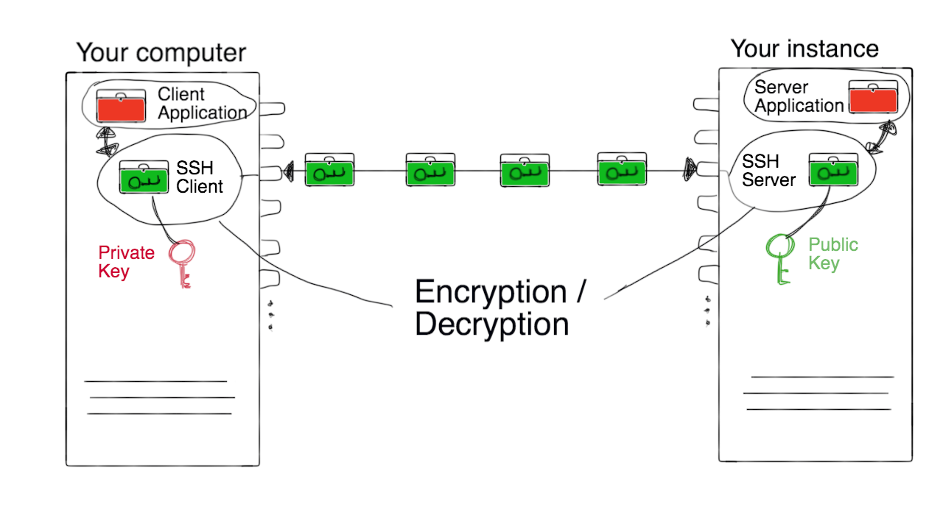

## Base64 – not Authentication

represent [binary data](https://en.wikipedia.org/wiki/Binary_data) in an [ASCII](https://en.wikipedia.org/wiki/ASCII) string format. Each Base64 digit represents exactly 6 bits of data.

Steps:

* take three ASCII numbers 155, 162, and 233
* Convert into binary stream formate 100110111010001011101001
* groupings of six characters: 100110 111010 001011 101001.
* The binary string 100110 converts to the decimal number 38: 0\*2^01 + 1\*2^1 + 1\*2^2 + 0\*2^3 + 0\*2^4 + 1\*2^5 = 0+2+4+0+0+32.
* Base64 6-bit values 38, 58, 11 and 41.
* Using the Base64 conversion table:
  + 38 is m
  + 58 is 6
  + 11 is L
  + 41 is p

# 10. Applications for Hands-on

## #1 – React + SpringBoot

<https://github.com/RameshMF/ReactJS-Spring-Boot-CRUD-Full-Stack-App>

<https://www.javaguides.net/2020/07/spring-boot-react-js-crud-example-tutorial.html>

<https://www.youtube.com/watch?v=n43h1eJ2EUE&list=PLGRDMO4rOGcNLnW1L2vgsExTBg-VPoZHr>

We will build two projects:

1. **sprint boot-backend (server)** – To develop REST API
2. **react-frontend (client)** – Consume REST API

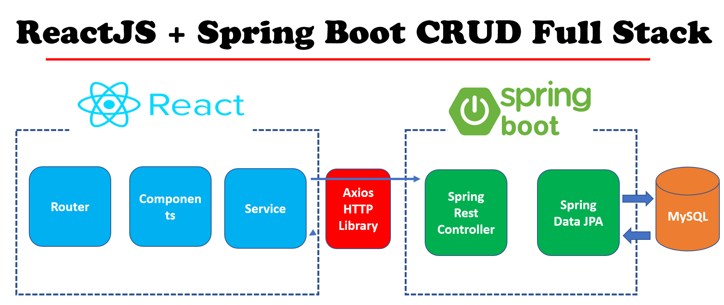

### SpringBoot – Employee Backend Service

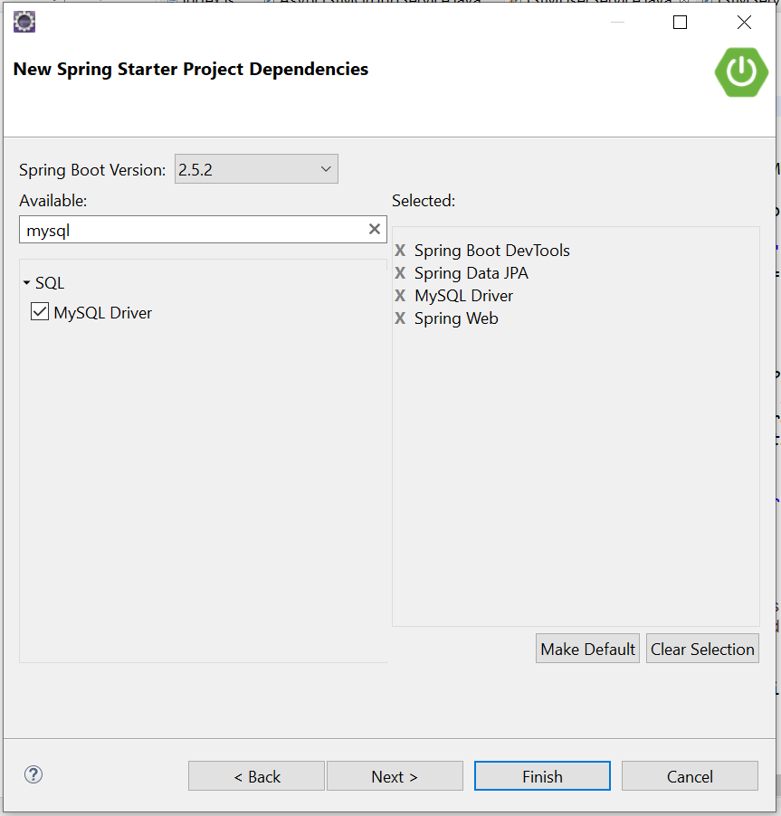

#### Configuring MySQL Database

application.properties

spring.datasource.url=jdbc:mysql://localhost:3306/webapp?useSSL=false

spring.datasource.username=root

spring.datasource.password=root

spring.jpa.properties.hibernate.dialect = org.hibernate.dialect.MySQL5InnoDBDialect

spring.jpa.hibernate.ddl-auto = update

**CREATE** **TABLE** `employee` (

`id` **INT**(11) **NOT** **NULL** **AUTO\_INCREMENT**,

`name` **VARCHAR**(50) **NOT** **NULL** **DEFAULT** '0' **COLLATE** 'latin1\_swedish\_ci',

`address` **VARCHAR**(50) **NOT** **NULL** **DEFAULT** '0' **COLLATE** 'latin1\_swedish\_ci',

`salary` **DOUBLE** **NULL** **DEFAULT** '0',

**PRIMARY** **KEY** (`id`) **USING** **BTREE**

);

#### Model class – Employee.java

**package** springboot.emp.model;

**import** javax.persistence.Column;

**import** javax.persistence.Entity;

**import** javax.persistence.GeneratedValue;

**import** javax.persistence.GenerationType;

**import** javax.persistence.Id;

**import** javax.persistence.Table;

@Entity

@Table

**public** **class** Employee {

@Id

@GeneratedValue(strategy = GenerationType.***IDENTITY***)

**private** Long id;

@Column

**private** String name;

@Column

**private** String address;

@Column

**private** Double salary;

**//setters & getterrs**

**public** Employee(Long id, String name, String address, Double salary) {

**super**();

**this**.id = id;

**this**.name = name;

**this**.address = address;

**this**.salary = salary;

}

}

#### Repository – EmployeeRepository.java

**package** springboot.emp.repository;

**import** org.springframework.data.jpa.repository.JpaRepository;

**import** org.springframework.stereotype.Repository;

**import** springboot.emp.model.Employee;

@Repository

**public** **interface** EmployeeRepository **extends** JpaRepository<Employee, Long>{

}

#### Exception – EmployeeException

**package** springboot.emp.exception;

**public** **class** EmployeeException **extends** RuntimeException{

**public** EmployeeException(String message) {

**super**(message);

}

}

#### Exception – EmployeeController

**package** springboot.emp.controller;

**import** java.util.List;

@RestController

@RequestMapping("/api/v1/")

**public** **class** EmployeeController {

@Autowired

**private** EmployeeRepository repository;

@GetMapping("/all")

**public** List<Employee> getAllEmployees(){

**return** repository.findAll();

}

}

#### Test Rest API

<http://localhost:8080/api/v1/all>

[

{

"name": "DILEEP",

"address": "XXXXXXXXX",

"salary": 0

},

{

"name": "DILEEP",

"address": "BANGLORE",

"salary": 0

}

]

### React – Employee Front End

#### 1.Create EmployeeReactApp – Empty Repo

Open Visual Studio Code > Terminal

**npx** **create-react-app** employee-react-app

Start react app

cd employee-react-app

npm start

You can now view employee-react-app in the browser.

Local: http://localhost:3000

On Your Network: http://192.168.0.105:3000

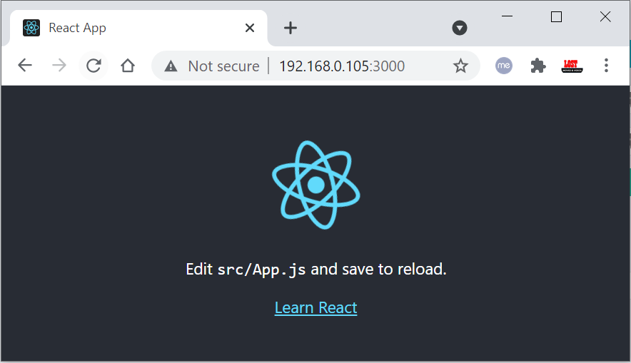

**Main files**

* public/index.html – Single page appl’n , contains  <div id="root"></div>

<!DOCTYPE html>

<html lang="en">

  <head>

    <meta charset="utf-8" />

    <link rel="icon" href="%PUBLIC\_URL%/favicon.ico" />

    <meta name="viewport" content="width=device-width, initial-scale=1" />

    <meta name="theme-color" content="#000000" />

    <meta

      name="description"

      content="Web site created using create-react-app"

    />

    <link rel="apple-touch-icon" href="%PUBLIC\_URL%/logo192.png" />

    <link rel="manifest" href="%PUBLIC\_URL%/manifest.json" />

    <title>React App</title>

  </head>

  <body>

    <noscript>You need to enable JavaScript to run this app.</noscript>

    <div id="root"></div>

  </body>

</html>

* src/App.js - Contains Component code to generate UI.

import logo from './logo.svg';

import './App.css';

function App() {

  return (

    <div className="App">

      <header className="App-header">

      <h1>Hello, World!!!</h1>

      </header>

    </div>

  );

}

export default App;

* src/index.js - get code from component & replace div content to render UI.

import React from 'react';

import ReactDOM from 'react-dom';

import './index.css';

import App from './App';

import reportWebVitals from './reportWebVitals';

ReactDOM.render(

  <React.StrictMode>

    <App />

  </React.StrictMode>,

  document.getElementById('root')

);

// If you want to start measuring performance in your app, pass a function

// to log results (for example: reportWebVitals(console.log))

// or send to an analytics endpoint. Learn more: https://bit.ly/CRA-vitals

reportWebVitals();

#### 3. Get All Employees – React Code

employee-react-app\src\component\ListAllEmployeesComponent.jsx

import React, { Component } from 'react';

import EmployeeService from '../services/EmployeeService';

class ListAllEmployeesComponent extends Component {

    constructor(props) {

        super(props)

        this.state = {

                employees: []

        }

    }

    componentDidMount(){

        EmployeeService.getEmployees().then((res) => {

            this.setState({ employees: res.data});

        });

    }

    render() {

        return (

            <div>

                <table className="table">

                    <thead>

                        <tr>

                            <th scope="col">ID</th>

                            <th scope="col">Name</th>

                            <th scope="col">Address</th>

                            <th scope="col">Salary</th>

                            <th scope="col">Action</th>

                        </tr>

                    </thead>

                    <tbody>

                                {

                                    this.state.employees.map(

                                        employee =>

                                        <tr key = {employee.id}>

                                             <td> {employee.name} </td>

                                             <td> {employee.address}</td>

                                             <td> {employee.salary}</td>

                                             <td>

                                                 Action

                                             </td>

                                        </tr>

                                    )

                                }

                            </tbody>

                </table>

            </div>

        );

    }

}

export default ListAllEmployeesComponent;

employee-react-app\src\services\EmployeeService.js

import axios from 'axios';

const EMPLOYEE\_API\_BASE\_URL = "http://localhost:8080/api/v1/all";

class EmployeeService {

    getEmployees() {

        return axios.get(EMPLOYEE\_API\_BASE\_URL);

    }

}

export default new EmployeeService()

Now if we open Root URL, it will display the Table Data.

<http://localhost:3000>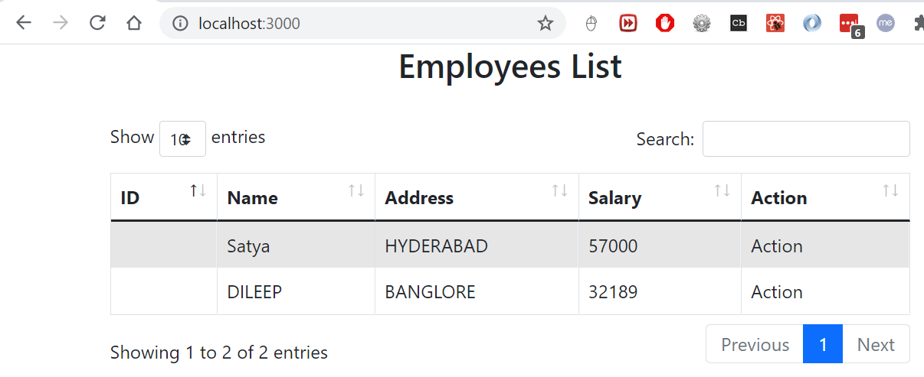

#### 3. Header & Footer

employee-react-app\src\component\HeaderComponent.jsx

import React, { Component } from 'react';

class HeaderComponent extends Component {

    render() {

        return (

            <div>

                <nav class="navbar navbar-dark bg-dark" >

                <div className="container">

                    <h3 style={{'color':'white'}}>EmployeeServices™ </h3>

                </div>

                </nav>

            </div>

        );

    }

}

export default HeaderComponent;

employee-react-app\src\component\FooterComponent.jsx

import React, { Component } from 'react';

class FooterComponent extends Component {

    render() {

        return (

            <div>

                <footer className="footer">

                    <div className="container">

                        <span className="text-muted">

© SatyaCodes 2020 , Satya Kaveti's Writing.

</span>

                    </div>

                </footer>

            </div>

        );

    }

}

export default FooterComponent;

employee-react-app\src\App.js

import './App.css';

import HeaderComponent from './component/HeaderComponent';

import FooterComponent from './component/FooterComponent';

import ListAllEmployeesComponent from './component/ListAllEmployeesComponent';

function App() {

  return (

    <div>

      <HeaderComponent/>

    <div className="container">

        <ListAllEmployeesComponent/>

    </div>

    <FooterComponent/>

    </div>

  );

}

export default App;

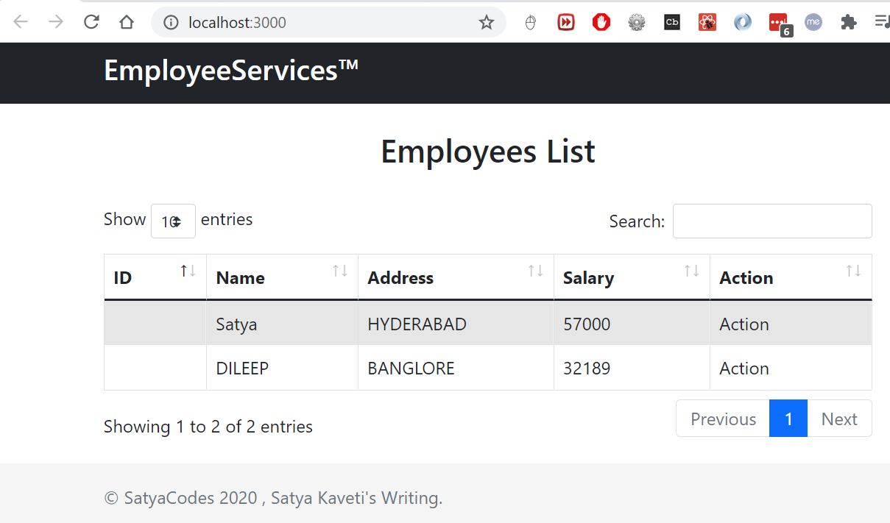

### Routing

Install react-router-dom

**npm** **install** **react-router-dom** --save

import './App.css';

import HeaderComponent from './component/HeaderComponent';

import HomeComponent from './component/HomeComponent';

import FooterComponent from './component/FooterComponent';

import ListAllEmployeesComponent from './component/ListAllEmployeesComponent';

import { BrowserRouter, Route, Switch } from 'react-router-dom';

import Employee from './component/Employee';

function App() {

  return (

    <div>

      <HeaderComponent />

      <BrowserRouter>

        <div className="container">

          <Switch>

             <Route exact path="/" component={HomeComponent}></Route>

             <Route exact path="/one" component={Employee}></Route>

           <Route exact path="/all" component={ListAllEmployeesComponent}></Route>

             <Route component={Error} />

          </Switch>

        </div>

      </BrowserRouter>

      <FooterComponent />

    </div>

  );

}

export default App;

**Complete Code. Github**

[**https://github.com/smlcodes/Books-Sync-Gitlab/tree/main/Codes/employee-react-app**](https://github.com/smlcodes/Books-Sync-Gitlab/tree/main/Codes/employee-react-app)

## #2 – Angular + SpringBoot

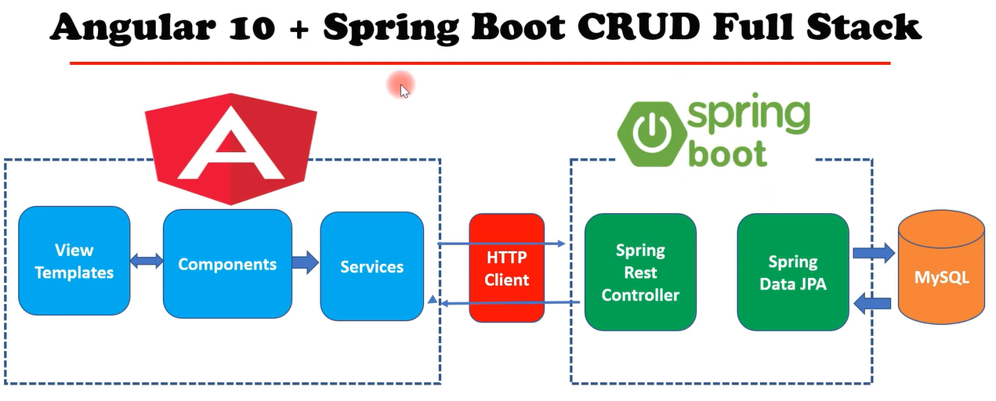

We are using above EmployeeServices as SpringBoot rest API, we create UI using Angular to display UI.

### Create Angular Project

You use the Angular CLI to create projects, generate application and library code, and perform a variety of ongoing development tasks such as testing, bundling, and deployment.

npm install -g @angular/cli

To create a new workspace and initial starter app.

ng new employee-angular-app

Run the application

ng serve --open

The --open option automatically opens your browser to <http://localhost:4200/>.If your installation and setup was successful, you should see a page similar to the following. 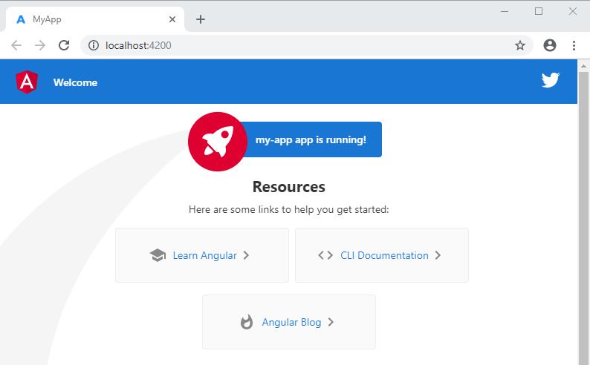

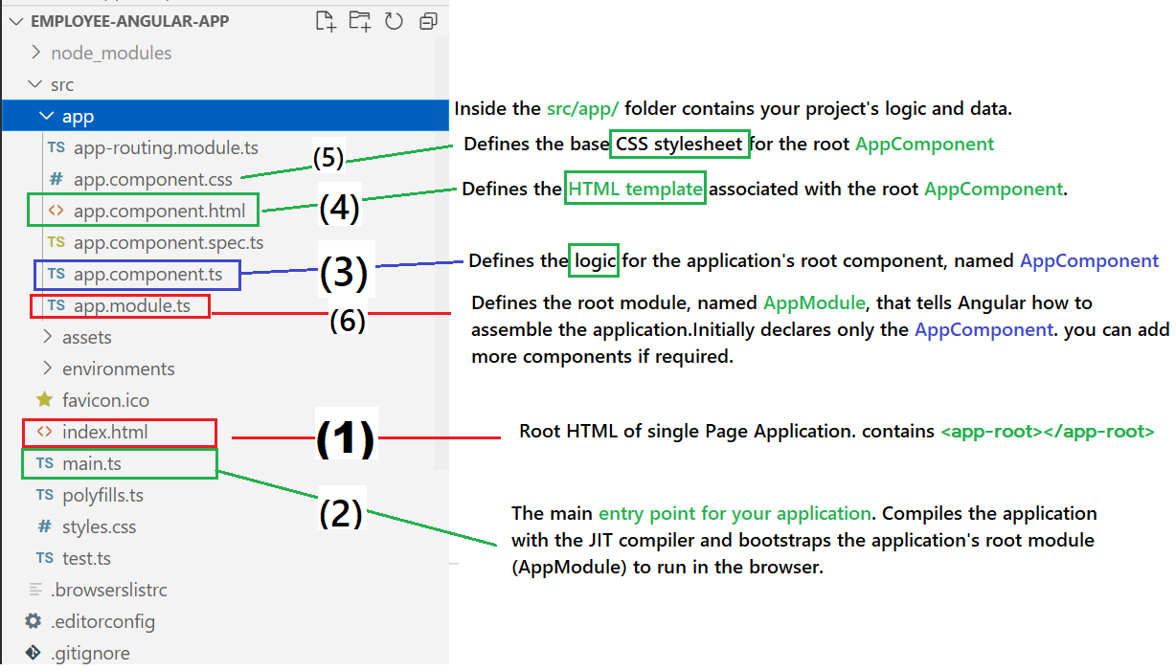

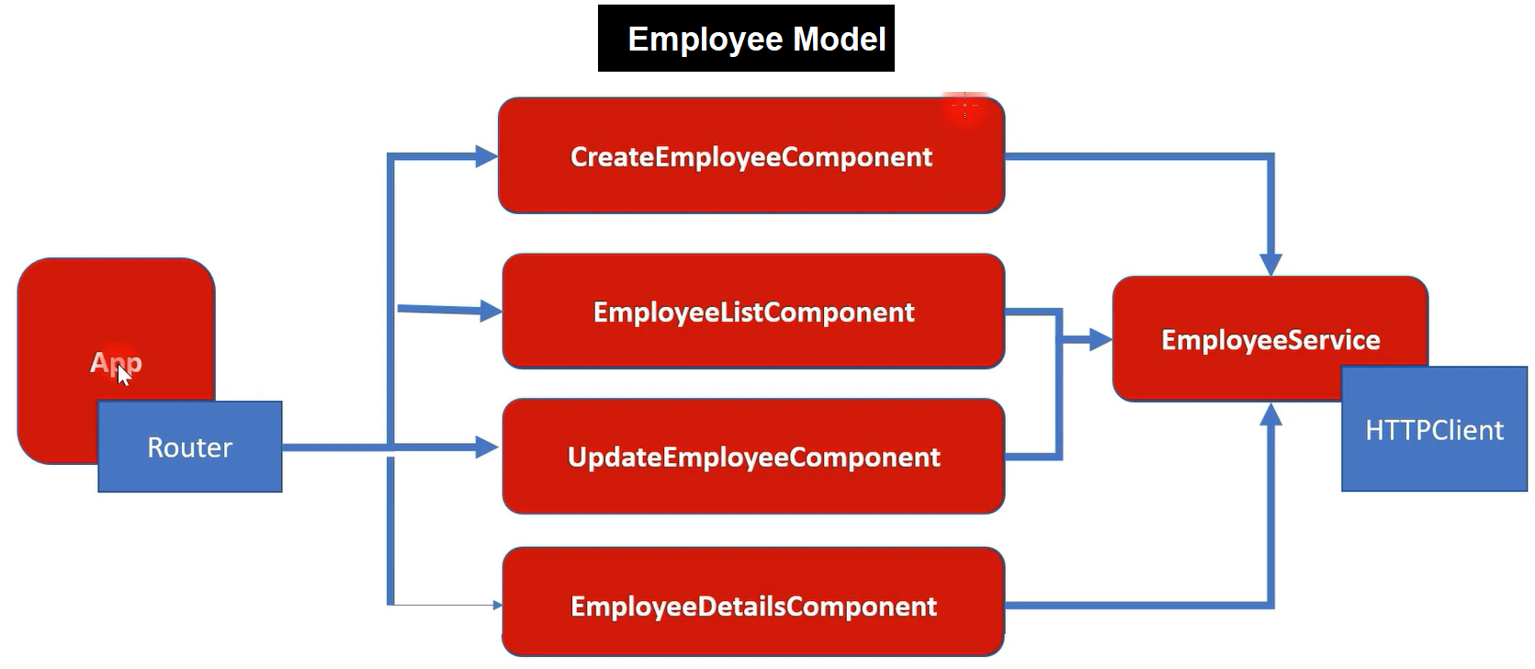

for generate any thing we need to use ng g c/s

* **g** -is for Generate
* **C** – is for Component
* **S**– is for Service

### EmployeeModel - Model class to hold Employee Data

**C:\Git\books\Codes\employee-angular-app**>ng g class employee

CREATE src/app/employee.spec.ts (162 bytes)

CREATE src/app/employee.ts (26 bytes)

Create Employee Model class with Employee Table Properties

export class Employee {

    id!: number;

    name!: string;

    address!: string;

    salary!: number;

}

### EmployeeListComponent - To Display all Employee data

**C:\Git\books\Codes\employee-angular-app>ng g c EmployeeList**

CREATE src/app/employee-list/**employee-list.component.html** (To display UI)

CREATE src/app/employee-list/**employee-list.component.spec.ts**

CREATE src/app/employee-list/**employee-list.component.ts** (Logic)

CREATE src/app/employee-list/**employee-list.component.css** (Stylesheet)

UPDATE src/app/**app.module.ts** (newly created component is added & imported)

import { NgModule } from '@angular/core';

import { BrowserModule } from '@angular/platform-browser';

import { AppRoutingModule } from './app-routing.module';

import { AppComponent } from './app.component';

import { EmployeeListComponent } from './employee-list/employee-list.component';

@NgModule({

  declarations: [

    AppComponent,

    EmployeeListComponent

  ],

  imports: [

    BrowserModule,

    AppRoutingModule

  ],

  providers: [],

  bootstrap: [AppComponent]

})

export class AppModule { }

Above are automatically added after generation of component.

**employee-list.component.html**

<h1>

Employees List Page

</h1>

**//employee-list.component.ts** (Default Generated Class)

import { Component, OnInit } from '@angular/core';

@Component({

  selector: 'app-employee-list',

  templateUrl: './employee-list.component.html',

  styleUrls: ['./employee-list.component.css']

})

export class EmployeeListComponent implements OnInit {

  constructor() { }

  ngOnInit(): void {

  }

}

If we place above app-employee-list in main html(app.component.html) it will display data generated by employeelist component.

**app.component.html**

<div>

…. Old code ….

 </div>

<app-employee-list></app-employee-list>

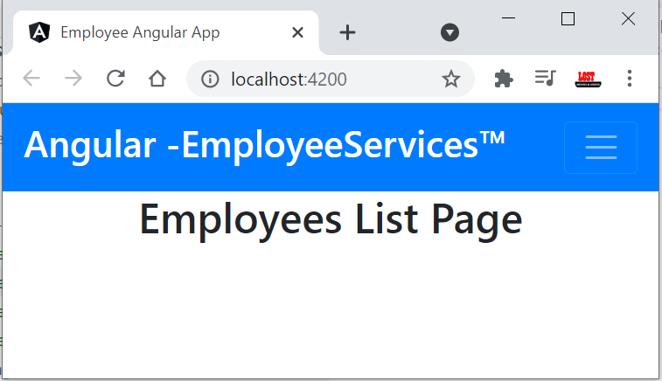

Change code to display sample Employee data

**employee-list.component.ts**

import { Component, OnInit } from '@angular/core';

import { Employee } from '../employee';

@Component({

  selector: 'app-employee-list',

  templateUrl: './employee-list.component.html',

  styleUrls: ['./employee-list.component.css'],

})

export class EmployeeListComponent implements OnInit {

  //List of emplyee objects created, initilaized to EMpty.

  employeeList!: Employee[];

  constructor() {}

  //Samle Employee Data.

  ngOnInit(): void {

    this.employeeList = [

      {

        id: 101,

        name: 'Satya',

        address: 'Init-data',

        salary: 18000,

      },

      {

        id: 102,

        name: 'RAM',

        address: 'Init-data',

        salary: 11000,

      },

    ];

  }

}

**employee-list.component.html**

<div class="card">

  <div class="card-body">

    <div class="col-10 mx-auto">

      <h2 class="text-center">Employees List</h2>

      <!-- <p> {{employeeList[0].name}}</p> -->

    </div>

    <br />

    <div class="row">

      <div class="col-10 mx-auto">

        <table id="example" class="table table-striped table-bordered" style="width: 100%">

          <thead>

            <tr>

              <th scope="col">ID</th>

              <th scope="col">Name</th>

              <th scope="col">Address</th>

              <th scope="col">Salary</th>

              <th scope="col">Action</th>

            </tr>

          </thead>

          <tbody>

            <tr \*ngFor="let employee of employeeList">

              <td> {{employee.id}} </td>

              <td> {{employee.name}} </td>

              <td> {{employee.address}} </td>

              <td> {{employee.salary}} </td>

              <td>

                <button class="btn btn-primary"><i class="fas fa-eye"></i> </button> <span>&nbsp;</span>

                <button class="btn btn-warning"><i class="fas fa-edit"></i> </button> <span>&nbsp;</span>

                <button class="btn btn-danger"><i class="fas fa-trash-alt"></i> </button>

              </td>

            </tr>

          </tbody>

        </table>

      </div>

    </div>

  </div>

</div>

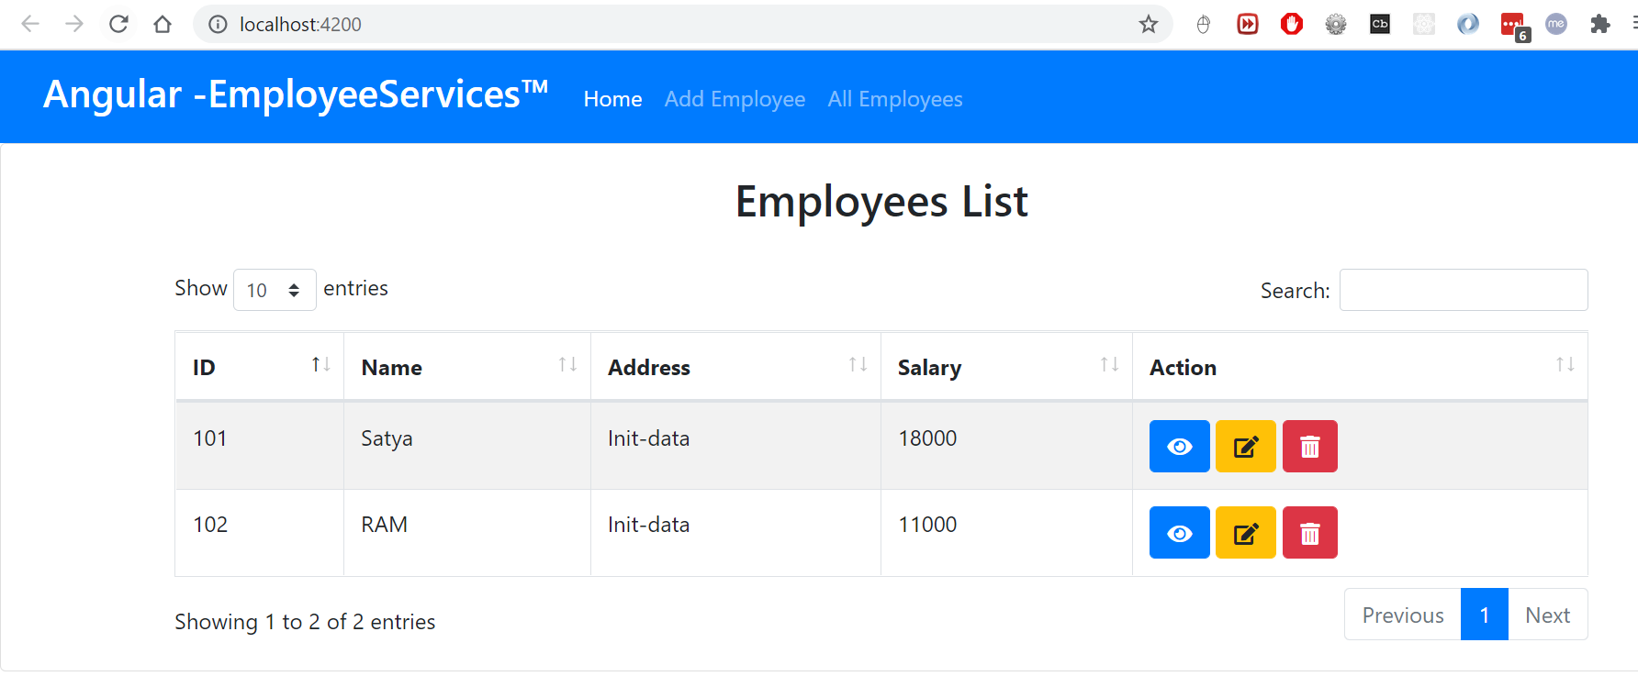

### EmployeeService – To communicate with SpringBoot Services

**C:\Git\books\Codes\employee-angular-app>ng g s employee**

CREATE src/app/employee.service.spec.ts (367 bytes)

CREATE src/app/**employee.service.ts** (137 bytes)

//**employee.service.ts (Default generated code)**

import { Injectable } from '@angular/core';

@Injectable({

  providedIn: 'root'

})

export class EmployeeService {

  constructor() { }

}

We need to use HttpClientModule to call Services. We need import that module in app.module.ts

//**employee.service.ts (CURD Operations Rest Call)**

import { Injectable } from '@angular/core';

import { HttpClient } from '@angular/common/http'

import { Observable } from 'rxjs';

import { Employee } from './employee';

@Injectable({

  providedIn: 'root'

})

export class EmployeeService {

  private baseURL = "http://localhost:8080/api/v1";

  constructor(private httpClient: HttpClient) { }

  getEmployeesList(): Observable<Employee[]>{

    return this.httpClient.get<Employee[]>(`${this.baseURL}/all`);

  }

  createEmployee(employee: Employee): Observable<Object>{

    return this.httpClient.post(`${this.baseURL}/addEmployee`, employee);

  }

  getEmployeeById(id: number): Observable<Employee>{

    return this.httpClient.get<Employee>(`${this.baseURL}/getEmployee/${id}`);

  }

  updateEmployee(id: number, employee: Employee): Observable<Object>{

    return this.httpClient.put(`${this.baseURL}/updateEmployee/${id}`, employee);

  }

  deleteEmployee(id: number): Observable<Object>{

    return this.httpClient.delete(`${this.baseURL}/deleteEmployee/${id}`);

  }

}

Now call getEmployeesList() method in EmployeeListComponent to get employees data.

// **employee-list.component.ts**

import { Component, OnInit } from '@angular/core';

import { Employee } from '../employee';

//1.Imported EmployeeService

import { EmployeeService } from '../employee.service';

@Component({

  selector: 'app-employee-list',

  templateUrl: './employee-list.component.html',

  styleUrls: ['./employee-list.component.css'],

})

export class EmployeeListComponent implements OnInit {

  //List of emplyee objects created, initilaized to EMpty.

  employeeList!: Employee[];

  //2. Created EmployeeService Object to call methods

  constructor(private employeeService: EmployeeService) {}

  //3.at the time of initilaizing calling getEmployees

  ngOnInit(): void {

    this.getEmployees();

  }

  //4.Finally, employeeList object contains all empdata coming from SpringBoot

  private getEmployees() {

    this.employeeService.getEmployeesList().subscribe((data) => {

      this.employeeList = data;

    });

  }

}

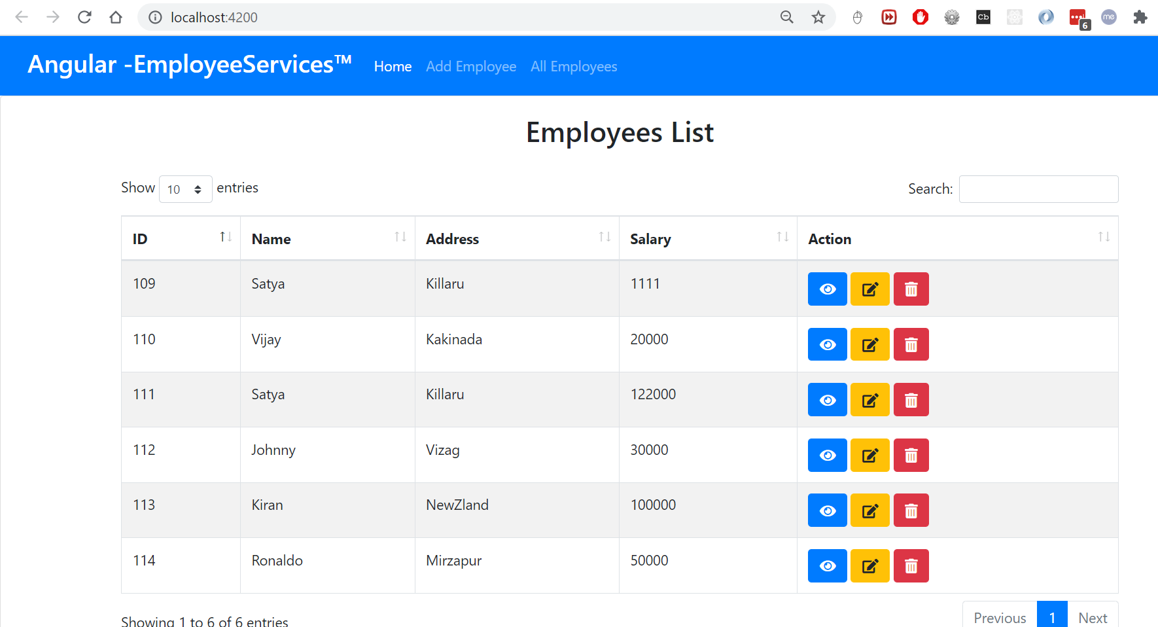

### Angular Routing

**app-routing.module.ts (Default generated code)**

import { NgModule } from '@angular/core';

import { RouterModule, Routes } from '@angular/router';

const routes: Routes = [];

@NgModule({

  imports: [RouterModule.forRoot(routes)],

  exports: [RouterModule]

})

export class AppRoutingModule { }

we need to configure path for each component like below

import { EmployeeListComponent } from './employee-list/employee-list.component';

const routes: Routes = [

  {path: 'all', component: EmployeeListComponent}

];

Next, in app.component.html – we need to place <route-outlet> to display the content based on path

<!--This is used directly to display all Empoyees

  <app-employee-list></app-employee-list> -->

<!-- Based on Route it will display content -->

<router-outlet></router-outlet>

Similarly, we need to create Components for ADD, UPADATE, DELETE employee

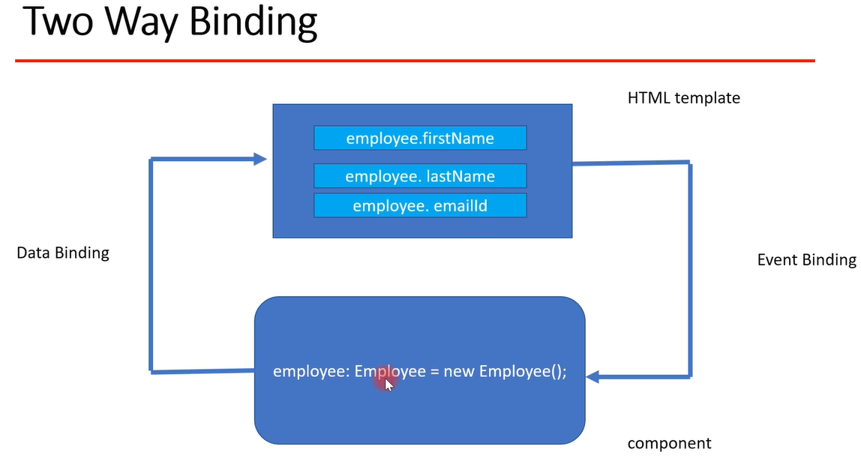

C:\Git\books\Codes\employee-angular-app>ng g c add-employee

CREATE src/app/add-employee/**add-employee.component.html**

CREATE src/app/add-employee/**add-employee.component.ts**

**Complete Code. Github**

[**https://github.com/smlcodes/Books-Sync-Gitlab/tree/main/Codes/employee-angular-app**](https://github.com/smlcodes/Books-Sync-Gitlab/tree/main/Codes/employee-angular-app)

### Ref.

<https://github.com/RameshMF/Angular-10-Spring-Boot-CRUD-Full-Stack-App>

<https://www.youtube.com/watch?v=tLBX9fq813c&list=PLGRDMO4rOGcNzi3CpBWsCdQSzbjdWWy-f>

## #3 – Micro Services - SpringBoot

Configure these 3

* <https://github.com/sqshq/piggymetrics> (BEST)
* <https://github.com/spring-petclinic/spring-petclinic-microservices>
* <https://github.com/piomin/sample-spring-microservices-new>

### a. [Piggy Metrics – Explained](https://github.com/sqshq/piggymetrics)

Link: <https://github.com/sqshq/piggymetrics>

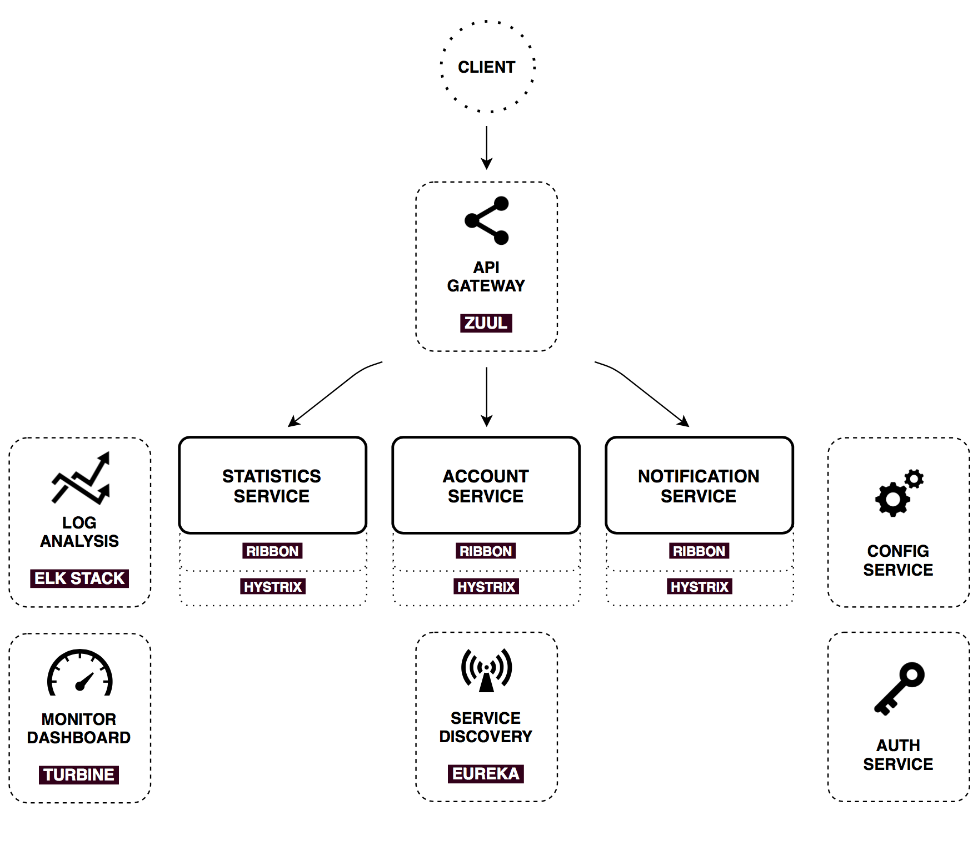

Not Configured

### b. PetClinic

* <https://github.com/spring-petclinic/spring-petclinic-microservices>

Update all yamls with Port numbers. It will Start, this is the order

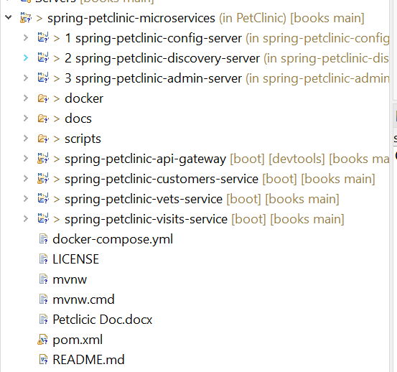

#### Docker Install

Update this 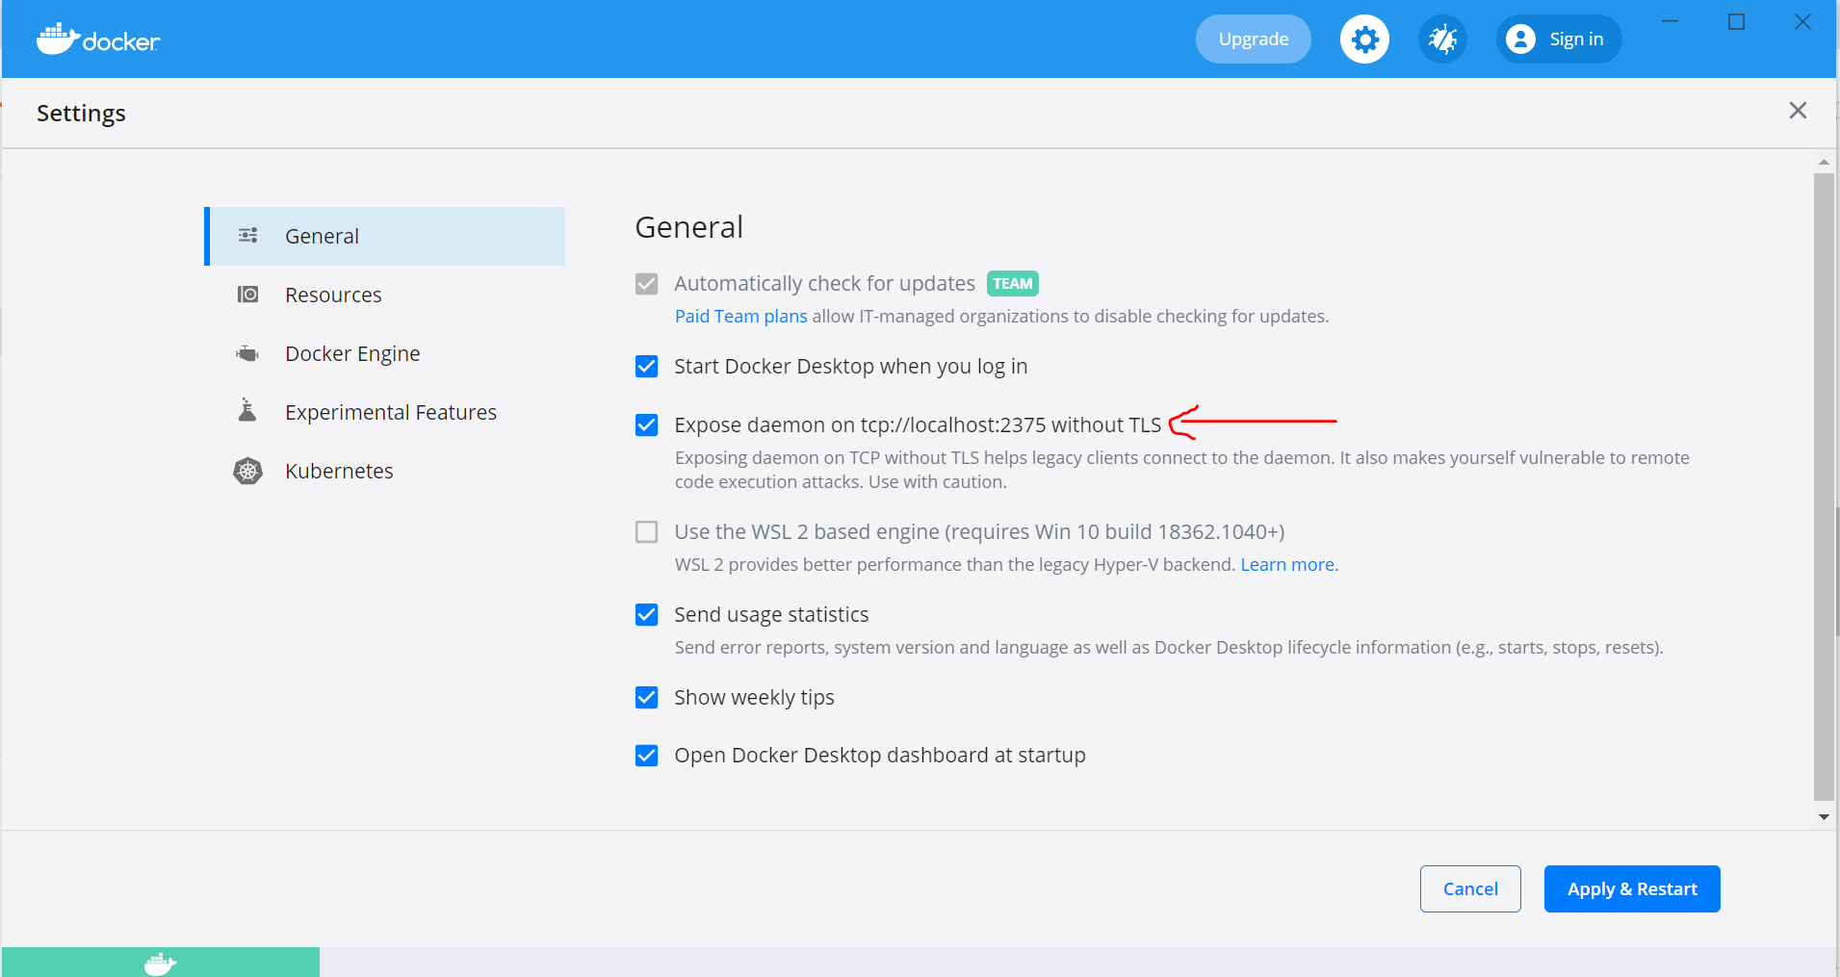

set DOCKER\_HOST=tcp://localhost:6666& mvnw clean install -P buildDocker

## #4 – Heroku - Deploying Spring Boot Applications to Heroku

I have Simple Employee Application written in SpringBoot.

**# application.properties**

# Hibernate ddl auto (create, create-drop, validate, update)

spring.jpa.hibernate.ddl-auto = update

spring.jpa.properties.hibernate.jdbc.lob.non\_contextual\_creation=true

Heroku does not have really MySQL.here we are using PostgreSQL. Update maven dependency.

**<dependency>**

**<groupId>org.postgresql</groupId>**

**<artifactId>postgresql</artifactId>**

**<scope>runtime</scope>**

**</dependency>**

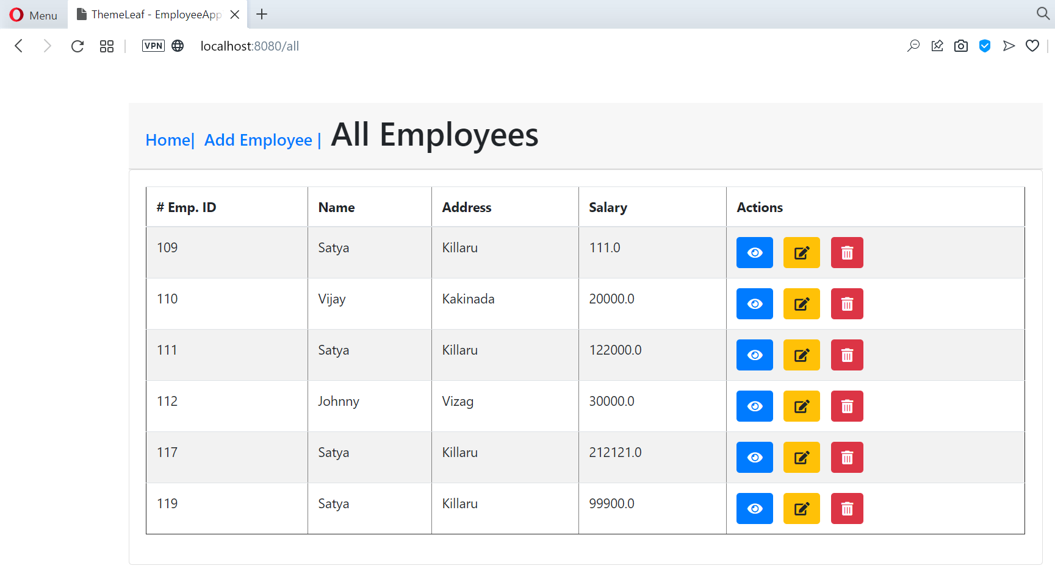

You can find here : [**Github**](https://github.com/smlcodes/Books-Sync-Gitlab/tree/main/Codes/SpringBoot-Thymeleaf)

### Create Heroku Account

Create Account: <https://www.heroku.com/>

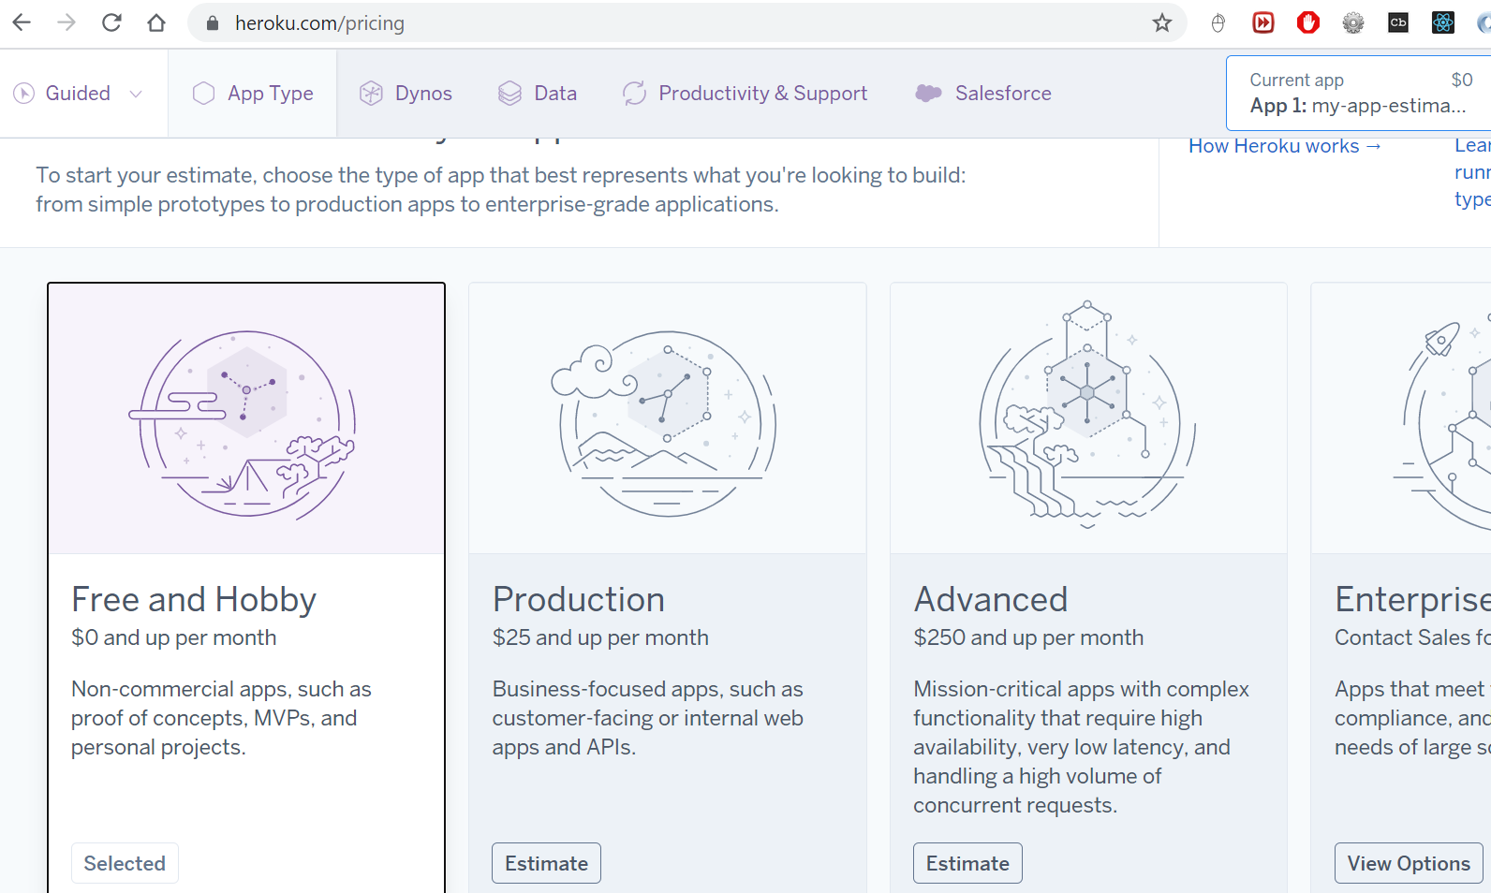

Signup Here : <https://signup.heroku.com/>

Login to App : <https://dashboard.heroku.com/apps>

### SpringBoot + Postegess from Web

Create App

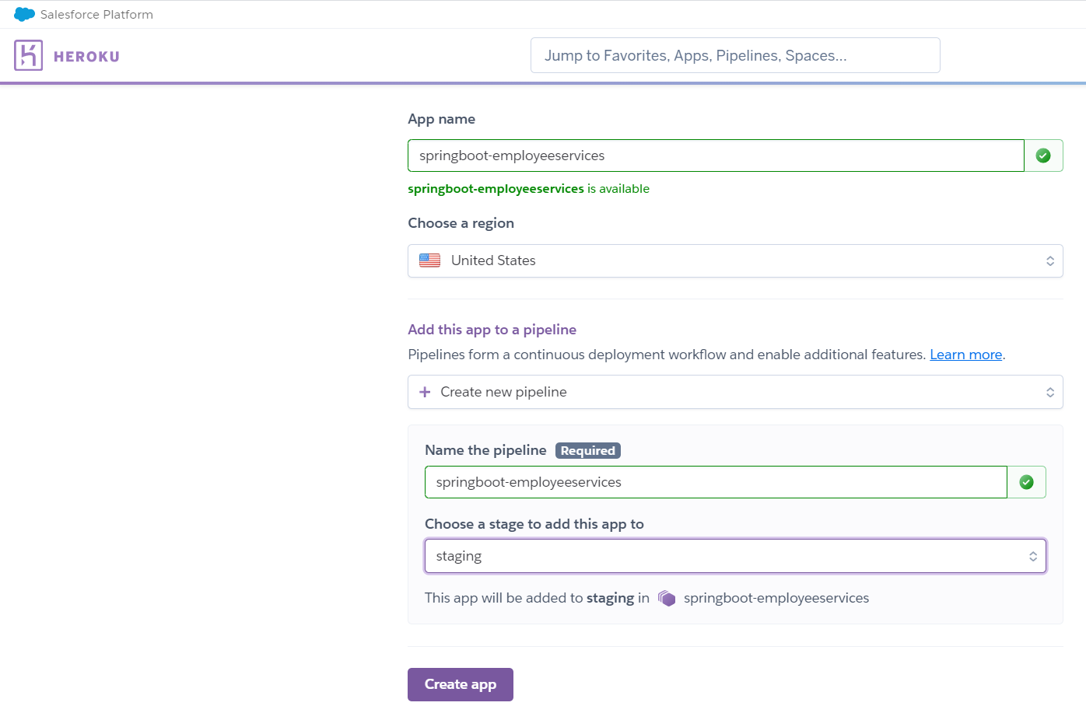

On Deploy tab

* Deployment method : Github
* App connected to GitHub : Choose Employee App 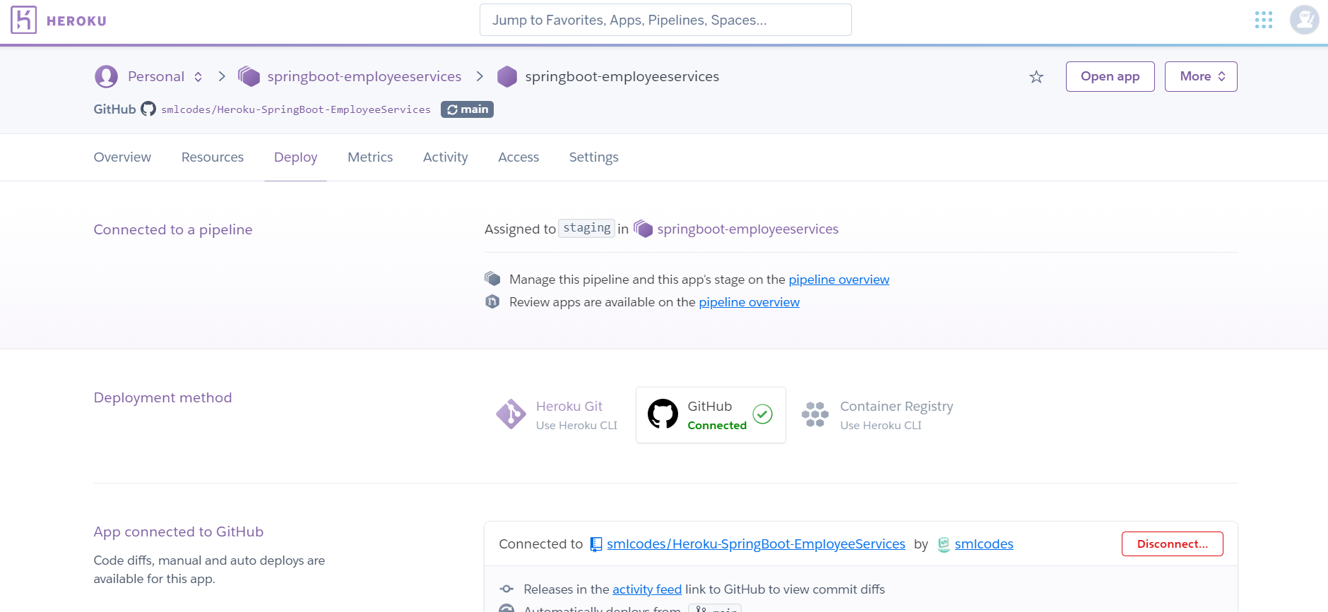
* Manual deploy : Click on Deployee Branch, It will deploy the code

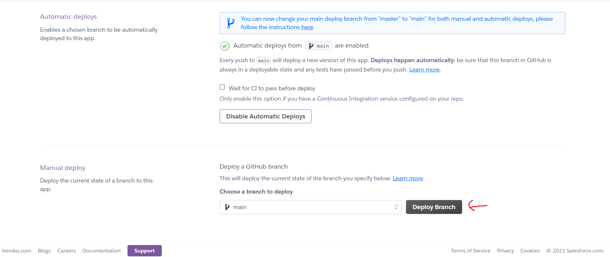

Add Heroku PostgresSql add-on on Resourcs tab. 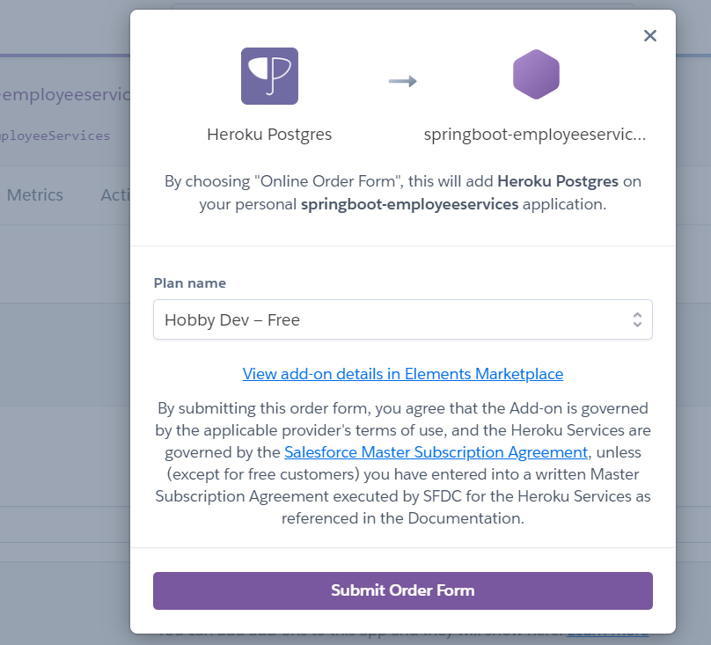

If any erros, check log by

If you have already created your Heroku app, you can easily add a remote to your local repository with the heroku git:remote command. All you need is your Heroku app’s name:

$ heroku git:remote -a <name>

<https://roytuts.com/how-to-deploy-spring-boot-data-jpa-application-to-heroku-cloud/>

<https://www.youtube.com/watch?v=E384MLaF4uU>

### Using Heroku CLI

The heroku create CLI command creates a new empty application on Heroku, along with an associated empty Git repository. If you run this command from your app’s root directory, the empty Heroku Git repository is automatically set as a remote for your local repository.

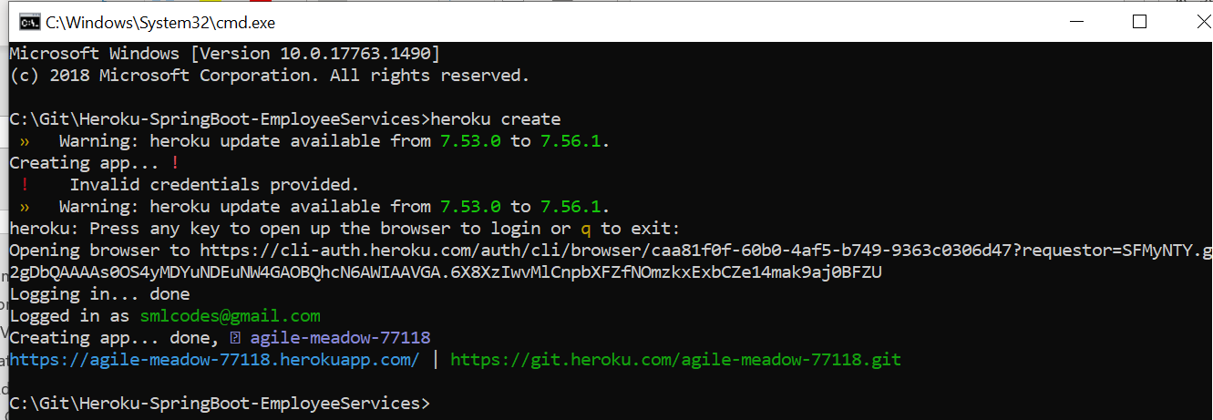

use the git remote command to confirm that a remote named heroku has been set for your app:

C:\Git\Heroku-SpringBoot-EmployeeServices>git remote

heroku

origin

To deploy your app to Heroku, you typically use the git push command to push the code from your local repository’s [master or main branch](https://devcenter.heroku.com/articles/git-branches) to your heroku remote, like so:

$ git push heroku main

Application deployed.

By reading postgress dependency in Maven, it will automatically configure PostgressSQL database. 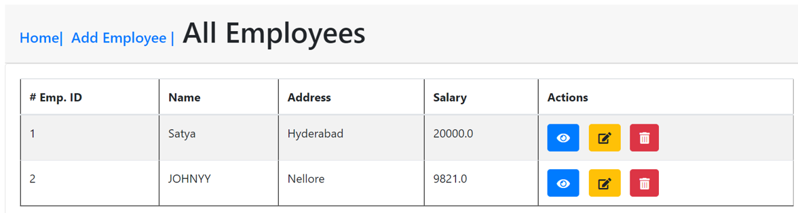

#### Ref.

<https://www.youtube.com/watch?v=k8z4UzV55ew>

<https://devcenter.heroku.com/articles/deploying-spring-boot-apps-to-heroku>

## #5 – Docker - Dockerize Spring MVC Application

Docker - Lamp Stack (Apache+MySQL+PHP)

After you have downloaded and installed the Docker demon, open the Docker engine and make sure the engine is running.

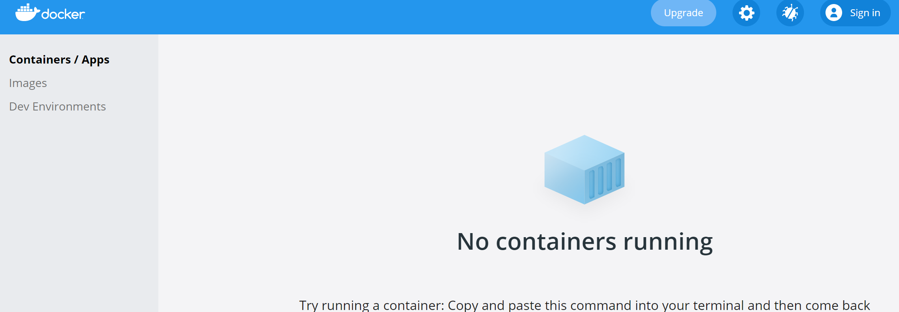

Open a command line verify if Docker is correctly installed on your computer.

docker version

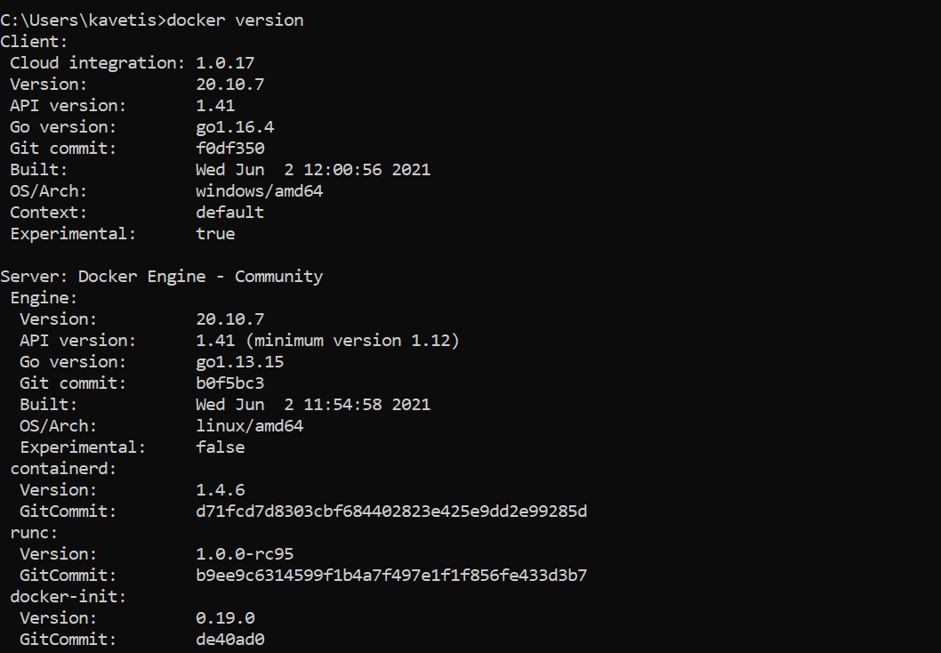

We are starting from scratch; make sure you have no containers and images running in your Docker engine.

Run docker container ls to check any available container. 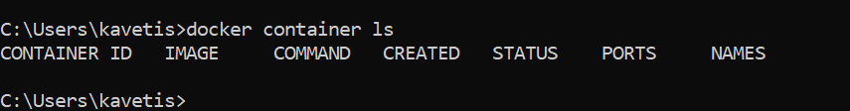

To remove a Docker container, run docker container rm <container's name>. And make sure no container is running.

#### docker-compose.yml

Docker compose file contains following hirarchi.

[Docker version](https://docs.docker.com/compose/compose-file/compose-versioning/#compatibility-matrix)

Services

|

<Service-Name>

<Image Details>

Docker version you want to use, the services you want to provide, and the containers you want to run.

#### Apache Server Container

Add Apache server instance

version: '3.8'

services:

php-apache-environment:

container\_name: php-apache

image: php:8.0-apache

volumes:

- ./php/src:/var/www/html/

ports:

- 8000:80

* version: '3.8' - Docker version
* container\_name - just a random name that you would like to name your PHP container.
* image - this the official PHP image, the version of PHP Apache you want to use.
* volumes - Root/home directory of the server
* ports - This means that we are setting up an Apache server to expose port 80. Port 8000 reaches out to the PHP scripts and executes them in a browser from within Docker containers.

Let’s test it out. Go ahead and run docker-compose up. That’s going to pull all the information, download the **Apache server**, **build the image**, and run the container.

C:\Git\books\Codes\Docker>docker-compose up

Creating network "docker\_default" with the default driver

Pulling php-apache-environment (php:8.0-apache)...

Digest: sha256:1a69e0b19f5e2d006bec4d985e678733bf452ce76bf558d15534a6ca1b73e089

Status: Downloaded newer image for php:8.0-apache

Creating php-apache ... done

If you open the Docker desktop engine, the container should be up and running.

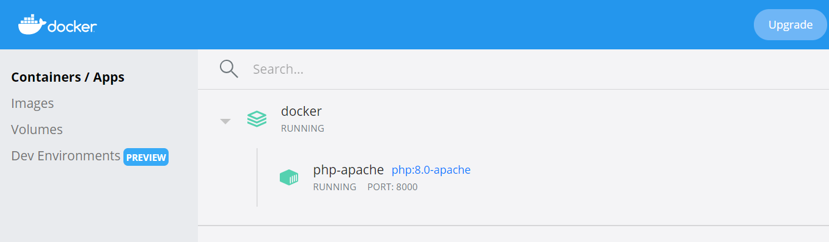

open your defined local host post in the browser, [http://localhost:8000/.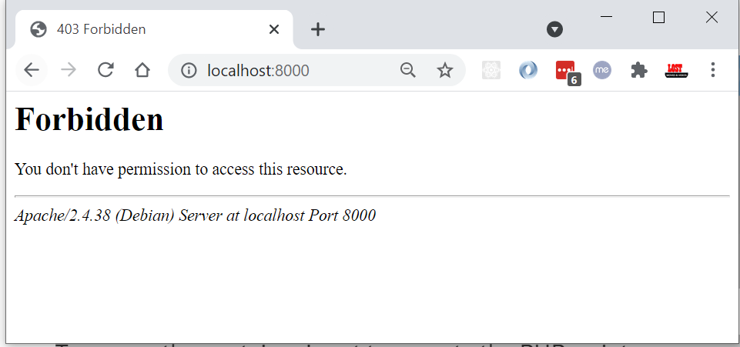](http://localhost:8000/.)

Docker will create php/src directory on the same folder where docker-compose.yml is there. 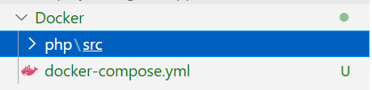

If you want write any PHP code, please place inside php/src folder. Lets create index.php

<?php

echo "<h1>SatyaCodes.ml</h1>";

echo "PHP Application Created using Docker";

?>

Refresh Browser

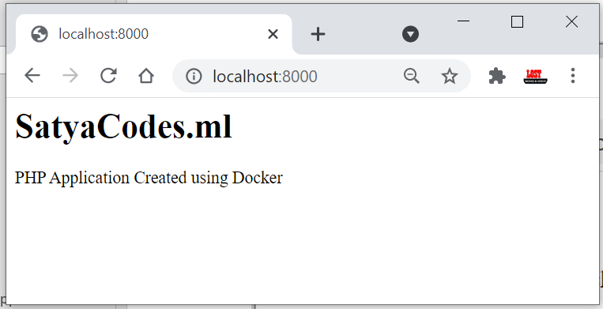

#### MySQL database container

You would probably want to set up a database to interact with your website. We will create another service to provide MySQL support inside the PHP container.

Now we need to build this custom image inside php-apache service in the docker-compose.yml file. PHP Apache also depends on the db service to connect to MySQL. We need to configure it by specifying a depends\_on environment.

This is how your docker-compose.yml file should look like.

version: '3.8'

services:

    php-apache-environment:

        container\_name: php-apache

        build:

            context: ./php

            dockerfile: Dockerfile

        depends\_on:

            - db

        volumes:

            - ./php/src:/var/www/html/

        ports:

            - 8000:80

    db:

        container\_name: db

        image: mysql

        restart: always

        environment:

            MYSQL\_ROOT\_PASSWORD: MYSQL\_ROOT\_PASSWORD

            MYSQL\_DATABASE: MYSQL\_DATABASE

            MYSQL\_USER: MYSQL\_USER

            MYSQL\_PASSWORD: MYSQL\_PASSWORD

        ports:

            - "9906:3306"

We need to add some MySQL support tools inside the PHP container for the two services (db and php-apache) to work correctly. This tool includes mysqli.

Inside your project directory, head to the /php folder, create a Docker file, name it Dockerfile and add the following PHP configurations.

FROM php:8.0-apache

RUN docker-php-ext-install mysqli && docker-php-ext-enable mysqli

RUN apt-get update && apt-get upgrade -y

Here we have created a custom PHP Apache image and an environment that will install mysqli, a PHP extension that will connect the PHP Apache to the MySQL server.

Now folder structure be like,

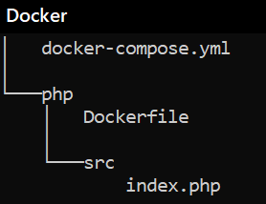

Run docker-compose up to pull and set up the MySQL environment. MySQL will be added to the container.

C:\Git\books\Codes\Docker>docker-compose up

Pulling db (mysql:)...

latest: Pulling from library/mysql

/mysqld.sock' port: 3306 MySQL Community Server – GP

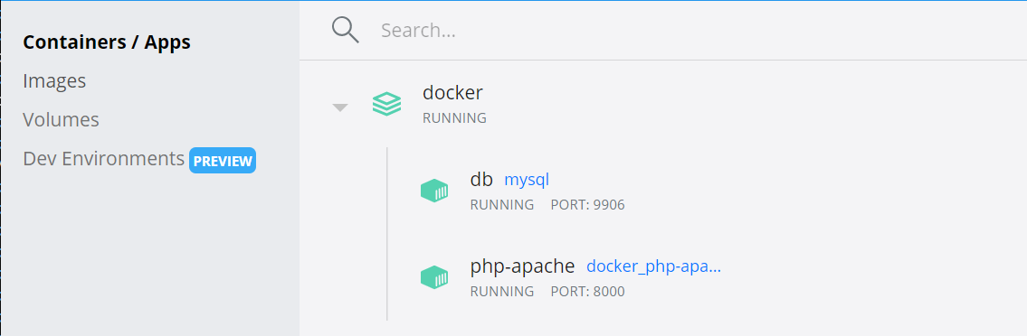

To test MySQL db connection, Update index.php with below code.

<?php

echo "<h1>SatyaCodes.ml</h1>";

echo "PHP Application Created using Docker";

$host = 'db';

// Database use name

$user = 'MYSQL\_USER';

//database user password

$pass = 'MYSQL\_PASSWORD';

// check the MySQL connection status

$conn = new mysqli($host, $user, $pass);

if ($conn->connect\_error) {

    die("<h3>Connection failed: </h3>" . $conn->connect\_error);

} else {

    echo "<h3>Connected to MySQL server successfully!</h3>";

}

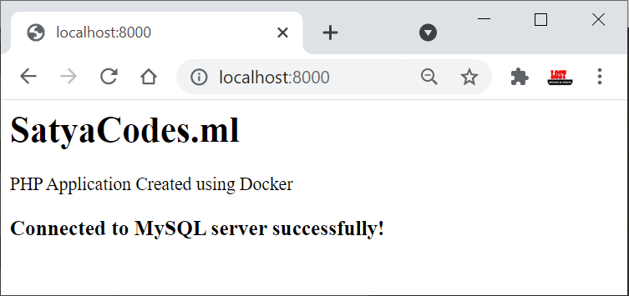

#### PhpMyadmin Container

    phpmyadmin:

        image: phpmyadmin/phpmyadmin

        ports:

            - '8080:80'

        restart: always

        environment:

            PMA\_HOST: db

        depends\_on:

            - db

Run docker-compose up. Open **http://localhost:8080/** to access the PHPMyAdmin. 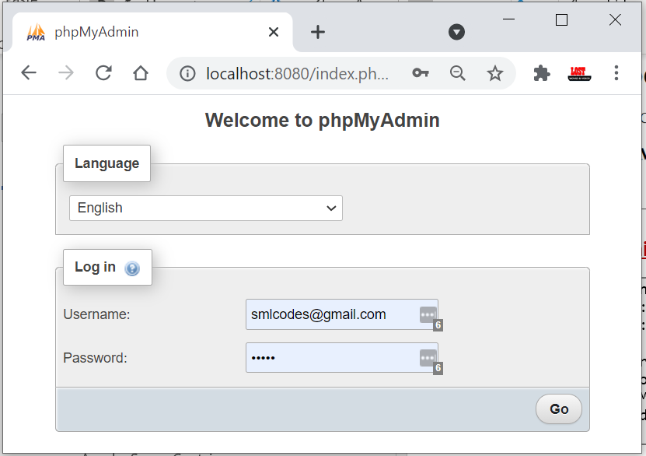

To login to the Phpmyadmin panel, use username as root and password as MYSQL\_ROOT\_PASSWORD. The password was already set in the MySQL environment variables (MYSQL\_ROOT\_PASSWORD: MYSQL\_ROOT\_PASSWORD)

Update index.php to get some sample data from MySQL

//SQL

create table `users` (

id int not null auto\_increment,

username text not null,

password text not null,

primary key (id)

);

insert into `users` (username, password) values

("admin","password"),

("Alice","this is my password"),

("Job","12345678");

index.php

<?php

echo "<h1>SatyaCodes.ml</h1>";

echo "PHP Application Created using Docker";

$host = 'db';

$user = 'MYSQL\_USER';

$pass = 'MYSQL\_PASSWORD';

$mydatabase = 'MYSQL\_DATABASE';

$conn = new mysqli($host, $user, $pass, $mydatabase);

$sql = 'SELECT \* FROM users';

if ($result = $conn->query($sql)) {

    while ($data = $result->fetch\_object()) {

        $users[] = $data;

    }

}

foreach ($users as $user) {

    echo "<br>";

    echo $user->username . " ==>   " . $user->password;

    echo "<br>";

}

?>

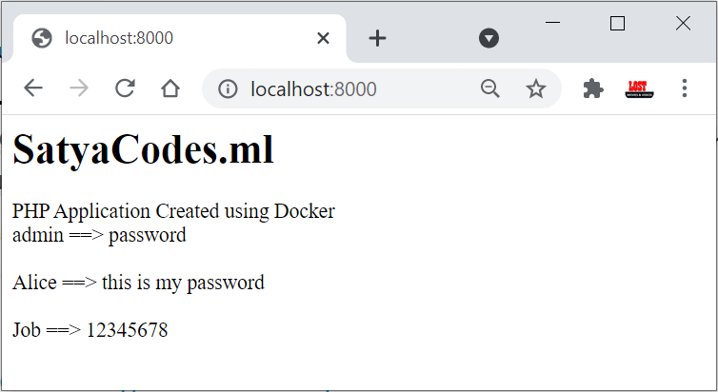

#### Ref.

* <https://www.section.io/engineering-education/dockerized-php-apache-and-mysql-container-development-environment/>
* <https://medium.com/code-kings/docker-building-a-lamp-stack-9503c62d9214>

SpringBoot – Docker Example

Consider a scenario - You have just joined a new organization as a developer. You will now have to setup the project with the assistance of a fellow developer. He suggests you follow certain steps for setting up the required environment and then start the project deployable like a WAR. You do the same but keep getting some or other issues regarding environment configuration. May be even your fellow developer has forgot some configuration property he might have set.

 Other similar scenario of this dependency hell are - The application is running on my dev machine but not in production. Dont know what issue is. There is also other scenarios like Matrix of Hell. But this is mostly related to DEVOPS people.

**Docker to the rescue. Docker is a tool designed to make it easier to create, deploy, and run applications by using containers.**

**Containers allow a developer to package up an application with all of the parts it needs, such as libraries and other dependencies, and ship it all out as one package.** Create self-contained development environments inside Docker containers. So, we share an environment already configured.

**An image is a lightweight, stand-alone, executable package that includes everything needed to run a piece of software, including the code, a runtime, libraries, environment variables, and config files.** **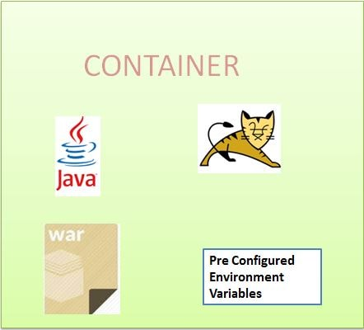**

So, an existing fellow developer will create an image of his environment and share it with the new developer. The new developer will just have to run the image as a docker container.

A container is a runtime instance of an image what the image becomes in memory when actually executed. It runs completely isolated from the host environment by default, only accessing host files and ports if configured to do so. **So the following scenarios we can consider the use of docker for Java Developers-**

* Sharing development workspace, with preconfigured development environment.
* Continuous integration is one of the most popular use cases for Docker. Teams looking build and deploy their applications quickly use Docker, combined with ecosystem tools like Jenkins, to drive apps from dev, testing staging and into production without having to change any code.
* Running UAT's using Docker

#### Deploying SpringBoot+MySQL using Dockerfile

We have following Code, after maven build it creates jar file. (SpringBoot-Thymeleaf-1.0.0-SNAPSHOT.jar)

<https://github.com/smlcodes/Books-Sync-Gitlab/tree/main/Codes/SpringBoot-Thymeleaf>

we have inbuilt apache tomcat in SpringBoot. So Apache tomcat container not required.

Create Dockerfile inside root directory SpringBoot-Thymeleaf

FROM openjdk:8

ADD target/SpringBoot-Thymeleaf-1.0.0-SNAPSHOT.jar SpringBoot-Thymeleaf-1.0.0-SNAPSHOT.jar

EXPOSE 8089

ENTRYPOINT ["java", "-jar", "SpringBoot-Thymeleaf-1.0.0-SNAPSHOT.jar"]

Here

* Use openJDK 8
* Add the SpringBoot-Thymeleaf-1.0.0-SNAPSHOT.jar from target directory
* Use port 8089 to run the application
* Execute SpringBoot-Thymeleaf-1.0.0-SNAPSHOT.jar -jar command

Build Doker image by using docker build -t <name> from the directory where Dockerfile is placed.

docker build -t springboot-thymeleaf .

Docker will create the image of our application& tagged it as SpringBoot-Thymeleaf

Once the image is built, use the following command to view the list of images:

docker images

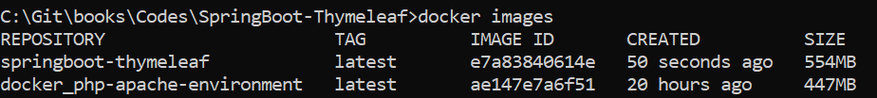

Create MySQL DB Container image

pull MySQL image from Docker Hub.

docker pull mysql:latest

Run MySQL Docker container

C:\Git\books\Codes\SpringBoot-Thymeleaf>

docker run -d

-p 6033:3306

--name=docker-mysql

--env="MYSQL\_ROOT\_PASSWORD=root"

--env="MYSQL\_PASSWORD=root"

--env="MYSQL\_DATABASE=webapp"

mysql

Similarly Start Sprint Boot application in the same manner using the following command.

docker run -t --link springboot-mysql:mysql -p 10222:10222 springboot-thymeleaf

#### Deploying SpringBoot+MySQL using Docker Compose

In above example we use CLI commands to run a database, and Spring Boot applications. We used Dockerfile to set up the environment and run the application by running containers separately and then building a link between them.

But for multiple container applications we can use the [docker-compose tool](https://dzone.com/articles/docker-basics-docker-compose). Docker CLI can manage a single container, but **docker-compose** can manage multiple containers and define the dependent services.

If we want to run services with the docker-compose tool, we have to follow these steps that are also defined in [Docker documentation](https://docs.docker.com/compose/).

1. We need to define the application environment with a [Dockerfile](https://dzone.com/articles/a-beginners-guide-to-the-dockerfile), so it can be reproduced anywhere.
2. We need to define the services that make up the application in docker-compose.yml so they can be run together in an isolated environment.
3. Run docker-compose commands to run/stop the container or deploy/undeploy the application.

We need a docker-compose.yml file to write the services. In a Dockerfile, we defined the environment of the application, and in docker-compose file we write down the other properties of services, like which service will run on which port, which service will be dependent on other services, which port will be forwarded to other port for public access, define network, cluster applications, etc.

Dockerfile

FROM openjdk:8

ADD target/SpringBoot-Thymeleaf-1.0.0-SNAPSHOT.jar SpringBoot-Thymeleaf-1.0.0-SNAPSHOT.jar

EXPOSE 8089

ENTRYPOINT ["java", "-jar", "SpringBoot-Thymeleaf-1.0.0-SNAPSHOT.jar"]

And the docker-compose.yml file looks like this:

version: '3'

services:

docker-mysql:

restart: always

container\_name: springboot-mysql

image: mysql

environment:

MYSQL\_DATABASE: webapp

MYSQL\_ROOT\_PASSWORD: root

MYSQL\_ROOT\_HOST: '%'

volumes:

- './sql:/docker-entrypoint-initdb.d'

ports:

- '3306:3306'

healthcheck:

test: /usr/bin/mysql --user=root --password=root--execute "SHOW DATABASES;"

interval: 2s

timeout: 20s

retries: 10

springboot-thymeleaf:

restart: on-failure

build: ./

expose:

- '10222'

ports:

- '10222:10222'

environment:

WAIT\_HOSTS: 'mysql:3306'

depends\_on:

- docker-mysql

We will go to the project root directory. To run the application, we will use following commands:

* docker-compose up — This will execute Dockerfile commands and will run services defined in the docker-compose file.
* docker-compose down — This will stop and remove all containers that were running by docker-compose file.
* docker-compose up --build — If we do an update on the Dockerfile, the war/jar file, or the docker-compose file.

<https://www.javainuse.com/fullstack>

<https://www.callicoder.com/spring-boot-docker-example/>

## #10 - StudentApp Document(old)

### StudentApp + AngularJs+ CurdRepository+MockMVC References

**CURD + POSTMAN**  
<https://www.callicoder.com/spring-boot-rest-api-tutorial-with-mysql-jpa-hibernate/>

**AngularJS+Templates**  
<https://examples.javacodegeeks.com/enterprise-java/spring/boot/spring-boot-and-angularjs-integration-tutorial/>

**Spring+AngularJS Controllers**  
<https://java2blog.com/spring-boot-angularjs-example/>

**SpringBoot MockMVC Tutorial**

* Mokito : <https://howtodoinjava.com/spring-boot2/spring-boot-mockito-junit-example/>
* MOCK MVC : <https://howtodoinjava.com/spring-boot2/spring-boot-mockmvc-example/>

### StudentApp MongoRepository

Example App : <https://www.journaldev.com/18156/spring-boot-mongodb>

**1. Add Maven Dependency:**    spring-boot-starter-data-mongodb

2.Create Sudent Collection

>use student

>db.createCollection("student");

>db.student.insert(  
   {  
      sno: 501,  
      name: "Satya Kaveti",  
      city:"Vijayawada",  
      marks:508  
   }  
)

3.in **application.propertis** , add Mongo DB details

spring.data.mongodb.database=student  
spring.data.mongodb.port=27017  
spring.data.mongodb.host=localhost

2.Create **StudentModel**.java with **@Document & Id**annotations

3.create **StudentMongoRepository**extends **MongoRepository**

4.Create **StudentMongoController.java**

**How can Spring Boot work without driver configuration?**

Spring Boot gives you defaults on all things, the default in database is **H2**, so when you want to change this and use any other database you must define the connection attributes in the **application.properties** file.

* H2 is one of the popular in memory databases. Spring Boot has default integration for H2
* is live only during the time of execution of the application, not for real world applications
* The h2-\*.jar is just an engine (the code) of the database. It is read-only and it does not store any information. The data in H2 can be stored either in memory or on disk in a specified file. You are actually specifying one:

In our Application we are using MySQL, so we provided details with out Driver detilas

spring.datasource.url = jdbc:mysql://localhost:3306/student?useSSL=false

spring.datasource.username = root

spring.datasource.password = root

<dependency>

<groupId>org.springframework.boot</groupId>

<artifactId>spring-boot-starter-data-jpa</artifactId>

</dependency>

<dependency>

<groupId>mysql</groupId>

<artifactId>mysql-connector-java</artifactId>

<scope>runtime</scope>

</dependency>

* [**@EnableAutoConfiguration**](https://docs.spring.io/spring-boot/docs/1.2.1.RELEASE/api/org/springframework/boot/autoconfigure/EnableAutoConfiguration.html) : This annotation tells Spring to automatically configure your application based on the dependencies that you have added in the **pom.xml** file.
* For example, If **spring-data-jpa** or **spring-jdbc** is in the classpath, then it automatically tries to configure a **DataSource** by reading the database properties from **application.properties** file.
* So,in above we just have to add the configuration and Spring Boot will take care of the rest.
* In the above properties file, the last two properties are for hibernate. Spring Boot uses Hibernate as the default JPA implementation.
* If you remove mysql-connector-java from pom.xml, SpringBoot unable to find the MySQL related java classes in insert application.propeties values to create datasource, it will throw below error.

Failed to bind properties under '' to com.zaxxer.hikari.HikariDataSource:

Property: driverclassname

Value: com.mysql.cj.jdbc.Driver

Origin: "driverClassName" from property source "source"

**Reason: Failed to load driver class com.mysql.cj.jdbc.Driver in either of HikariConfig class loader or Thread context classloader**

Action:

Update your application's configuration

So finally, SpringBoot uses Drivers & all normal stuff though @EnableAutoConfiguration to do the job

### Spring Boot with multiple databases

In Our StudentApp we have multiple Databases.

1.if we use only one Database :MySQL we can use default spring.data.\*properties. Spring @EnableAutoConfiguration will create Datasource by reading these properties

spring.datasource.url = jdbc:mysql://localhost:3306/student?useSSL=false

spring.datasource.username = root

spring.datasource.password = root

2.if we use two databases :MySQL, Mongo we can use default spring.data.\*properties of therir respective databases. Spring @EnableAutoConfiguration will create two different Datasource by reading these properties

spring.data.mongodb.database=student

spring.data.mongodb.port=27017

spring.data.mongodb.host=localhost

3.If we use two DB’s with our own Config properties we need to Ovveride DataSource Manually

#----------- MySQL -------------

own.spring.mysql.datasource.url = jdbc:mysql://localhost:3306/student?useSSL=false

own.spring.mysql.datasource.username = root

own.spring.mysql.datasource.password = root

#----------- MongoDB -------------

own.spring.mongo.datasource.database=student

own.spring.mongo.datasource.port=27017

own.spring.mongo.datasource.host=localhost

Because we want the Spring Boot autoconfiguration to pick up those different properties (and actually instantiate two different DataSources), we need to instantiate our DataSource beans manually in a configuration class

@Configuration  
public class MultipleDataSourceConfiguration {  
   
    @Bean  
    @Primary  
    @ConfigurationProperties(prefix="own.spring.mysql.datasource")  
    public DataSource primaryDataSource() {  
        return DataSourceBuilder.create().build();  
    }  
   
    @Bean  
    @ConfigurationProperties(prefix="own.spring.mongo.datasource")  
    public DataSource secondaryDataSource() {  
        return DataSourceBuilder.create().build();  
    }  
}

* <https://medium.com/@joeclever/using-multiple-datasources-with-spring-boot-and-spring-data-6430b00c02e7>
* <http://www.java2novice.com/spring-boot/configure-multiple-datasources/>
* <https://www.infoq.com/articles/Multiple-Databases-with-Spring-Boot>

**@Conditional & @Profilers**

While developing Spring based applications we may come across a need to register beans conditionally.

For example, you may want to register a DataSource bean pointing to the **dev** database abd different **production database** while running in production.

To address this problem, Spring 3.1 introduced the concept of **Profiles**. When you run the application you can activate the desired profiles ,and only those beans of that profiles will be registered.

@Configuration

public class AppConfig

{

@Bean

@Profile("DEV")

public DataSource devDataSource() {

...

}

@Bean

@Profile("PROD")

public DataSource prodDataSource() {

...

}

}

Then you can specify the active profile using System Property **-Dspring.profiles.active=DEV**

Now we can configure both **JdbcUserDAO**and **MongoUserDAO**beans conditionally using **@Conditional**as follows:

@Configuration

public class AppConfig

{

@Bean

@Conditional(MySQLDatabaseTypeCondition.class)

public UserDAO jdbcUserDAO(){

return new JdbcUserDAO();

}

@Bean

@Conditional(MongoDBDatabaseTypeCondition.class)

public UserDAO mongoUserDAO(){

return new MongoUserDAO();

}

}

**How EnableAutoConfiguration implemented?**

auto-configuration is implemented with standard @Configuration classes. Additional @Conditional annotations are used to constrain when the auto-configuration should apply.

### SpringBoot Security

spring-boot-starter-security: take care of all the required dependencies related to spring security.

<dependency>

<groupId>org.springframework.boot</groupId>

<artifactId>spring-boot-starter-security</artifactId>

</dependency>

This will include the *SecurityAutoConfiguration*class – containing the initial/default security configuration.

Just Run the project & see the magic



**We never created this login form, but from where it came from?**

SpringSecurity default comes with login page & you can login with generated password which is already printed in the console

Using generated security password: **8b4667a4-cc3a-47fd-b51f-b6f5e83745df**

Def.user name is : **user**

You can change the password by providing a security.user.password. This and other useful properties are externalized via [SecurityProperties](https://github.com/spring-projects/spring-boot/tree/v1.4.0.RELEASE/spring-boot-autoconfigure/src/main/java/org/springframework/boot/autoconfigure/security/SecurityProperties.java" \t "_top) (properties prefix "security").

security.user.name=user

security.user.name=password

security.basic.enabled=true

To discard the security auto-configuration and add our own configuration, we need to exclude the ***SecurityAutoConfiguration*** class.

**@SpringBootApplication(exclude = { SecurityAutoConfiguration.class })**

public class SpringBootSecurityApplication {

    public static void main(String[] args) {

        SpringApplication.run(SpringBootSecurityApplication.class, args);

    }

}

Or by adding some configuration into the *application.properties* file:

spring.autoconfigure.exclude=org.springframework.boot.autoconfigure.security.SecurityAutoConfiguration

If we disabling security auto-configuration, we need to provide our own configuration, by extends WebSecurityConfigurerAdapter

@Configuration

@EnableWebSecurity

**public** **class** SecurityConfig **extends** WebSecurityConfigurerAdapter {

@Override

**public** **void** configure(HttpSecurity http) **throws** Exception {

// It allows configuring web based security for specific http requests

http

.authorizeRequests()

.anyRequest().authenticated()

.and()

.formLogin()

.and()

.httpBasic();

/\* ============ Custom login Page URL ==========

http

.authorizeRequests()

.antMatchers("/admin/\*\*").hasRole("ADMIN")

.antMatchers("/anonymous\*").anonymous()

.antMatchers("/login\*").permitAll()

.anyRequest().authenticated()

.and()

.formLogin()

.loginPage("/login.html")

.loginProcessingUrl("/perform\_login")

.defaultSuccessUrl("/homepage.html", true)

//.failureUrl("/login.html?error=true")

.failureHandler(authenticationFailureHandler())

.and()

.logout()

.logoutUrl("/perform\_logout")

.deleteCookies("JSESSIONID")

.logoutSuccessHandler(logoutSuccessHandler());

\*/

}

@Bean

@Override

**public** UserDetailsService userDetailsService() {

UserDetails user =

User.~~withDefaultPasswordEncoder~~()

.username("user")

.password("user")

.roles("USER")

.build();

**return** **new** InMemoryUserDetailsManager(user);

}

}

Let’s summarize what we did in order to add Spring Boot Security to his web app. To secure his web app,

* we added Spring Boot Security to the classpath.
* Once it was in the classpath, Spring Boot Security was enabled by default.
* Then customized the security by extending  WebSecurityConfigurerAdapter and added his own configure and userDetailsServiceimplementation.
* <http://localhost:8080/login?logout>
* <https://docs.spring.io/spring-security/site/docs/current/guides/html5/form-javaconfig.html>
* <https://examples.javacodegeeks.com/enterprise-java/spring/boot/spring-boot-security-example/>

### SpringBoot AOP

Actually we don’t have Spring AOP starter in Springboot, but we can integrate using traditional Spring Framework

<dependency>

<groupId>org.springframework</groupId>

<artifactId>spring-aop</artifactId>

<version>5.0.1.RELEASE</version>

<scope>compile</scope>

</dependency>

<dependency>

<groupId>org.aspectj</groupId>

<artifactId>aspectjweaver</artifactId>

<version>1.8.12</version>

<scope>compile</scope>

</dependency>

Applications are generally developed with multiple layers. A typical Java application has

* Web Layer - Exposing the services to outside world using REST or a web application
* Business Layer - Business Logic
* Data Layer - Persistence Logic

While the responsibilities of each of these layers are different, there are a few common aspects that apply to all layers

* Logging
* Security

In this example we are implementing Logging – we are trying to Log the all the Application flow like, what controller is calling, what method is executing on performing certain operation.

**package** app.aop;

@Aspect

@Configuration

**public** **class** StudentAOP {

**private** Logger logger = LoggerFactory.*getLogger*(**this**.getClass());

//What kind of method calls I would intercept

//execution(\* PACKAGE.\*.\*(..))

//Weaving & Weaver

@Before("execution(\* app.repository.\*.\*(..))")

**public** **void** before(JoinPoint joinPoint){

//Advice

logger.info(" \n \n====== @Before===== \t app.repository");

logger.info(" Allowed execution for {}", joinPoint);

logger.info(" ====== @Before===== \n \n");

}

@AfterReturning(value = "execution(\* app.controller.\*.\*(..))",

returning = "result")

**public** **void** afterReturning(JoinPoint joinPoint, Object result) {

logger.info("\n \n ====== @AfterReturning ===== \t : app.controller ");

logger.info("{} returned with value {}", joinPoint, result);

logger.info(" ====== @AfterReturning ===== \n \n");

}

@After(value = "execution(\* app.security.\*.\*(..))")

**public** **void** after(JoinPoint joinPoint) {

logger.info("\n \n ====== @After ===== \t : app.security");

logger.info("after execution of {}", joinPoint);

logger.info(" ====== @After ===== \n \n");

}

}

**====== @After ===== : app.security**

2019-02-10 22:50:12.232 INFO 8152 --- [ main] dentAOP$$EnhancerBySpringCGLIB$$bb027782 : after execution of execution(UserDetailsService app.security.SecurityConfig.userDetailsService())

2019-02-10 22:50:12.236 INFO 8152 --- [ main] dentAOP$$EnhancerBySpringCGLIB$$bb027782 : **====== @After =====**

**====== @AfterReturning ===== : app.controller**

2019-02-10 22:43:58.212 INFO 2440 --- [nio-8080-exec-7] dentAOP$$EnhancerBySpringCGLIB$$45dcbfee : execution(List app.controller.StudentMongoController.getAllStudents()) returned with value [Student [sno=501, name=vinay, city=karnool, marks=545], Student [sno=502, name=VINOD, city=BNHGG, marks=456]]

2019-02-10 22:43:58.212 INFO 2440 --- [nio-8080-exec-7] dentAOP$$EnhancerBySpringCGLIB$$45dcbfee : **====== @AfterReturning =====**

Getting all users.2019-02-10 22:43:58.248 INFO 2440 --- [nio-8080-exec-9] dentAOP$$EnhancerBySpringCGLIB$$45dcbfee :

**====== @AfterReturning ===== : app.controller**

2019-02-10 22:43:58.248 INFO 2440 --- [nio-8080-exec-9] dentAOP$$EnhancerBySpringCGLIB$$45dcbfee : execution(List app.controller.StudentMongoController.getAllStudents()) returned with value [Student [sno=501, name=vinay, city=karnool, marks=545], Student [sno=502, name=VINOD, city=BNHGG, marks=456]]

2019-02-10 22:43:58.248 INFO 2440 --- [nio-8080-exec-9] dentAOP$$EnhancerBySpringCGLIB$$45dcbfee : **====== @AfterReturning =====**

**Pointcut** - Pointcut is the **expression** used to define when a call to a method should be intercepted. In the above example, "execution(\* app.repository.\*.\*(..))" is the pointcut.

**Advice** - It is the **logic that you would want to exceute** when you intercept a method. In the above example, it is the code inside the before(JoinPoint joinPoint)method.

**Aspect** – is the Class we defiend, combination of on which method **(Pointcut)** and what to do **(Advice)** is called an Aspect.

**Join Point** - When the code is executed and the condition for pointcut is met, the advice is executed. The Join Point is a specific execution instance of an advice.

**Weaver** - Weaver is the framework which implements AOP - AspectJ or Spring AOP.

* <http://www.springboottutorial.com/spring-boot-and-aop-with-spring-boot-starter-aop>
* <https://www.javainuse.com/spring/spring-boot-aop>

### SpringBoot Acuator - Health check, Auditing, Metrics,Monitoring

Actuator brings production-ready features to our application.

**Monitoring our app, gathering metrics, understanding traffic or the state of our database becomes trivial with this dependency.**

<dependency>

    <groupId>org.springframework.boot</groupId>

    <artifactId>spring-boot-starter-actuator</artifactId>

</dependency>

Once above maven dependency is included in the POM file, **16 different actuator REST endpoints**, such as actuator, beans, dump, info, loggers, and metrics are exposed

Some of important and widely used actuator endpoints are given below:

|  |  |
| --- | --- |
| **ENDPOINT** | **USAGE** |
| /env | Returns list of properties in current environment |
| /health | Returns application health information. |
| /auditevents | Returns all auto-configuration candidates and the reason why they ‘were’ or ‘were not’ applied. |
| /beans | Returns a complete list of all the Spring beans in your application. |
| /trace | Returns trace logs (by default the last 100 HTTP requests). |
| /dump | It performs a thread dump. |
| /metrics | It shows metrics information like JVM memory used, system CPU usage, open files, and much more. |

You can access all avaible endpoint by this URL: [**http://localhost:8080/actuator**](http://localhost:8080/actuator)

{

"\_links": {

"self": {

"href": *"http://localhost:8080/actuator"*,

"templated": false

},

"health": {

"href": *"http://localhost:8080/actuator/health"*,

"templated": false

},

"health-component-instance": {

"href": *"http://localhost:8080/actuator/health/{component}/{instance}"*,

"templated": true

},

"health-component": {

"href": *"http://localhost:8080/actuator/health/{component}"*,

"templated": true

},

"info": {

"href": *"http://localhost:8080/actuator/info"*,

"templated": false

}

}

}

If you see we have only 2 endpoints showing (health, info) out of 16 endpoints

By default, all the actuator endpoints are exposed over **JMX** but only the health and info endpoints are exposed over **HTTP**.

Here is how you can expose actuator endpoints over HTTP and JMX using application properties -

**Exposing Actuator endpoints over HTTP**

# Use "\*" to expose all endpoints, or a comma-separated list to expose selected ones

management.endpoints.web.exposure.include=\*

management.endpoints.web.exposure.exclude=

**Exposing Actuator endpoints over JMX**

# Use "\*" to expose all endpoints, or a comma-separated list to expose selected ones

management.endpoints.jmx.exposure.include=\*

management.endpoints.jmx.exposure.exclude=

#### Securing Actuator Endpoints with Spring Security

Actuator endpoints are sensitive and must be secured from unauthorized access. you can add spring security to your application using the following dependency -

<dependency>

<groupId>org.springframework.boot</groupId>

<artifactId>spring-boot-starter-security</artifactId>

</dependency>

we can override the default spring security configuration and define our own access rules.

#### Creating a Custom Actuator Endpoint

To customize the endpoint and define your own endpoint, simply Create a classs annotate with @Endpoint URL :

**import** org.springframework.boot.actuate.endpoint.annotation.Endpoint;

**import** org.springframework.boot.actuate.endpoint.annotation.ReadOperation;

**import** org.springframework.stereotype.Component;

@Endpoint(id="helloEndpoint")

@Component

**public** **class** ListEndPoints {

@ReadOperation

**public** String mypoint(){

**return** "Hello" ;

}

}



Few more Endpoints











<https://dzone.com/articles/spring-boot-actuator-a-complete-guide>

<https://www.callicoder.com/spring-boot-actuator/>

### Spring cloud

Spring Cloud focuses on providing good out of box experience for typical use cases and extensibility mechanism to cover others.

* Distributed/versioned configuration
* Service registration and discovery
* Routing
* Service-to-service calls
* Load balancing
* Circuit Breakers
* Global locks
* Leadership election and cluster state
* Distributed messaging

<https://github.com/Debesh1234/DemoSpringBootProjects>

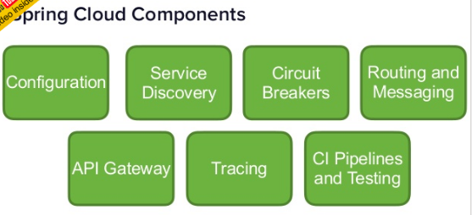

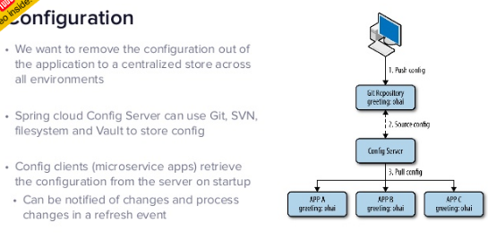

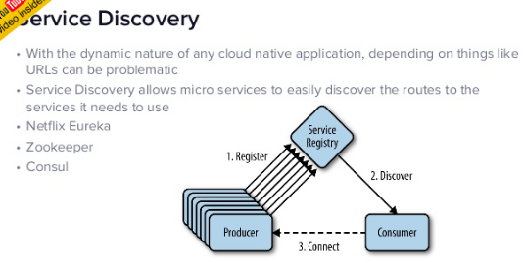

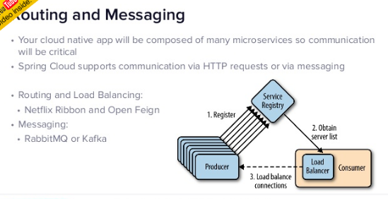

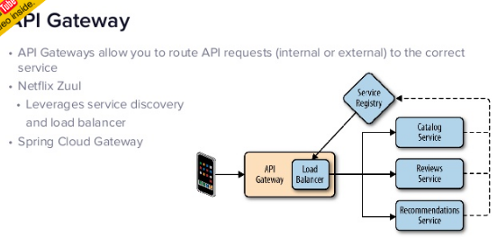

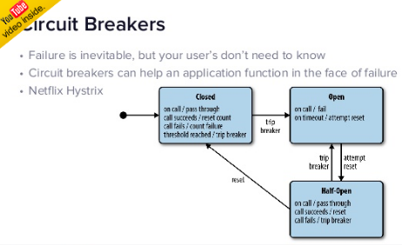

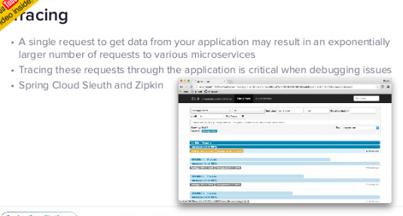

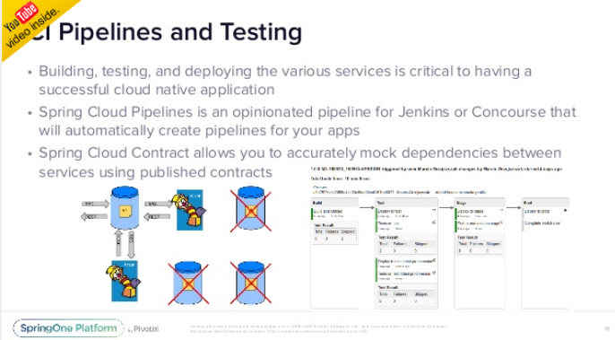

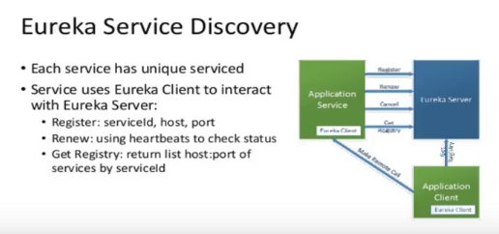

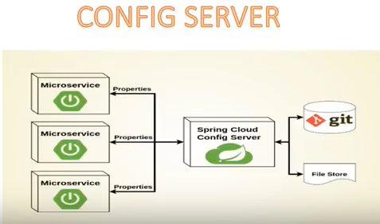

Read it Enough : <http://www.optisolbusiness.com/Micro-Services-Architecture-Spring-Boot-and-Netflix-Infrastructure.pdf>

### SpringBoot MicroServices

Microservices allows us **to break our large system into the number of independent** collaborating processes.

**Shopping system without Microservices (Monolith architecture)**

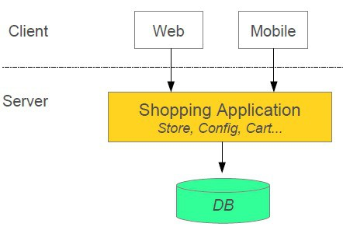

**Shopping system with Microservices**

In this architecture style, the main application divided into a set of sub-applications called microservices. One large Application divided into multiple collaborating processes as below.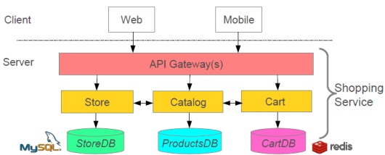

**Microservices Benefits**

* The smaller code base is easy to maintain.
* Easy to scale as an individual component.
* Technology diversity i.e. we can mix libraries, databases, frameworks etc.
* Fault isolation i.e. a process failure should not bring the whole system down.
* Better support for smaller and parallel team.
* Independent deployment
* Deployment time reduce

**Microservices Challenges**

* Distributed System so hard to debug and trace the issues
* Greater need for an end to end testing
* Required cultural changes in across teams like Dev and Ops working together even in the same team.

#### Microservices Tooling Supports

**1. Use Spring for creating Microservices**

* Setup new service by using Spring Boot
* Expose resources via a RestController
* Consume remote services using RestTemplat

**2.Service Discovery**

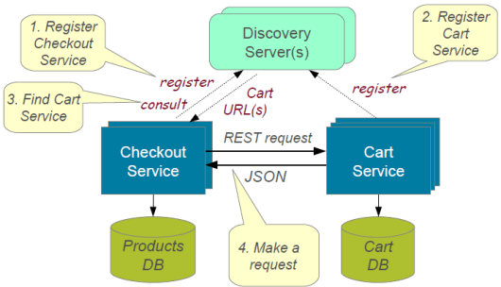

To build a simple microservices system following steps required

1. **Creating Discovery Service (Creating Eureka Discovery Service)**
2. **Creating MicroService (the Producer),** Register itself with Discovery Service with logical service.

**3. Create Microservice Consumers** find Service registered with Discovery ServiceDiscovery client using a smart **RestTemplate**to find microservice.

#### Example:

In this Example we have 3 Micro services should communicate each other.

Each micrpservice could have seprate Server & Separate DB

**Discovery Server**

Register Service

**User**

**Server**

**Accounts**

**Server**

1**. Discovery Microservice server** – To register microservice URLS

<https://github.com/dineshonjava/discovery-microservice-server>

@EnableEurekaServer –EurekaServer Acts as a Discovery Server. To Make our class as Discovery server use @EnableEurekaServer on the top of Spring Application class

@SpringBootApplication

**@EnableEurekaServer**

public class DiscoveryMicroserviceServerApplication {

public static void main(String[] args) {

SpringApplication.run(DiscoveryMicroserviceServerApplication.class, args);

}

}

Run this Eureka Server application with right click and run as Spring Boot Application and open in browser [**http://localhost:1111/**](http://localhost:1111/)

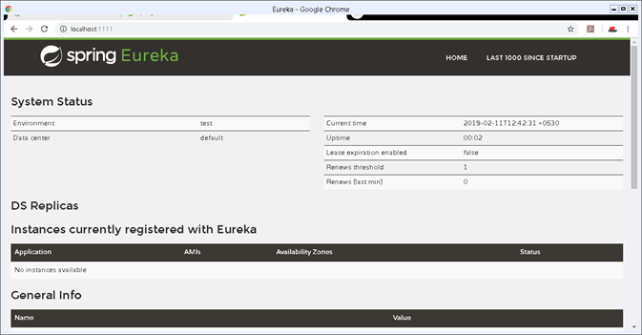

**2. Accounts Microservice Server** – It conatins Bank Account Deatils

<https://github.com/dineshonjava/accounts-microservice-server>

**Account.java – for Account details**

public class Account implements Serializable{

private static final long serialVersionUID = 1L;

private Long amount;

private String number;

private String name;

//Setter and getters

}

**AccountController** – all these Controller urs are Registers with Discovery Service

@RestController

public class AccountController {

protected Logger logger = Logger

.getLogger(AccountController.class.getName());

@Autowired

AccountRepository accountRepository;

**@RequestMapping("/accounts")**

public Account[] all() {

logger.info("accounts-microservice all() invoked");

List<Account> accounts = accountRepository.getAllAccounts();

logger.info("accounts-microservice all() found: " + accounts.size());

return accounts.toArray(new Account[accounts.size()]);

}

**@RequestMapping("/accounts/{id}")**

public Account byId(@PathVariable("id") String id) {

logger.info("accounts-microservice byId() invoked: " + id);

Account account = accountRepository.getAccount(id);

logger.info("accounts-microservice byId() found: " + account);

return account;

}

}

To make all our controller URLS register with Discovery server, we need to annotate our main Spring Application class with ***@EnableDiscoveryClient***

@SpringBootApplication

**@EnableDiscoveryClient**

public class AccountsMicroserviceServerApplication {

public static void main(String[] args) {

SpringApplication.run(AccountsMicroserviceServerApplication.class, args);

}

}

Now run this account service application as **Spring Boot application** and after few seconds refresh the browser to the home page of **Eureka Discovery Server**at **http://localhost:1111/** .

Now one Service registered to the Eureka registered instances with Service Name “**ACCOUNT-MICROSERVICE**” as below

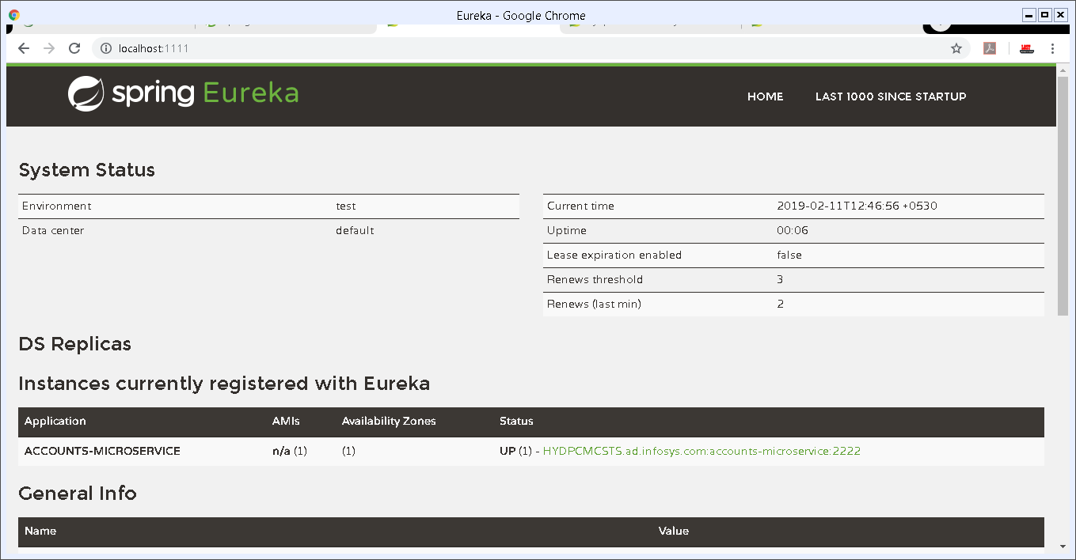

**3. Webclient Mroservice server** – User will ask for Specific Account details with AccNo

<https://github.com/dineshonjava/webclient-microservice-server>

Create users to find the Producer Service registered with Discovery Service by adding ***@EnableDiscoveryClient***. This annotation also allows us to query Discovery server to find microservices

@SpringBootApplication

**@EnableDiscoveryClient**

public class WebclientMicroserviceServerApplication {

public static final String ACCOUNTS\_SERVICE\_URL = "http://ACCOUNTS-MICROSERVICE";

public static void main(String[] args) {

SpringApplication.run(WebclientMicroserviceServerApplication.class, args);

}

@Bean

@LoadBalanced

public RestTemplate restTemplate() {

return new RestTemplate();

}

@Bean

public AccountRepository accountRepository(){

return new RemoteAccountRepository(ACCOUNTS\_SERVICE\_URL);

}

}

Now run this consumer service application as **Spring Boot application** and after few seconds refresh the browser to the home page of **Eureka Discovery Server**at [**http://localhost:1111**](http://localhost:1111)

Now one more Service registered to the Eureka registered instances with Service Name “**ACCOUNTS-WEB**” as below

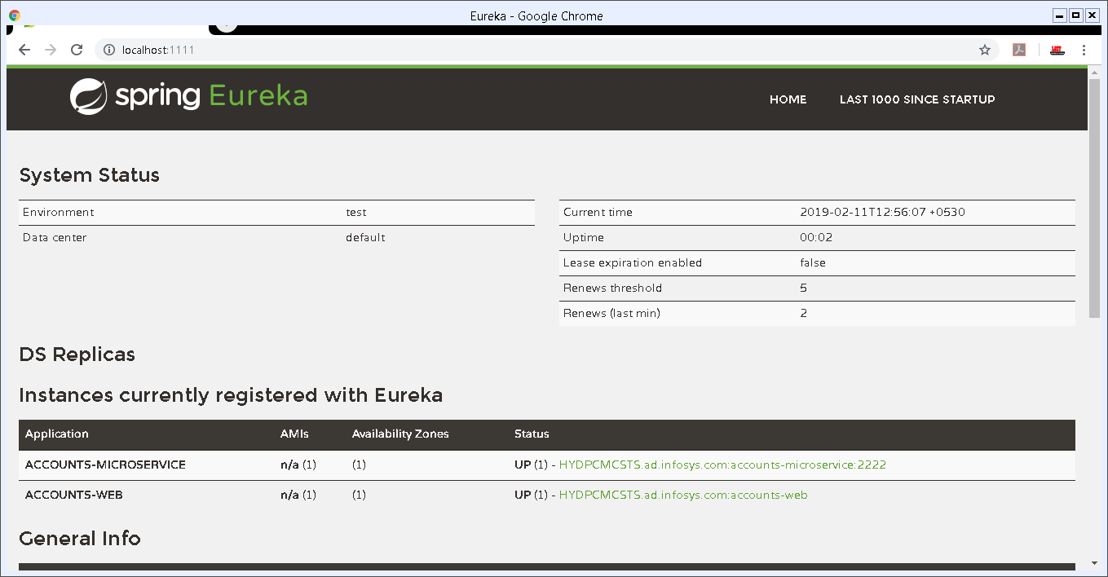

**4.Access URL Through Web Application**

We already created a Web Application in **Webclient Mroservice server** to call registred Discovery Server URLs.which is running on

**http://localhost:8080/**

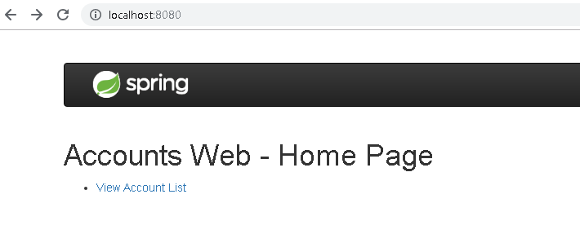

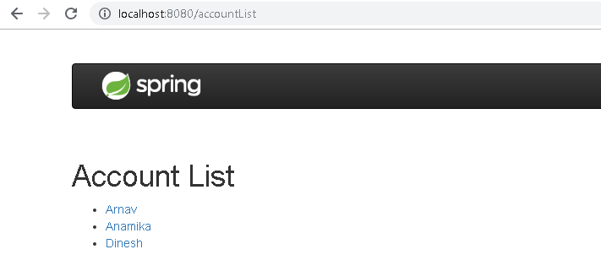

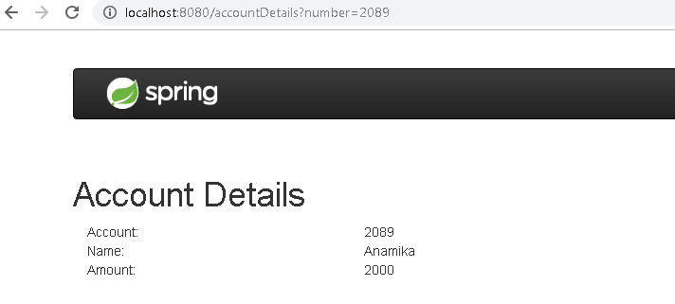

<https://www.dineshonjava.com/microservices-with-spring-boot/>

<https://spring.io/blog/2015/07/14/microservices-with-spring>

### Reactive JavaRx

* Reactive comes from the word react, which means to **react to changes** in the state instead of actually doing the state change.
* The reactive model listens to changes in the event and runs the relevant code accordingly.
* **observer/subscriber** attached listening to the stream would receive the data.

The basic building blocks of RxJava are:

* **Observables**: That emits data streams
* **Observers and Subscribers**: That consume the data stream. The only difference between an Observer and a Subscriber is that a Subscriber class has the methods to unsubscribe/resubscribe independently without the need of the observerable methods.
* **Operators**: That transform the data stream

[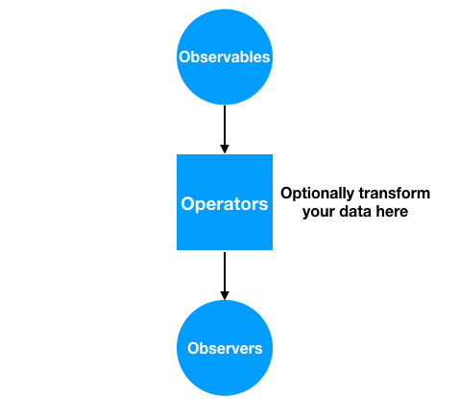](https://cdn.journaldev.com/wp-content/uploads/2018/02/rxjava-basics-flow.png)

<https://cdn.journaldev.com/wp-content/uploads/2018/02/rxjava-basics-flow.png>

### SpringBoot – Reactive Programming

**Spring WebFlux framework is part of Spring 5 and provides reactive programming support for web applications**

**Spring WebFlux internally uses**[**Project Reactor**](http://projectreactor.io/)**and its publisher implementations –**[**Flux**](https://projectreactor.io/docs/core/release/api/reactor/core/publisher/Flux.html)**and**[***Mono***](https://projectreactor.io/docs/core/release/api/reactor/core/publisher/Mono.html).

<dependency>

    <groupId>org.springframework.boot</groupId>

    <artifactId>spring-boot-starter-webflux</artifactId>

    <version>2.0.3.RELEASE</version>

</dependency>

**We’ll now build a very simple Reactive REST *EmployeeManagement* application – using Spring WebFlux:**

* We’ll use a simple domain model – *Employee* with an *id* and a *name* field
* We’ll build REST APIs for publishing and retrieve Single as well as Collection *Employee*resources using *RestController*and *WebClient*
* And we will also be creating a secured reactive endpoint using WebFlux and Spring Security

@RestController

@RequestMapping("/employees")

public class EmployeeReactiveController {

    private final EmployeeRepository employeeRepository;

@GetMapping("/{id}")

private **Mono<Employee>** getEmployeeById(@PathVariable String id) {

    return employeeRepository.findEmployeeById(id);

}

@GetMapping

private **Flux<Employee>** getAllEmployees() {

    return employeeRepository.findAllEmployees();

}

}

**Reactive Web Client**

[*WebClient*](https://docs.spring.io/spring/docs/current/spring-framework-reference/web-reactive.html#webflux-client) introduced in Spring 5 is a non-blocking client with support for Reactive Streams.

**On the client side, we use *WebClient* to retrieve data from our endpoints created in*EmployeeController.***

public class EmployeeWebClient {

    WebClient client = WebClient.create("[http://localhost:8080](http://localhost:8080/)");

  Mono<Employee> employeeMono = client.get()

  .uri("/employees/{id}", "1")

  .retrieve()

  .bodyToMono(Employee.class);

employeeMono.subscribe(System.out::println);

Flux<Employee> employeeFlux = client.get()

  .uri("/employees")

  .retrieve()

  .bodyToFlux(Employee.class);

employeeFlux.subscribe(System.out::println);

}

<https://www.baeldung.com/spring-webflux>

<https://www.journaldev.com/20763/spring-webflux-reactive-programming>

### AngularJs(Angular 1) vs Angular (Angular 2)

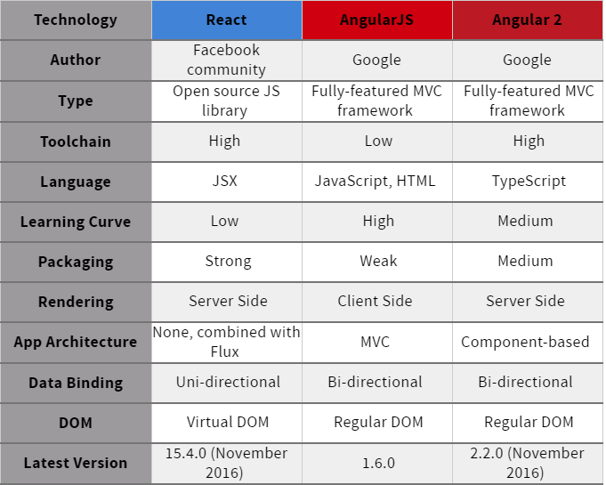

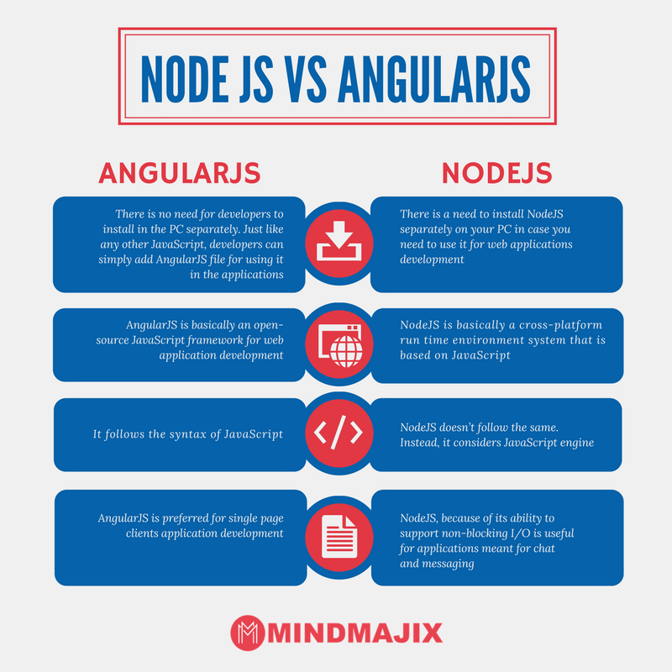

### What exactly node.js is?

Is it a web server or a programming language for server-side scripts?

* So here’s how it is, how it’s always been: a browser sends a request to a website. The site’s server receives the request, tracks down the requested file, performs any database queries as needed, and sends a response to the browser. In traditional web servers, such as Apache, each request causes the server to create a new system process to handle that request
* Now think about what that means for a traditional web server like Apache. For each and every user connected to the site, your server has to keep a connection open. Each connection requires a process, and each of those processes will spend most of its time either sitting idle (consuming memory) or waiting on a database query to complete. This means that it’s hard to scale up to high numbers of connections without grinding to a near halt and using up all your resources.
* So what’s the solution? Here’s where some of that jargon from before comes into play: specifically **non-blocking** and **event-driven**
* Think of **a non-blocking** server as a loop: it just keeps going round and round. A request comes in, the loop grabs it, passes it along to some other process (like a database query), sets up a callback, and keeps going round, ready for the next request. It doesn’t just sit there, waiting for the database to come back with the requested info.
* If the database query comes back — fine, we’ll deal with that the same way: throw a response back to the client and keep looping around. There’s theoretically no limit on how many database queries you can be waiting on, or how many clients have open requests, because you’re not spending any time waiting for them. You deal with them all in their own time
* **event-driven means**: the server only reacts when an event occurs. That could be a request, a file being loaded, or a query being executed — it really doesn’t matter.

### How to host node.js applications?

You need to Host AWS or Google Cloud or any other cloud platform because it needs Node.js to be installed.

### Npm, bower packges

Let’s understand by Example

I used the complete [**MEAN**](http://mean.io/) stack for this series

**MEAN** is a set of Open Source components that together, provide an end-to-end framework for building dynamic web applications;

* **M**ongoDB : Document database – used by your back-end application to store its data as JSON (JavaScript Object Notation) documents
* **E**xpress (sometimes referred to as Express.js): Back-end web application framework running on top of Node.js
* **A**ngular (formerly Angular.js): Front-end web app framework; runs your JavaScript code in the user’s browser, allowing your application UI to be dynamic
* **N**ode.js : JavaScript runtime environment – lets you implement your application back-end in JavaScript

1.create **package.json** to install some Node packages.(like maven, here we can see **express.js** dependency)

//package.json

{

"name": "node-rest-auth",

"main": "server.js",

"dependencies": {

"bcrypt": "^0.8.5",

"body-parser": "~1.9.2",

**"express": "~4.9.8",**

"jwt-simple": "^0.3.1",

"mongoose": "~4.2.4",

"morgan": "~1.5.0",

"passport": "^0.3.0",

"passport-jwt": "^1.2.1"

}

}

To install pacakges Run

**npm install**

This will install all our modules to **node\_modules/**.

We can also install one by one without package.json as below, it will get latest version of it

npm install mongojs

npm install express

2.create **server.js**, here we import all the needed elements and create our server with url localhost:9090

var express = require('express');

var app = express();

var bodyParser = require('body-parser');

var morgan = require('morgan');

var mongoose = require('mongoose');

var passport = require('passport');

var config = require('./config/database'); // get db config file

var User = require('./app/models/user'); // get the mongoose model

var port = process.env.PORT || 9090;

var jwt = require('jwt-simple');

// get our request parameters

app.use(bodyParser.urlencoded({ extended: false }));

app.use(bodyParser.json());

// log to console

app.use(morgan('dev'));

// Use the passport package in our application

app.use(passport.initialize());

// demo Route (GET **http://localhost:9090**)

app.get('/', function(req, res) {

res.send('Hello! The API is at http://localhost:' + port + '/api');

});

// Start the server

app.listen(port);

console.log('There will be dragons: http://localhost:' + port);

**3.config/database.js**

module.exports = {

'secret': 'devdacticIsAwesome',

'database': 'mongodb://localhost/node-rest-auth'

};

4. user model for our user authentication

**//app/models/user.js**

var mongoose = require('mongoose');

var Schema = mongoose.Schema;

var bcrypt = require('bcrypt');

// Thanks to http://blog.matoski.com/articles/jwt-express-node-mongoose/

// set up a mongoose model

var UserSchema = new Schema({

name: {

type: String,

unique: true,

required: true

},

password: {

type: String,

required: true

}

});

UserSchema.pre('save', function (next) {

var user = this;

if (this.isModified('password') || this.isNew) {

bcrypt.genSalt(10, function (err, salt) {

if (err) {

return next(err);

}

bcrypt.hash(user.password, salt, function (err, hash) {

if (err) {

return next(err);

}

user.password = hash;

next();

});

});

} else {

return next();

}

});

UserSchema.methods.comparePassword = function (passw, cb) {

bcrypt.compare(passw, this.password, function (err, isMatch) {

if (err) {

return cb(err);

}

cb(null, isMatch);

});

};

module.exports = mongoose.model('User', UserSchema);

Now the basics are set up, and you can start our server from now on just with

**node server.js**

<https://devdactic.com/restful-api-user-authentication-1/>

#### Now NPM vs Bower

Npm and Bower are both **dependency management tools**. But the main difference between both is

* **npm is used for installing Node js modules**
* **bower is used for managing front end components like html, css, js etc**

running bower install will fetch the package and put it in /vendor directory,  
running npm install it will fetch it and put it into /node\_modules directory.

**Grunt** is quite different from Npm and Bower. Grunt is a javascript task runner tool. You can do a lot of things using grunt which you had to do manually otherwise

There are grunt plugins for **compilation, uglifying your javascript, copy files/folders, minifying javascript etc.**

# 11. CTMS Project Explained

## SpringBoot – LDAP login with MyTrials LDAP server

## Deployment

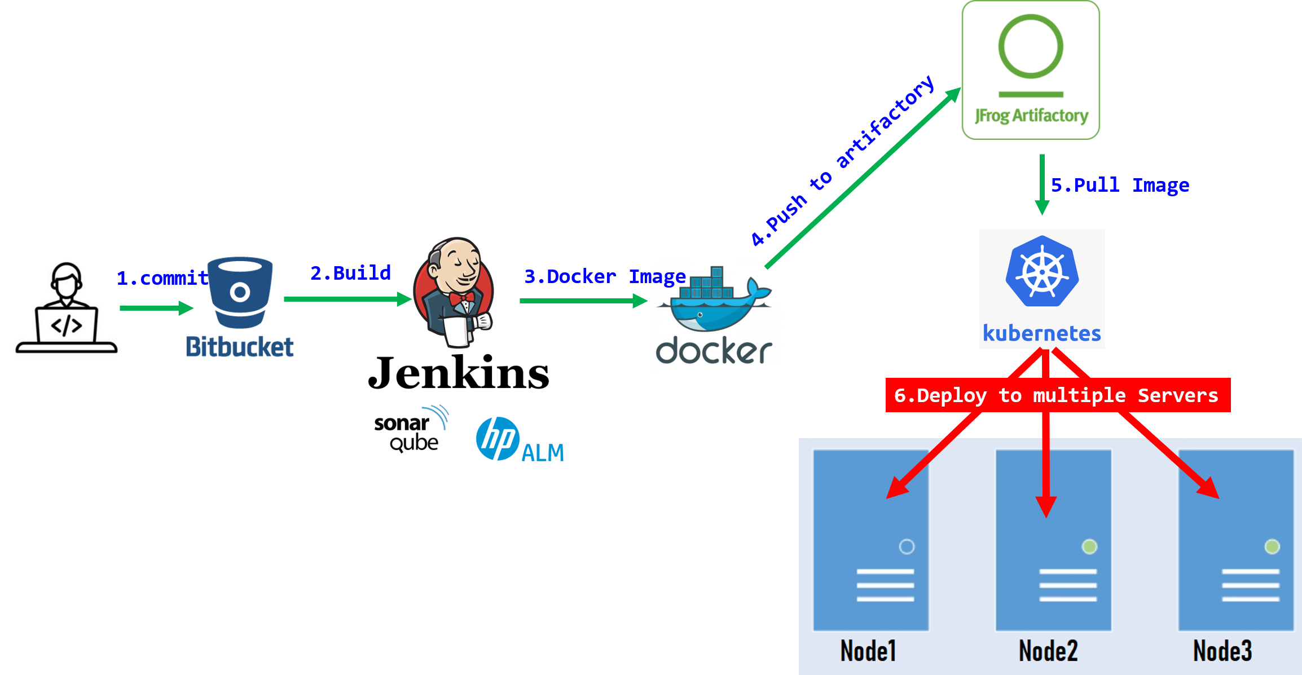

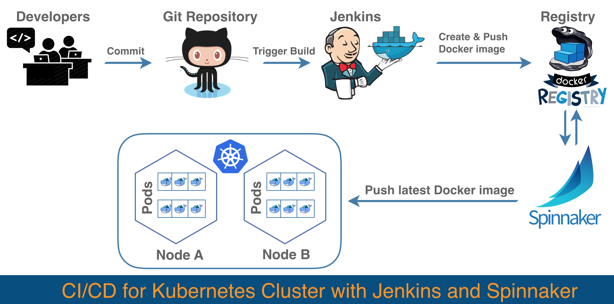

1.Configure SpringBoot Project

We have SpringBoot application in Github.

<https://github.com/smlcodes/Docker-SpringBoot-EmployeeServices.git>

we have removed MySQL dependency from docker because we do not require serate MySQL instance for each Image.

Build & Run the github code.

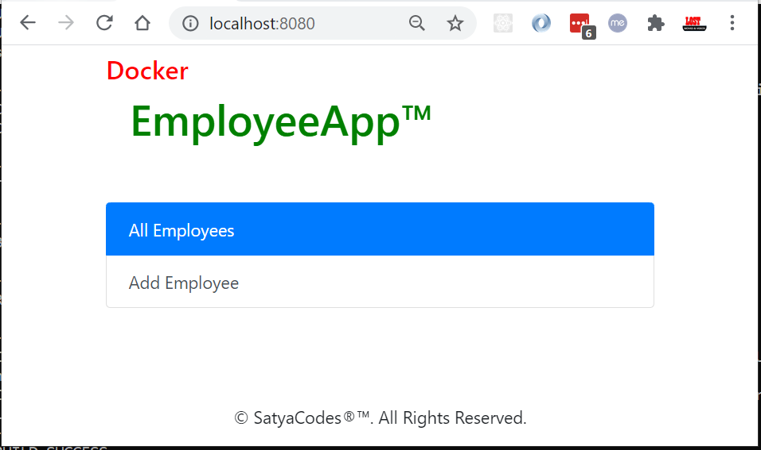

2.Create MySQL Database in Azure

<https://docs.microsoft.com/en-us/azure/mysql/quickstart-create-mysql-server-database-using-azure-portal>

2.Manual Docker Image for SpringBoot Project

To containerize an application, we enclose our application inside a container image and publish that image to a shared registry. The container runtime pulls this image from the registry, unpacks the image, and runs the application inside it.

#### a. Building a Container Image the Conventional Way

**1.Creating a Dockerfile**

A Dockerfile is a plain text file that contains instructions from which a Docker image is built. Create a Dockerfile in the project’s root folder.

A Dockerfile contains the commands below.

* **FROM**: directive sets the image on which the container will be based on.
* **RUN**: executes commands in the container.
* **COPY**: creates a copy of files from the file system in the container.
* **CMD**: sets the executable commands within the container.

# Image based on JAVA Container

FROM openjdk:8-jdk-alpine

ARG JAR\_FILE=target/\*.jar

COPY ${JAR\_FILE} Docker-EmployeeServices-1.0.jar

EXPOSE 8080

ENTRYPOINT ["java","-jar","/Docker-EmployeeServices-1.0.jar"]

**2.Building the Application**

We first build the application with Maven. This creates an executable JAR of the application. We need to convert this executable JAR into a Docker image for running in a Docker engine.

**mvn clean package**

**3. Building the Container Image**

We need to create Docker image from jar file by running docker build -t Repository:TAGVERSION

**docker build -t employeeservices:latest .**

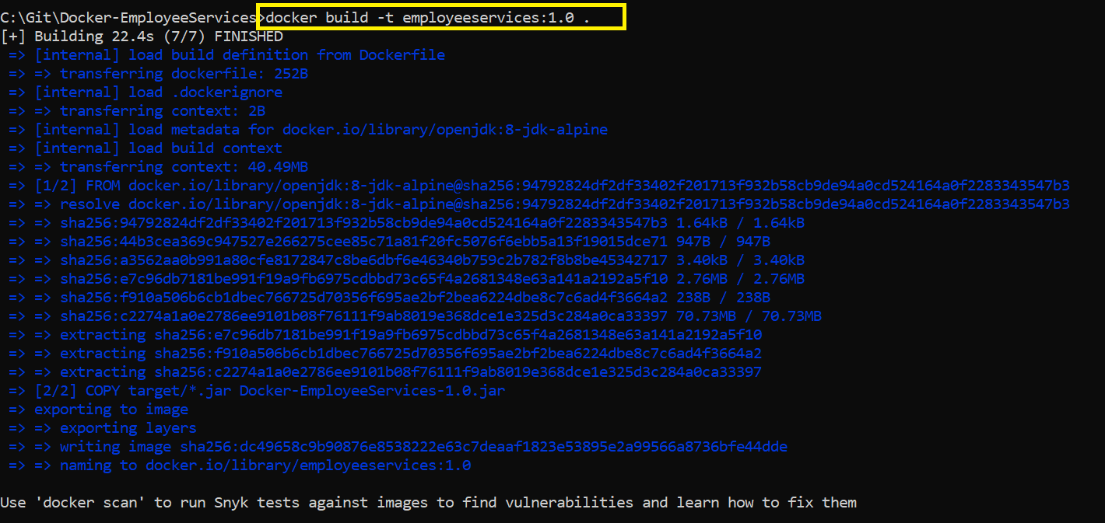

We can see our image listed with the command:

docker images

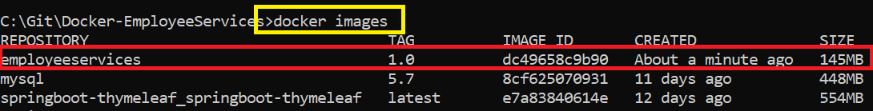

4. **Viewing the Layers Inside the Container Image**

We will use the [dive tool](https://github.com/wagoodman/dive) to view check layers inside the image. using dive Repository:TAGVERSION

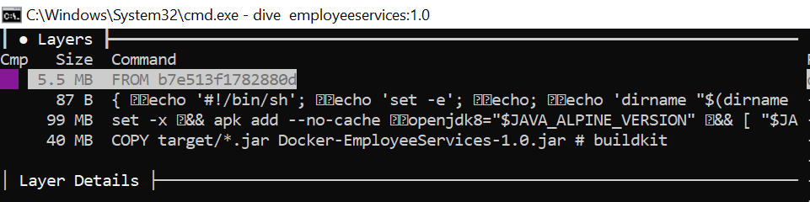

5.Running Docker Image

**docker run** --name employeeservices -d -p 8080:8080 employeeservices:latest

6.Execute the command below to list all the running Docker containers.

**docker container ps**

7.Access Running application by docker URL

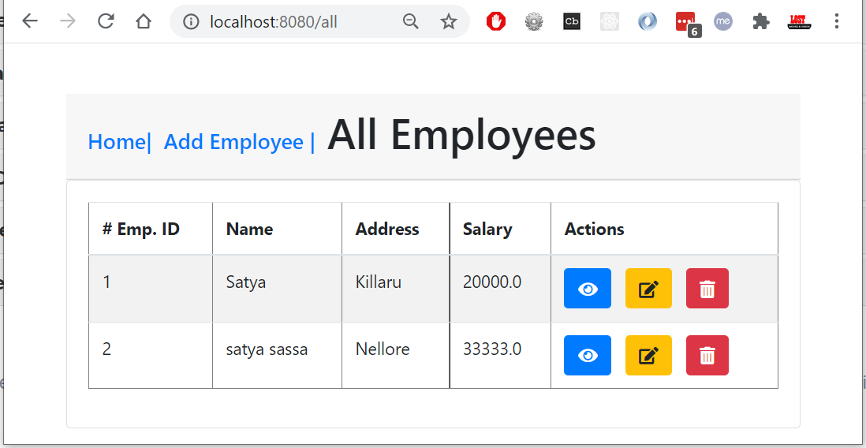

<https://reflectoring.io/spring-boot-docker/>

#### b. Building Using Maven

<https://medium.com/swlh/build-a-docker-image-using-maven-and-spring-boot-58147045a400>

By using Maven, we have multiple options.

1. Using the integrated Spring Boot **build-image** goal.
2. Using the **jib-maven-plugin** from Google.
3. Using the **dockerfile-maven-plugin** from Spotify.

#1.Using the integrated Spring Boot build-image goal.

Spring Boot comes pre-shipped with its own plugin for building Docker images and you don’t need to make any changes. It is available through the standard spring-boot-starter-parent that is included in your pom.xml.

you **do not need to write a** Dockerfile either and the plugin takes care of Spring-recommended security, memory, and performance optimizations. if there is a Dockerfile located within your source code repository, **it will be ignored**.

To create Docker image, just run

**mvn spring-boot:build-image**

make sure project name must be on small letters & no special symbols

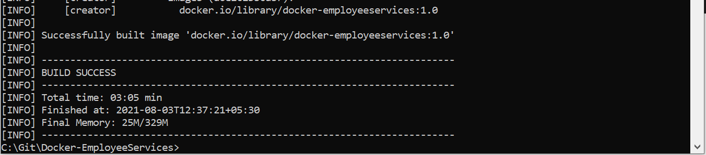

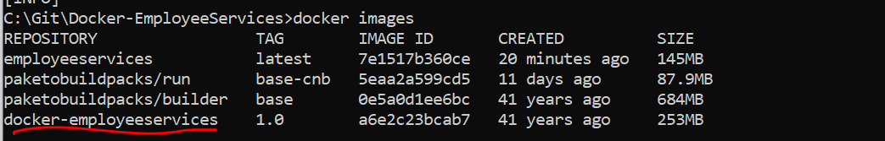

#2 Using the jib-maven-plugin from Google

Jib is a Maven and Gradle plugin for creating Docker images for Java applications.

* **it does not require Docker to be installed locally**
* **it does not require you to have written a** Dockerfile
* Best Choice for Continuous Integration / build server
* [jib-maven-plugin](https://github.com/GoogleContainerTools/jib/tree/master/jib-maven-plugin) will build and push the image straight to the Docker registry of choice.

**Using Local System**

Since we are not pushing to a Docker registry, we will tell Jib to use our local Docker installation by using the dockerBuild goal.

pom.xml

<plugin>

<groupId>com.google.cloud.tools</groupId>

<artifactId>jib-maven-plugin</artifactId>

<version>2.6.0</version>

<configuration>

<from>

<image>gcr.io/distroless/java:8</image>

</from>

<to>

<image>docker-employeeservices:${project.version}</image>

</to>

</configuration>

</plugin>

# Builds to a container image and pushes registry.

**$ mvn compile jib:build**

# Builds to a Docker daemon in local system.

**$ mvn compile jib:dockerBuild**

# This builds and saves your image as tarball to target/jib-image.tar

**$ mvn compile jib:buildTar**

# you can load tar Image into docker with

**docker load --input target/jib-image.tar**

$ mvn clean compile jib:dockerBuild

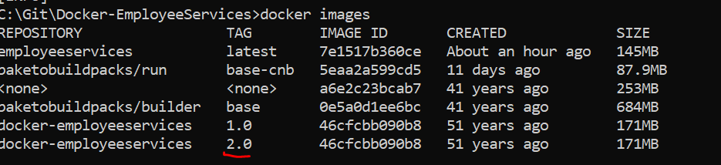

The only configuration we needed is to provide was <to><image>, which is the name of our Docker image. We can now use that plugin to create a Docker image that will be available on our local Docker daemon.

To build the Docker image, run the command, without maven dependency in pom.xml

**mvn compile com.google.cloud.tools:jib-maven-plugin:2.3.0:dockerBuild**

**Using DockerHub**

1.add registry credentials to the Maven Maven\conf\settings.xml file

<server>

<id>registry.hub.docker.com</id>

<username>smlcodes</username>

<password>passw0rd@</password>

</server>

2.Update pom.xml

<plugin>

<groupId>com.google.cloud.tools</groupId>

<artifactId>jib-maven-plugin</artifactId>

<version>2.6.0</version>

<configuration>

<from>

<image>gcr.io/distroless/java:8</image>

</from>

<to>

<image>smlcodes/docker-employeeservices:${project.version}</image>

</to>

</configuration>

</plugin>

* Typically, you don’t need to provide **<from>** as by default, as it uses a distro-less Java 8 image. However, I have used Java 11, so I have explicitly mentioned that here. Moreover, depending on your use case, you may want to use a different base image
* **<image>** This refers to the target image that will pushed to the container registry**.**

**To Build & Publish docker image**

**mvn compile jib:build**

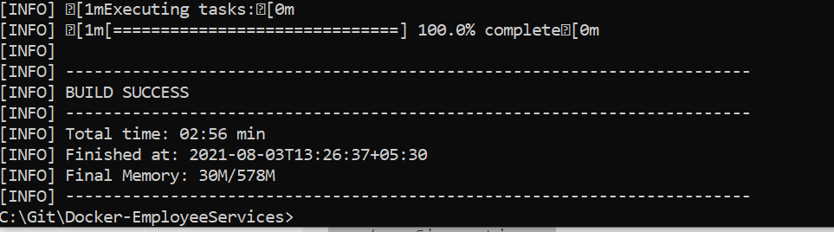

**Check Docker HUB online**

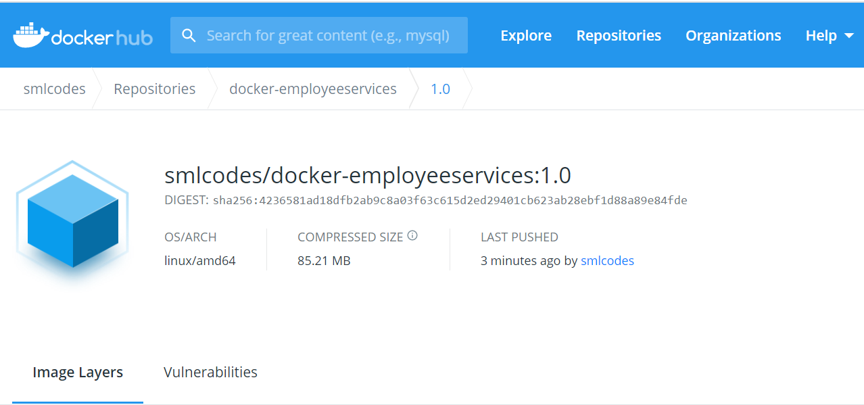

I have used a Docker registry, but you can use any cloud provider's (ECS, GCR, ACR) container registry.For other options available for use with the plugin, you can refer to the [documentation](https://github.com/GoogleContainerTools/jib/tree/master/jib-maven-plugin).

#3 Using the dockerfile-maven-plugin

Add your Dockerfile into your root directory alongside your pom.xml.

<plugin>

<groupId>com.spotify</groupId>

<artifactId>dockerfile-maven-plugin</artifactId>

<version>1.4.13</version>

<executions>

<execution>

<id>default</id>

<goals>

<goal>build</goal>

<goal>push</goal>

</goals>

</execution>

</executions>

<configuration>

<repository>${project.artifactId}</repository>

<tag>${project.version}</tag>

<buildArgs>

<JAR\_FILE>target/${project.build.finalName}.jar</JAR\_FILE>

</buildArgs>

</configuration>

</plugin>

3.Jenkins Configuration

Downoad & Start Jenkins from [**here**](https://www.jenkins.io/download/)

cd C:\Docker\Jenkins

java -jar jenkins.war --httpPort=2222

echo "Jenkins Started . . . "

**Login to Jenkins**

<http://localhost:2222/>

admin/admin

4.Docker Image PUSH to JFrog Artifactory

Go to JFrog Website: <https://jfrog.com/start-free> create an account,login

<https://satyajohnny.jfrog.io/>

satyajohnny/123

On your system cmdline

docker login satyajohnny.jfrog.io

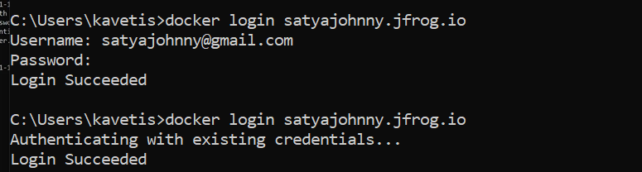

From next time onwards it won’t ask for Credencials

Go to Adminstartion > Add Repository > Local > Select : Docker > Name : jenkins-docker-images 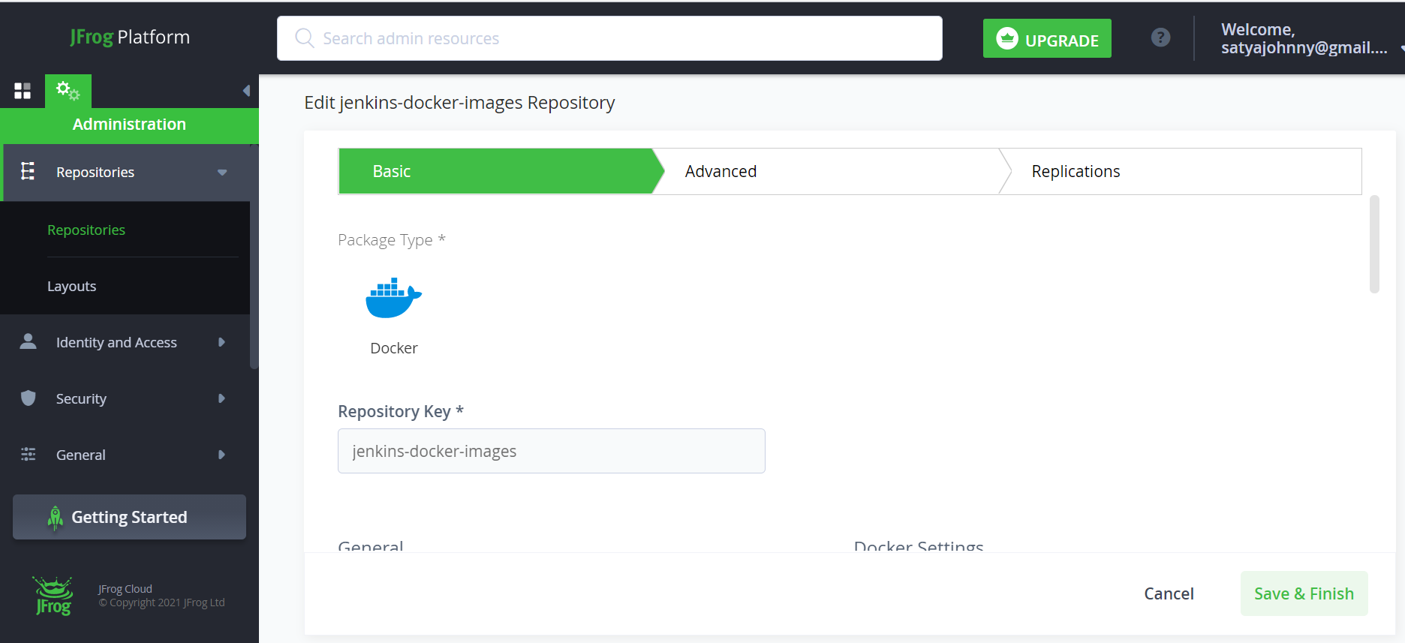

To Integrate with Jenkins, follow <http://satyacodes.ml/jenkins/jfrog-integration>

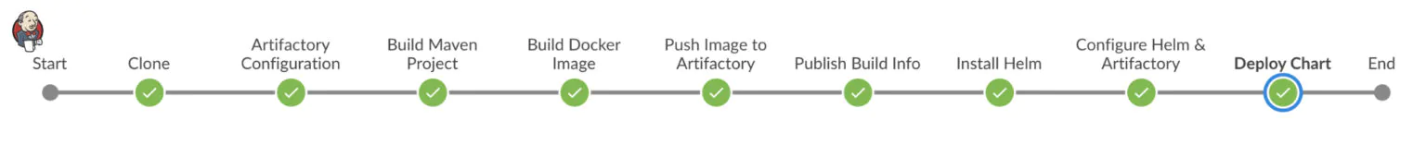

**pipeline** {

**agent** *any*

**tools** {

//Java, Maven Configured in Globol tools configuration. and here the names we provided for configuration

*jdk* 'Java8'

*maven* 'Maven'

}

**stages** {

**stage** ('Clone') {

**steps** {

//github-creds are github login creds, configured in Credencial Manager

git branch: 'main',

credentialsId: 'github-creds',

url: 'https://github.com/smlcodes/Docker-SpringBoot-EmployeeServices.git'

}

}

/\*

Artifactory-1 - similarly like Globol tool configuration.

But we are configured manually, passed as ServerID

rtMavenResolver - To get Jars of Pom.xml

rtMavenDeployer - To Deploy Newly created jars on Build

\*/

**stage** ('Artifactory Configuration') {

**steps** {

rtServer (

*id*: 'Artifactory-1',

url: "https://satyajohnny.jfrog.io/artifactory",

credentialsId: "jfrog-creds"

)

rtMavenResolver (

*id*: 'maven-resolver',

serverId: 'Artifactory-1',

releaseRepo: 'libs-release-libs-release',

snapshotRepo: 'libs-release-libs-snapshot'

)

rtMavenDeployer (

*id*: 'maven-deployer',

serverId: 'Artifactory-1',

releaseRepo: 'libs-release-libs-release-local',

snapshotRepo: 'libs-release-libs-snapshot-local',

threads: 6

)

}

}

**stage**('Build Maven Project') {

**steps** {

rtMavenRun (

tool: 'Maven',

pom: 'pom.xml',

goals: '-X clean install',

deployerId: "maven-deployer",

resolverId: "maven-resolver"

)

}

}

}

}

After Running this New jars added to JFrog Artifactory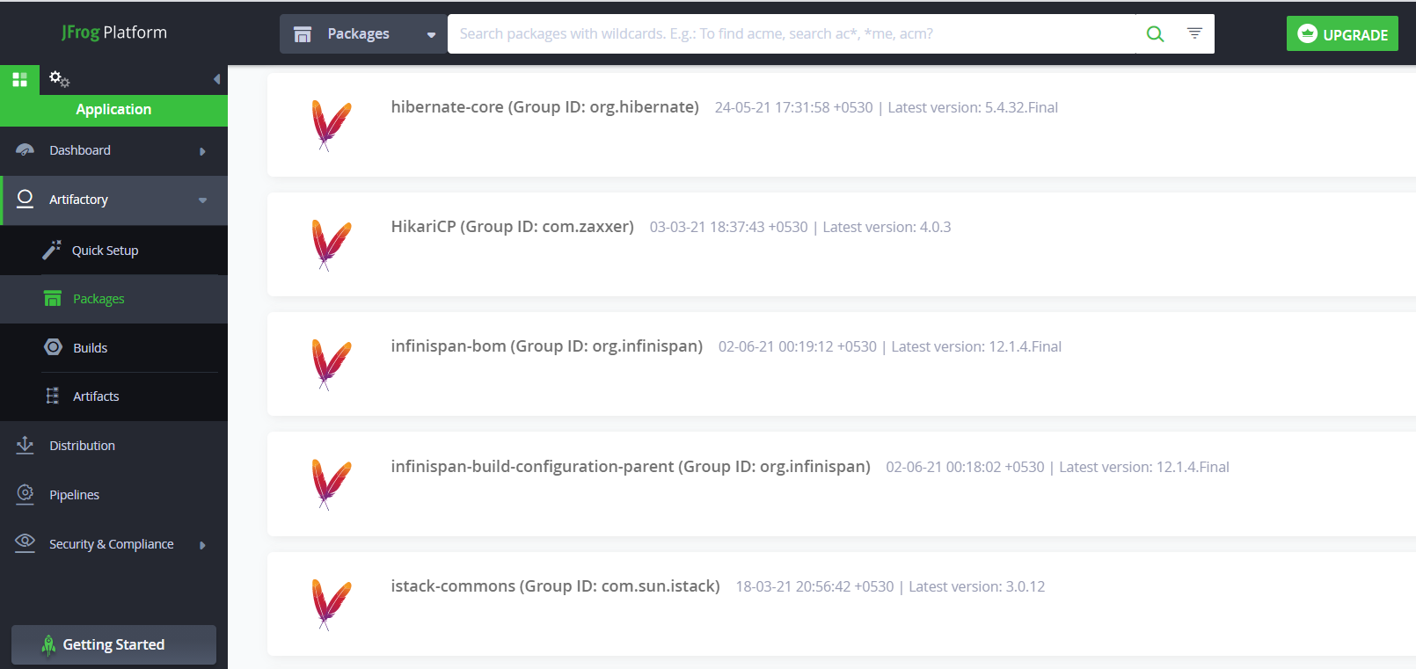

4.Docker Image Push to Docker HUB

First, create a environment to save docker image informations.

dockerImage = ''

Change the build stage to save build information in environment.

dockerImage = docker.build registry + ":$BUILD\_NUMBER"

**pipeline** {

**environment** {

registry = "smlcodes/docker-employeeservices"

registryCredential = 'docker-creds'

dockerImage = ''

}

**agent** *any*

**tools** {

*jdk* 'Java8'

*maven* 'Maven'

}

**stages** {

**stage**('Clone') {

**steps** {

git branch: 'main',

credentialsId: 'github-creds',

url: 'https://github.com/smlcodes/docker-springboot-employeeservices.git'

}

}

/\*

Artifactory-1 - similarly like Globol tool configuration.

But we are configured manually, passed as ServerID

rtMavenResolver - To get Jars of Pom.xml

rtMavenDeployer - To Deploy Newly created jars on Build

\*/

**stage**('Artifactory Configuration') {

**steps** {

rtServer(

*id*: 'Artifactory-1',

url: "https://satyajohnny.jfrog.io/artifactory",

credentialsId: "jfrog-creds"

)

rtMavenResolver(

*id*: 'maven-resolver',

serverId: 'Artifactory-1',

releaseRepo: 'libs-release-libs-release',

snapshotRepo: 'libs-release-libs-snapshot'

)

rtMavenDeployer(

*id*: 'maven-deployer',

serverId: 'Artifactory-1',

releaseRepo: 'libs-release-libs-release-local',

snapshotRepo: 'libs-release-libs-snapshot-local',

threads: 6

)

}

}

**stage**('Build Maven Project') {

**steps** {

rtMavenRun(

tool: 'Maven',

pom: 'pom.xml',

goals: '-U clean install',

deployerId: "maven-deployer",

resolverId: "maven-resolver"

)

}

}

**stage**('Build Docker Image') {

**steps** {

*echo* "\n \n \n \n \*\*\*\*\*\*\*\*\*\*\*\*\*\*\*\*\*\*\*\*\*\*\*\*\*\*\*\*\*\*\*\*\*\*\*\*\*\*\*"

*echo* " Build Docker Image"

*echo* "\*\*\*\*\*\*\*\*\*\*\*\*\*\*\*\*\*\*\*\*\*\*\*\*\*\*\*\*\*\*\*\*\*\*\*\*\*\*\*\n \n \n"

**script** {

**docker**.build("satyajohnny.jfrog.io/" + "docker-employeeservices:2.0.${env.BUILD\_NUMBER}")

dockerImage = **docker**.build registry + ":$BUILD\_NUMBER"

}

}

}

**stage**('Push Image to DockerHub') {

**steps** {

**script** {

*echo* "\n \n \n \n \*\*\*\*\*\*\*\*\*\*\*\*\*\*\*\*\*\*\*\*\*\*\*\*\*\*\*\*\*\*\*\*\*\*\*\*\*\*\*"

*echo* " Push Image to DockerHub"

*echo* "\*\*\*\*\*\*\*\*\*\*\*\*\*\*\*\*\*\*\*\*\*\*\*\*\*\*\*\*\*\*\*\*\*\n \n \n"

**docker**.withRegistry('', registryCredential) {

dockerImage.push()

}

}

}

}

} //Stages End

} //Pipeline End

Ref. <https://medium.com/@gustavo.guss/jenkins-building-docker-image-and-sending-to-registry-64b84ea45ee9>

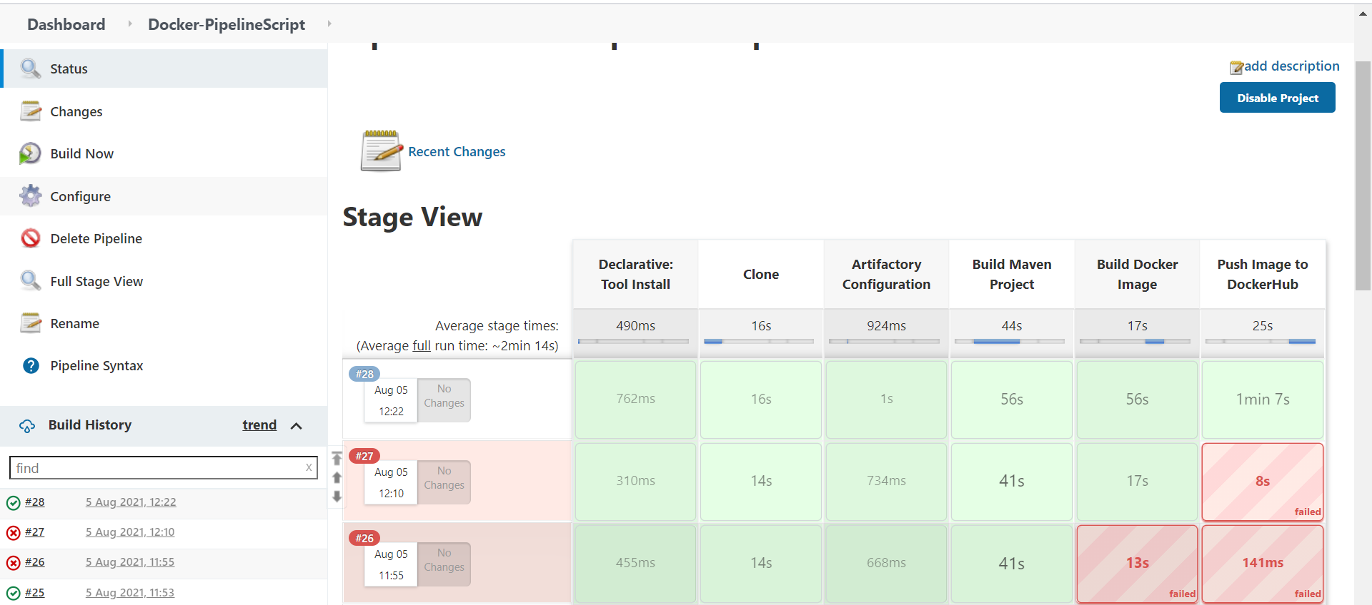

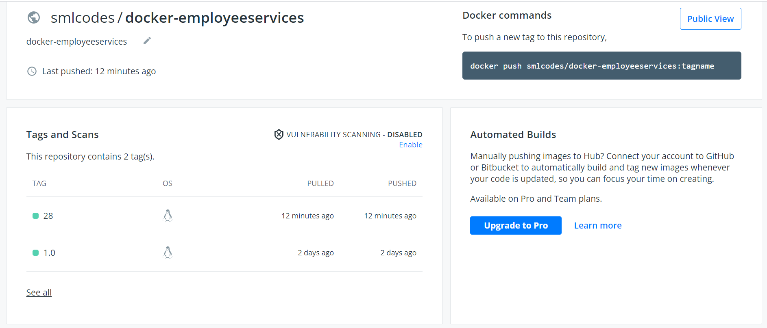

4.Docker Image Push to Azure Container Registery

To Quick start Azure Container Registery follow

<https://docs.microsoft.com/en-us/azure/container-registry/container-registry-get-started-portal>

Select **Create a resource** > **Containers** > **Container Registry**. 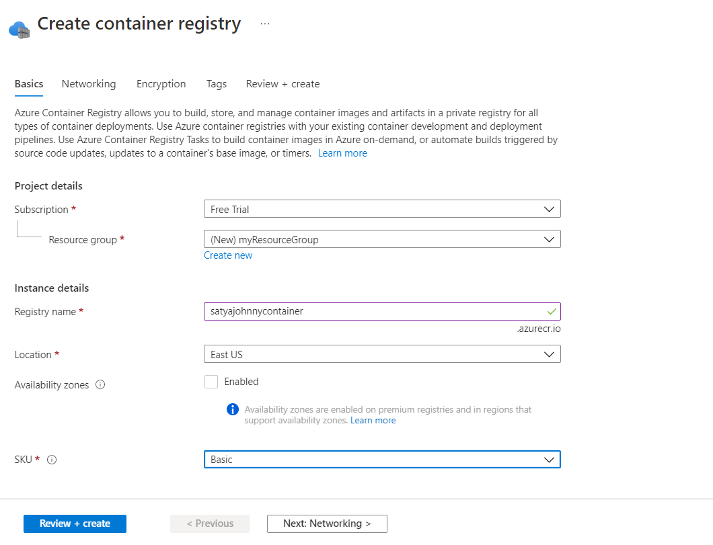

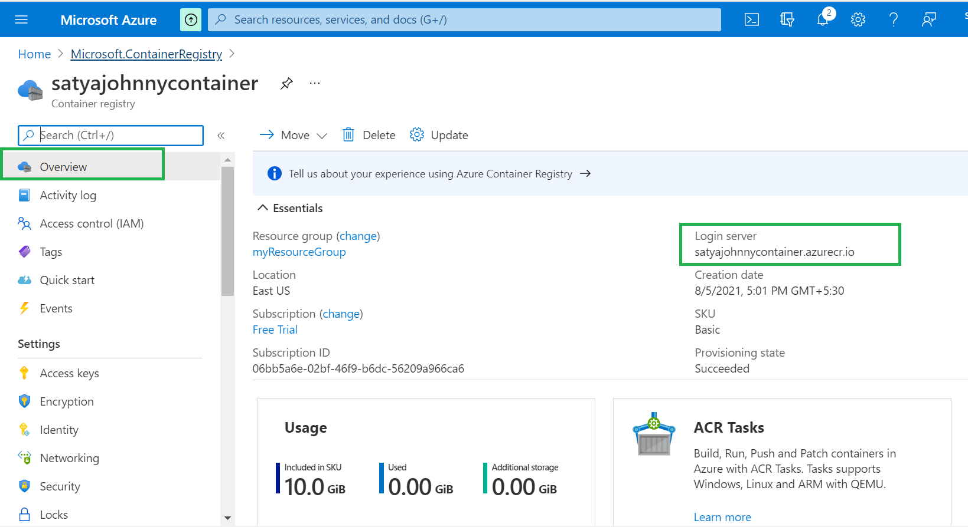

Go to Access Keys in Container Registry and enable the admin user, then use the autogenerated credentials to login via Docker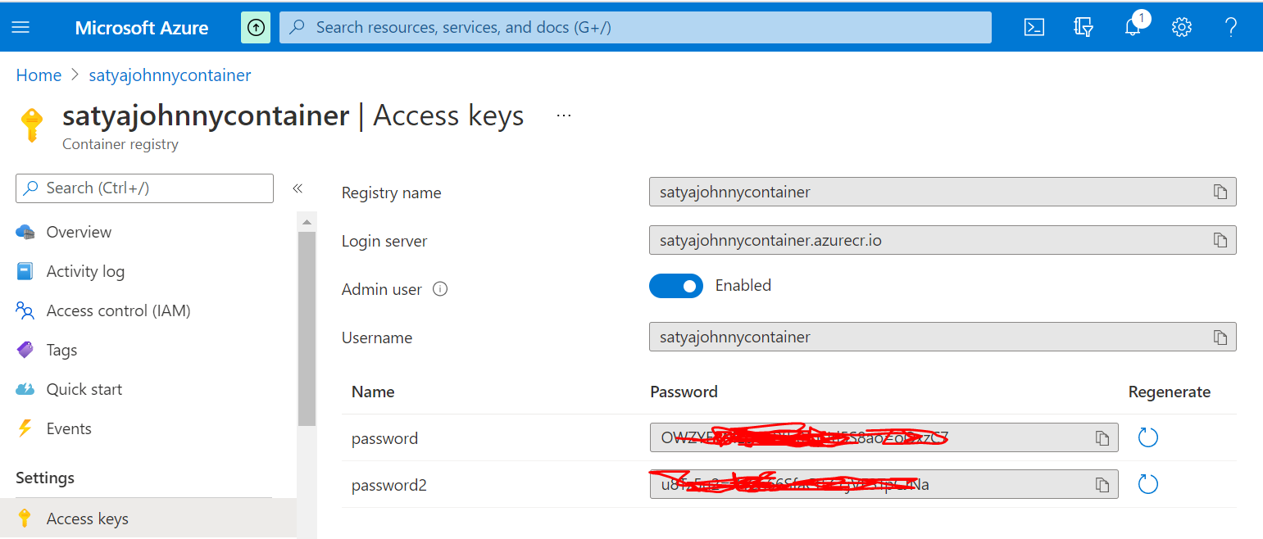

Configure these credencials in Jenkins with name 'azurecontainer-creds'

**pipeline** {

**environment** {

dockerregistry = "smlcodes/docker-employeeservices"

dockercreds = 'docker-creds'

dockerHubImage = ''

//Go to Access Keys in Container Registry and enable the admin user, then use the autogenerated credentials to login via Docker

azureregistry = "satyajohnnycontainer.azurecr.io"

azurecreds = 'azurecontainer-creds'

azureImage = ''

}

**agent** *any*

**tools** {

*jdk* 'Java8'

*maven* 'Maven'

}

**stages** {

**stage**('Clone') {

**steps** {

git branch: 'main',

credentialsId: 'github-creds',

url: 'https://github.com/smlcodes/docker-springboot-employeeservices.git'

}

}

**stage**('Artifactory Configuration') {

**steps** {

rtServer(

*id*: 'Artifactory-1',

url: "https://satyajohnny.jfrog.io/artifactory",

credentialsId: "jfrog-creds"

)

rtMavenResolver(

*id*: 'maven-resolver',

serverId: 'Artifactory-1',

releaseRepo: 'libs-release-libs-release',

snapshotRepo: 'libs-release-libs-snapshot'

)

rtMavenDeployer(

*id*: 'maven-deployer',

serverId: 'Artifactory-1',

releaseRepo: 'libs-release-libs-release-local',

snapshotRepo: 'libs-release-libs-snapshot-local',

threads: 6

)

}

}

**stage**('Build Maven Project') {

**steps** {

rtMavenRun(

tool: 'Maven',

pom: 'pom.xml',

goals: '-U clean install',

deployerId: "maven-deployer",

resolverId: "maven-resolver"

)

}

}

**stage**('Build Docker Image') {

**steps** {

**script** {

azureImage = **docker**.build("satyajohnnycontainer.azurecr.io/" + "docker-employeeservices:2.0.${env.BUILD\_NUMBER}")

}

}

}

**stage**('Push Image to Azure Container Registry') {

**steps** {

**script** {

**docker**.withRegistry('https://satyajohnnycontainer.azurecr.io', azurecreds) {

azureImage.push()

}

}

}

}

**stage** ('Publish Build Info') {

**steps** {

rtPublishBuildInfo (

serverId: "Artifactory-1"

)

}

}

} //Stages End

} //Pipeline End

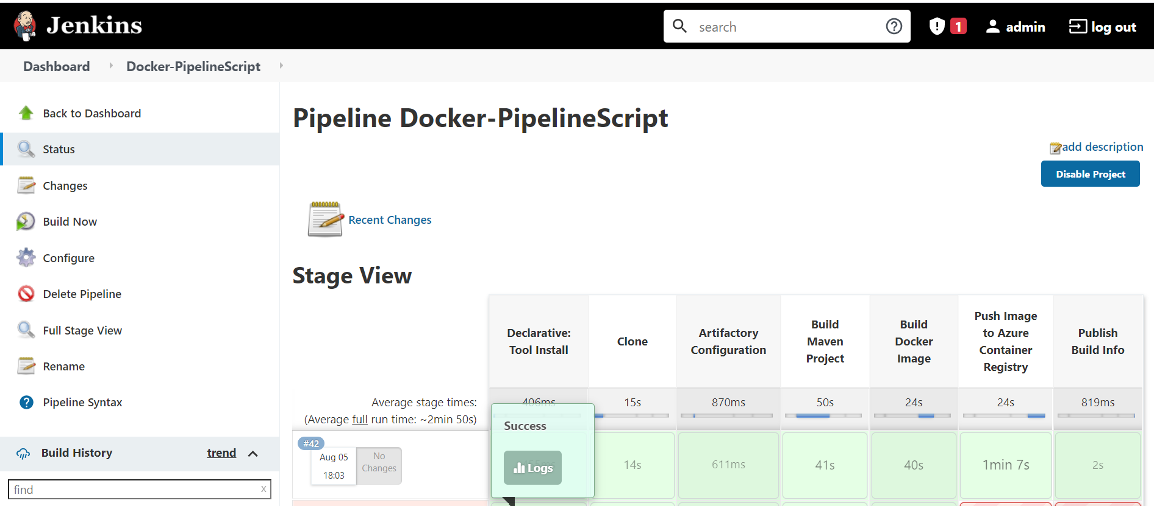

Now go to Azure Container Registery > Services > Repository , see Docker Image published

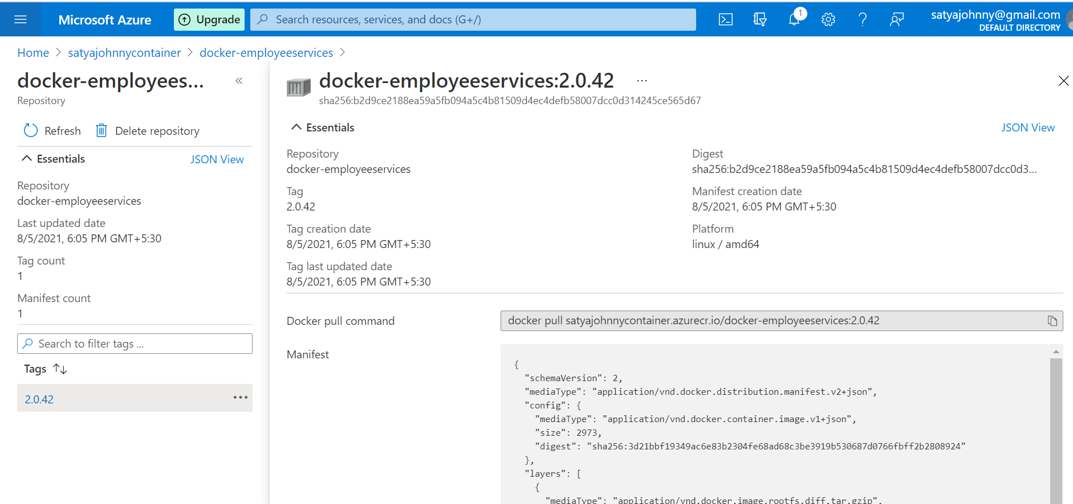

#Login

az acr login --name satyajohnnycontainer

#List images in registry

az acr repository list --name satyajohnnycontainer --output table

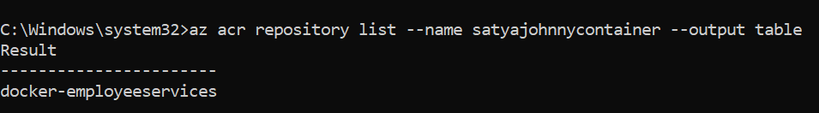

5.AKS – Azure Kuberneter Service

AKS is a managed Kubernetes service that lets you quickly deploy and manage clusters. We will see how to create AKS cluster in Azure cloud using Azure CLI.

**Pre-requistes:**

* Azure CLI is installed on your local machine.
* Account setup in Azure.

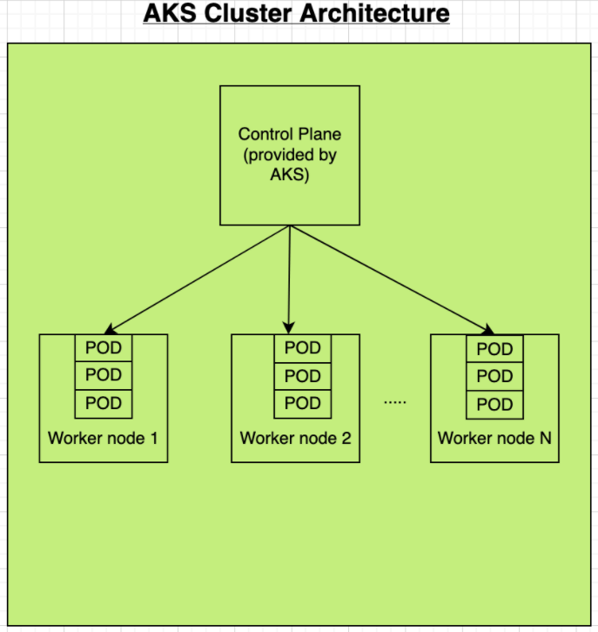

#### Create Azure Container Registry

#Login to Azure

**az login**

#Create a resource group first.

az group create --name **myResourceGroup** --location eastus

Run the below command to create your own private container registry using **Azure Container Registry**

az acr create --resource-group myResourceGroup --name **satyajohnnycontainer** --sku Standard --location eastus

**Create AKS cluster with 2 worker nodes**

**Create AKS cluster with 2 worker nodes**

az aks create --resource-group myResourceGroup --name satyajohnnyAKSCluster **--node-count 2** --enable-addons monitoring --generate-ssh-keys

C:\Windows\system32>az aks create **--resource-group myResourceGroup --name** satyajohnnyAKSCluster **--node-count 2 --enable-addons monitoring --generate-ssh-keys**

SSH key files 'C:\Users\kavetis\.ssh\id\_rsa' and 'C:\Users\kavetis\.ssh\id\_rsa.pub' have been generated under ~/.ssh to allow SSH access to the VM. If using machines without permanent storage like Azure Cloud Shell without an attached file share, back up your keys to a safe location

Resource provider 'Microsoft.OperationalInsights' used by this operation is not registered. We are registering for you.

Once Above cmd run completes, we can see many no. of services are created which are required by AKS. 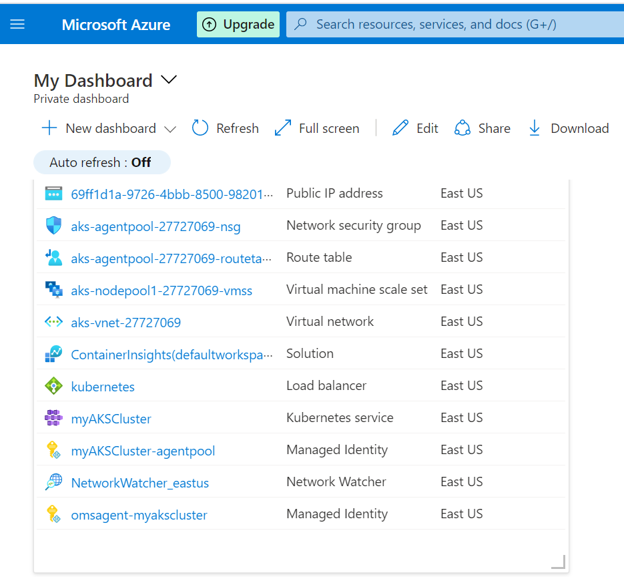

We can see 2 Nodes inside AKS Cluster 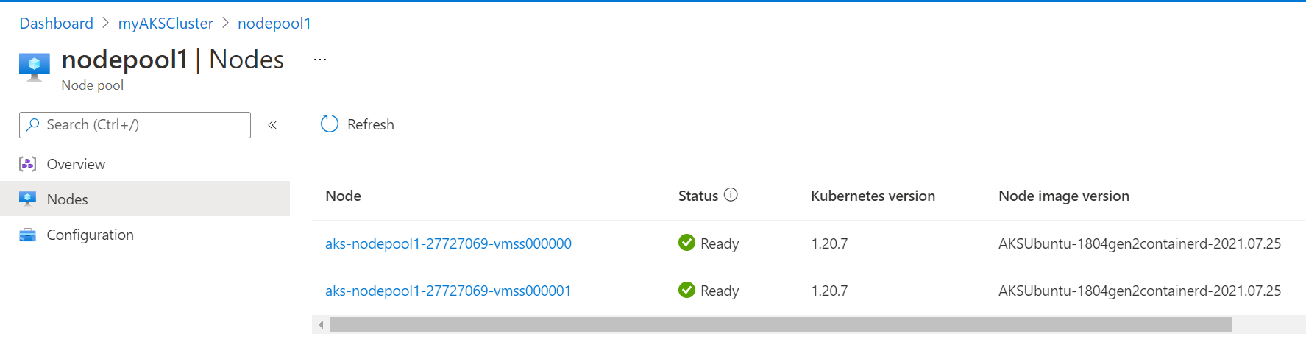

#### Connect to the cluster

az aks get-credentials --resource-group myResourceGroup --name satyajohnnyAKSCluster --overwrite-existing

To verify the connection to your cluster, use the [kubectl get](https://kubernetes.io/docs/reference/generated/kubectl/kubectl-commands" \l "get) command to return a list of the cluster nodes.

kubectl get nodes

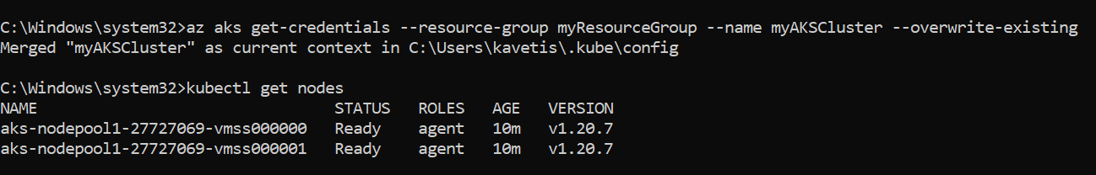

# List all deployments in a specific namespace

kubectl get deployments --all-namespaces=true

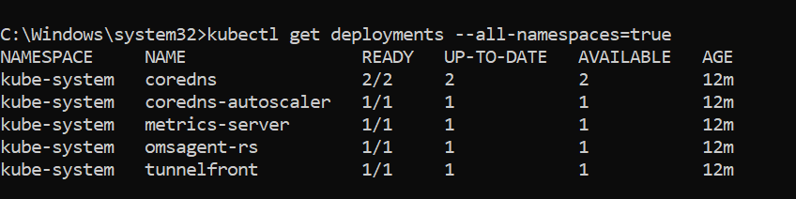

#### Update Jenkins Pipeline

**pipeline** {

**agent** *any*

**environment** {

registry = "smlcodes/docker-employeeservices"

registryCredential = 'docker-creds'

dockerImage = ''

}

**stages** {

**stage**('checkout') {

**steps** {

git branch: 'main',

credentialsId: 'github-creds',

url: 'https://github.com/smlcodes/docker-springboot-employeeservices.git'

}

}

**stage**('Artifactory Configuration') {

**steps** {

rtServer(

*id*: 'Artifactory-1',

url: "https://satyajohnny.jfrog.io/artifactory",

credentialsId: "jfrog-creds"

)

rtMavenResolver(

*id*: 'maven-resolver',

serverId: 'Artifactory-1',

releaseRepo: 'libs-release-libs-release',

snapshotRepo: 'libs-release-libs-snapshot'

)

rtMavenDeployer(

*id*: 'maven-deployer',

serverId: 'Artifactory-1',

releaseRepo: 'libs-release-libs-release-local',

snapshotRepo: 'libs-release-libs-snapshot-local',

threads: 6

)

}

}

**stage**('Build Maven Project') {

**steps** {

rtMavenRun(

tool: 'Maven',

pom: 'pom.xml',

goals: '-U clean install',

deployerId: "maven-deployer",

resolverId: "maven-resolver"

)

}

}

**stage**('Build Docker image') {

**steps** {

**script** {

dockerImage = **docker**.build registry + ":$BUILD\_NUMBER"

}

}

}

// Uploading Docker images into Docker Hub

**stage**('Upload Image to Docker HUB') {

**steps** {

**script** {

**docker**.withRegistry('', registryCredential) {

dockerImage.push()

dockerImage.push('latest')

}

}

}

}

**stage**('Remove Unused docker image') {

**steps** {

*bat* "docker rmi $registry:$BUILD\_NUMBER"

}

}

**stage**('K8S Deploy') {

**steps** {

**script** {

kubernetesDeploy(

configs: 'Kubernetes.yaml',

kubeconfigId: 'aks-creds',

enableConfigSubstitution: **true**

)

}

}

}

}

}

**always** {

// remove built docker image and prune system

print 'Cleaning up the Docker system.'

*bat* 'docker system prune -f'

}

Kubernetes.yaml – For Docker HUB

apiVersion: apps/v1

kind: Deployment

metadata:

name: docker-employeeservices-manual

spec:

replicas: 2

selector:

matchLabels:

app: docker-employeeservices-manual

template:

metadata:

labels:

app: docker-employeeservices-manual

spec:

containers:

- name: docker-employeeservices-manual

image: smlcodes/docker-employeeservices

# image: wingtiptoysregistry.azurecr.io/gs-spring-boot-docker:latest

---

apiVersion: v1

kind: Service

metadata:

name: docker-employeeservices-manual-service

spec:

type: LoadBalancer

ports:

- port: 80

targetPort: 8080

selector:

app: docker-employeeservices-manual

Build Pipleline

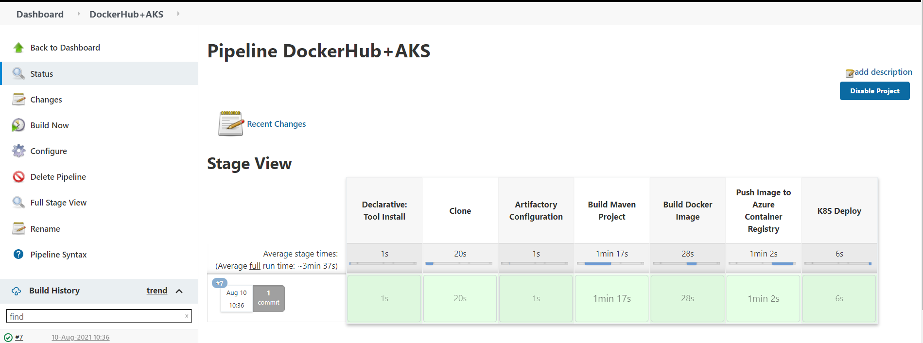

Build Is Success, But if you see AKS Cluster it is unable to Pull the Image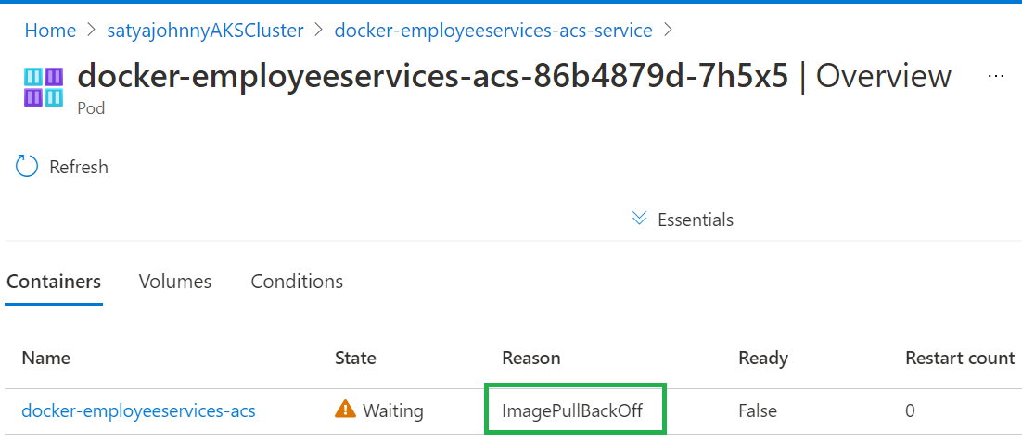

Here we can see that AKS is not able to pull image from ACR. Let’s describe the pod and look for more information.

**kubectl get pods**

docker-employeeservices-acs-86b4879d-7h5x5 0/1 **ImagePullBackOff** 0 16h

docker-employeeservices-acs-86b4879d-b4zc2 0/1 **ImagePullBackOff** 0 16h

kubectl describe pods **docker-employeeservices-acs-86b4879d-7h5x5** 

Here the Problem is ACS & AKS Integration. For that we need to run below command

az aks update -n myAKSCluster -g myResourceGroup --attach-acr <acr-name>

az aks update -n satyajohnnyAKSCluster -g myResourceGroup --attach-acr satyajohnnycontainer

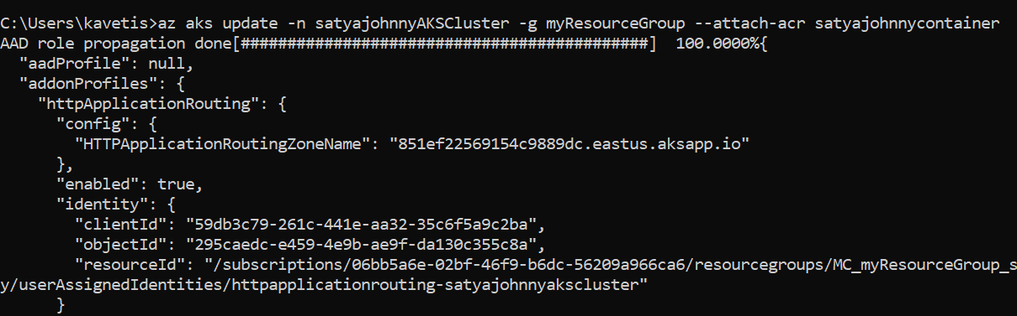

When we attach ACR to AKS, it actually grants the ‘acrpull’ role assignment to ACR specified by name or resource ID. Check Integarion Status

az aks check-acr --name satyajohnnyAKSCluster --resource-group myResourceGroup --acr satyajohnnycontainer.azurecr.io

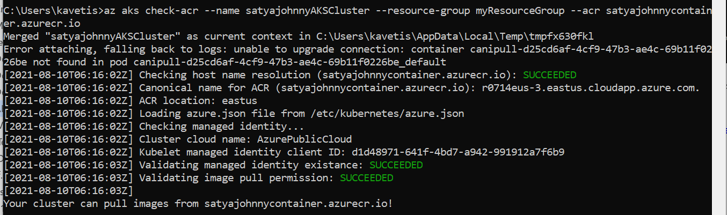

Re-Run Pipeline Again.

6. Verify deployments to K8S

kubectl get pods

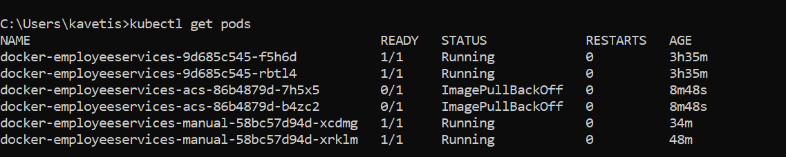

kubectl get deployments

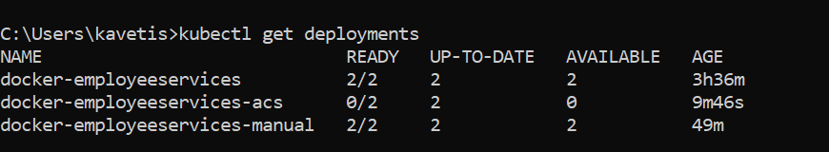

kubectl get services

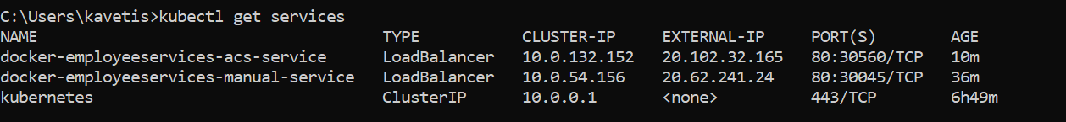

Here **External-IP** is the Public IP Where we can access Our Application.

You can also get from UI, Go to AKS Portal in below Image

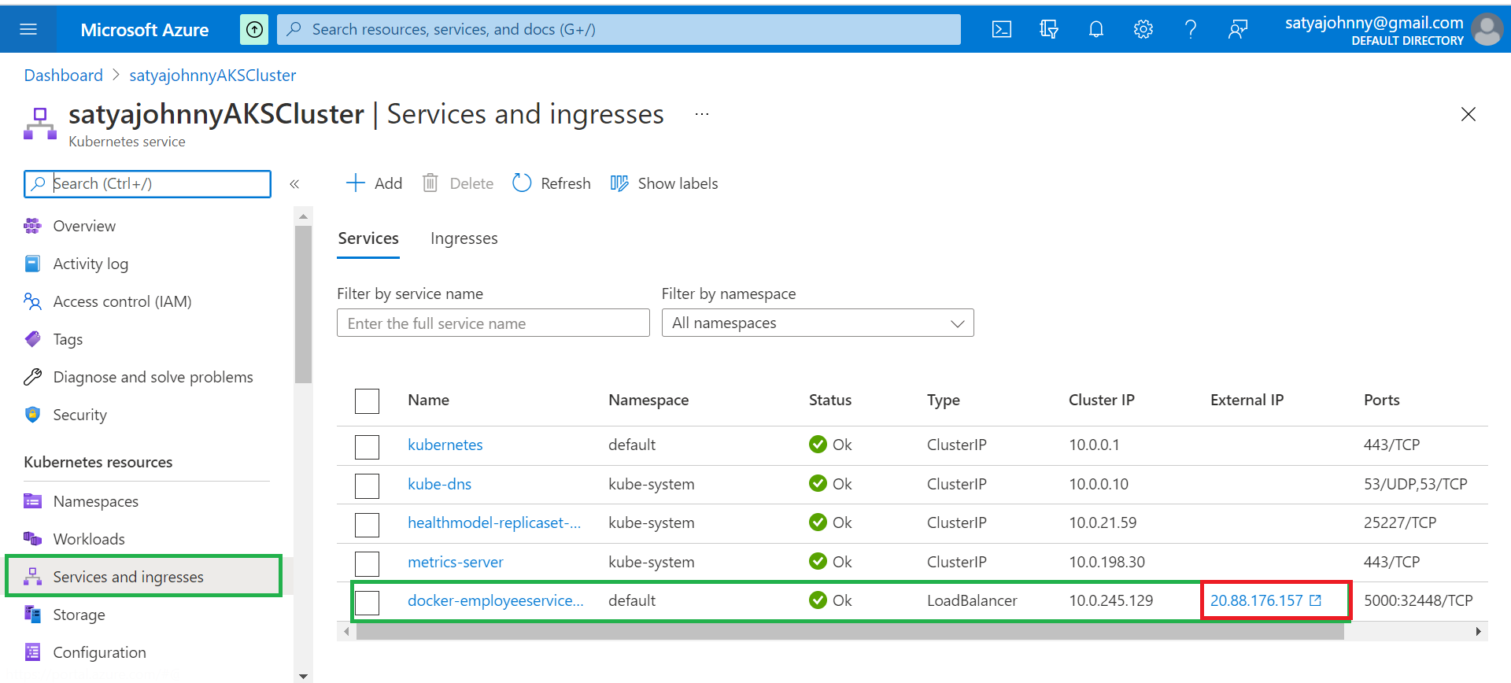

Check Pods are Running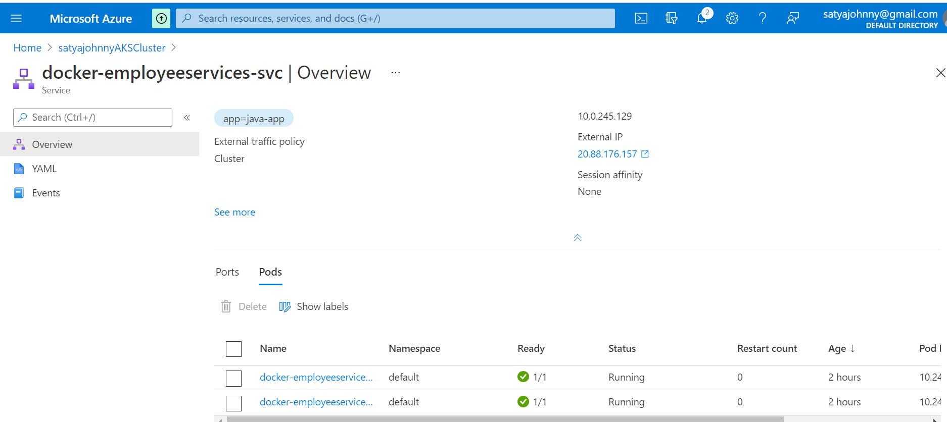

open public IP **without port**

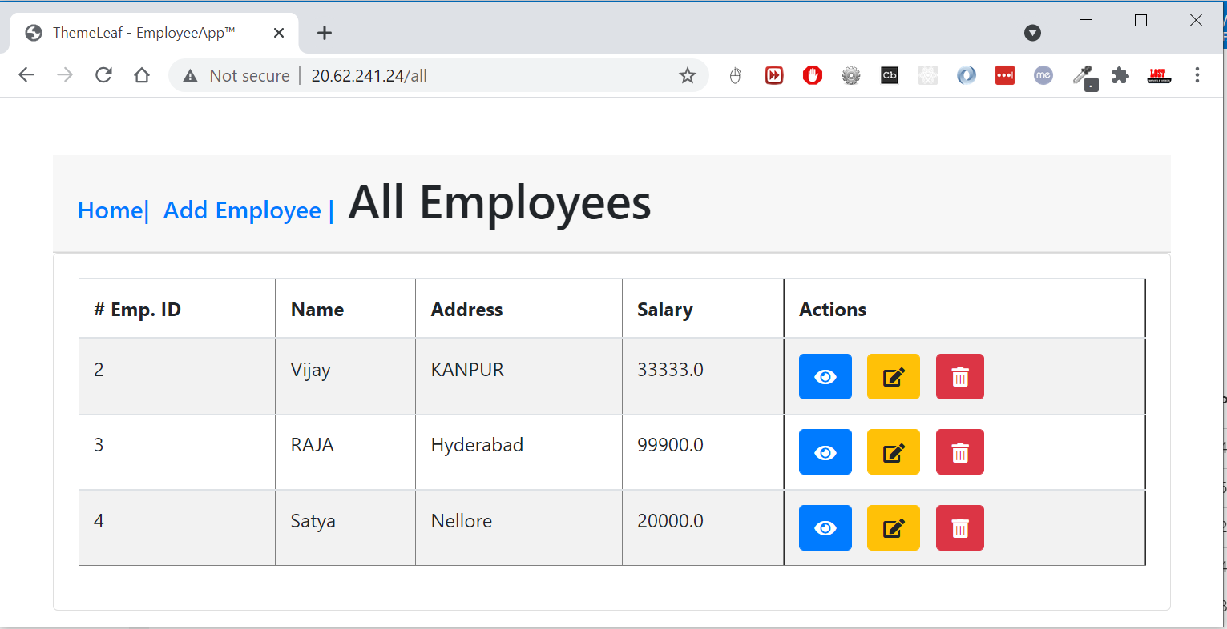

8. Final Working Pipeline Code

Dockerfile

# Image based on JAVA Container

FROM openjdk:8-jdk-alpine

ARG JAR\_FILE=target/\*.jar

COPY ${JAR\_FILE} Docker-EmployeeServices-2.0.jar

EXPOSE 8080

ENTRYPOINT ["java","-jar","/Docker-EmployeeServices-2.0.jar"]

Jenkinsfile

**pipeline** {

**environment** {

dockerregistry = "smlcodes/docker-employeeservices"

dockercreds = 'docker-creds'

dockerHubImage = ''

//Go to Access Keys in Container Registry and enable the admin user, then use the autogenerated credentials to login via Docker

azureregistry = "satyajohnnycontainer.azurecr.io"

azurecreds = 'azurecontainer-creds'

azureImage = ''

}

**agent** *any*

**tools** {

//Java, Maven Configured in Globol tools configuration. and here the names we provided for configuration

*jdk* 'Java8'

*maven* 'Maven'

}

**stages** {

**stage**('Clone') {

**steps** {

//github-creds are github login creds, configured in Credencial Manager

git branch: 'main',

credentialsId: 'github-creds',

url: 'https://github.com/smlcodes/docker-springboot-employeeservices.git'

}

}

/\*

Artifactory-1 - similarly like Globol tool configuration.

But we are configured manually, passed as ServerID

rtMavenResolver - To get Jars of Pom.xml

rtMavenDeployer - To Deploy Newly created jars on Build

\*/

**stage**('Artifactory Configuration') {

**steps** {

rtServer(

*id*: 'Artifactory-1',

url: "https://satyajohnny.jfrog.io/artifactory",

credentialsId: "jfrog-creds"

)

rtMavenResolver(

*id*: 'maven-resolver',

serverId: 'Artifactory-1',

releaseRepo: 'libs-release-libs-release',

snapshotRepo: 'libs-release-libs-snapshot'

)

rtMavenDeployer(

*id*: 'maven-deployer',

serverId: 'Artifactory-1',

releaseRepo: 'libs-release-libs-release-local',

snapshotRepo: 'libs-release-libs-snapshot-local',

threads: 6

)

}

}

**stage**('Build Maven Project') {

**steps** {

rtMavenRun(

tool: 'Maven',

pom: 'pom.xml',

goals: '-U clean install',

deployerId: "maven-deployer",

resolverId: "maven-resolver"

)

}

}

**stage**('Build Docker Image') {

**steps** {

*echo* "\n \n \n \n \*\*\*\*\*\*\*\*\*\*\*\*\*\*\*\*\*\*\*\*\*\*\*\*\*\*\*\*\*\*\*\*\*\*\*\*\*\*\*\*\*\*\*\*\*\*\*\*\*\*\*\*\*\*\*\*\*\*\*\*\*\*\*\*\*\*\*\*\*\*\*\*\*\*\*\*\*\*"

*echo* " Build Docker Image"

*echo* "\*\*\*\*\*\*\*\*\*\*\*\*\*\*\*\*\*\*\*\*\*\*\*\*\*\*\*\*\*\*\*\*\*\*\*\*\*\*\*\*\*\*\*\*\*\*\*\*\*\*\*\*\*\*\*\*\*\*\*\*\*\*\*\*\*\*\*\*\*\*\*\*\*\*\*\*\*\*\n \n \n"

**script** {

//docker.build("satyajohnny.jfrog.io/" + "docker-employeeservices:2.0.${env.BUILD\_NUMBER}")

dockerHubImage = **docker**.build dockerregistry + ":$BUILD\_NUMBER"

azureImage = **docker**.build("satyajohnnycontainer.azurecr.io/" + "docker-employeeservices:${env.BUILD\_NUMBER}")

}

}

}

**stage**('Push Image to Azure Container Registry') {

**steps** {

**script** {

*echo* "\n \n \n \n \*\*\*\*\*\*\*\*\*\*\*\*\*\*\*\*\*\*\*\*\*\*\*\*\*\*\*\*\*\*\*\*\*\*\*\*\*\*\*\*\*\*\*\*\*\*\*\*\*\*\*\*\*\*\*\*\*\*\*\*\*\*\*\*\*\*\*\*\*\*\*\*\*\*\*\*\*\*"

*echo* " Push Image to Azure Container Registry"

*echo* "\*\*\*\*\*\*\*\*\*\*\*\*\*\*\*\*\*\*\*\*\*\*\*\*\*\*\*\*\*\*\*\*\*\*\*\*\*\*\*\*\*\*\*\*\*\*\*\*\*\*\*\*\*\*\*\*\*\*\*\*\*\*\*\*\*\*\*\*\*\*\*\*\*\*\*\*\*\*\n \n \n"

**docker**.withRegistry('https://satyajohnnycontainer.azurecr.io', azurecreds) {

azureImage.push()

azureImage.push('latest')

}

}

}

}

// Uploading Docker images into Docker Hub

**stage**('Push Image to Docker HUB') {

**steps** {

**script** {

**docker**.withRegistry('', dockercreds) {

dockerHubImage.push()

dockerHubImage.push('latest')

}

}

}

}

**stage**('Remove Unused docker image') {

**steps** {

*bat* "docker rmi $dockerregistry:$BUILD\_NUMBER"

}

}

// Deploy To Azure Kubernetes Cluster

**stage**('K8S Deploy') {

**steps** {

**script** {

kubernetesDeploy(

configs: 'Kubernetes.yaml',

kubeconfigId: 'aks-creds',

enableConfigSubstitution: **true**

)

}

}

}

/\*

Push Image to Artfifactory Not Woking

serverId : Configred Artfifactory Server Name

host : docker daemon host where Docker currenlty running system/localhost

targetRepo : Repo name in Artfifactory

\*/

/\*

stage ('Push Image to Artifactory') {

steps {

echo "\n \n \n \n \*\*\*\*\*\*\*\*\*\*\*\*\*\*\*\*\*\*\*\*\*\*\*\*\*\*\*\*\*\*\*\*\*\*\*\*\*\*\*\*\*\*\*\*\*\*\*\*\*\*\*\*\*\*\*\*\*\*\*\*\*\*\*\*\*\*\*\*\*\*\*\*\*\*\*\*\*\*"

echo " Not Working on LocalHost : Push Docker Image to Artifactory"

echo "\*\*\*\*\*\*\*\*\*\*\*\*\*\*\*\*\*\*\*\*\*\*\*\*\*\*\*\*\*\*\*\*\*\*\*\*\*\*\*\*\*\*\*\*\*\*\*\*\*\*\*\*\*\*\*\*\*\*\*\*\*\*\*\*\*\*\*\*\*\*\*\*\*\*\*\*\*\*\n \n \n"

rtDockerPush(

serverId: "Artifactory-1",

image: "satyajohnny.jfrog.io/" + "docker-employeeservices:2.0.${env.BUILD\_NUMBER}",

host: 'tcp://thedockerhost:2375/',

targetRepo: 'jenkins-docker-images',

properties: 'project-name=docker-employeeservices:2.0;status=stable'

)

}

}

\*/

/\*

stage('Push Image to DockerHub') {

steps {

script {

echo "\n \n \n \n \*\*\*\*\*\*\*\*\*\*\*\*\*\*\*\*\*\*\*\*\*\*\*\*\*\*\*\*\*\*\*\*\*\*\*\*\*\*\*\*\*\*\*\*\*\*\*\*\*\*\*\*\*\*\*\*\*\*\*\*\*\*\*\*\*\*\*\*\*\*\*\*\*\*\*\*\*\*"

echo " Working - Push Image to DockerHub"

echo "\*\*\*\*\*\*\*\*\*\*\*\*\*\*\*\*\*\*\*\*\*\*\*\*\*\*\*\*\*\*\*\*\*\*\*\*\*\*\*\*\*\*\*\*\*\*\*\*\*\*\*\*\*\*\*\*\*\*\*\*\*\*\*\*\*\*\*\*\*\*\*\*\*\*\*\*\*\*\n \n \n"

docker.withRegistry('', dockercreds) {

dockerHubImage.push()

}

}

}

}

\*/

} //Stages End

} //Pipeline End

**always** {

// remove built docker image and prune system

print 'Cleaning up the Docker system.'

*bat* 'docker system prune -f'

}

Kubernetes.yaml

apiVersion: apps/v1

kind: Deployment

metadata:

name: docker-employeeservices-acs

spec:

replicas: 2

selector:

matchLabels:

app: docker-employeeservices-acs

template:

metadata:

labels:

app: docker-employeeservices-acs

spec:

containers:

- name: docker-employeeservices-acs

image: satyajohnnycontainer.azurecr.io/docker-employeeservices:latest

#image: smlcodes/docker-employeeservices

---

apiVersion: v1

kind: Service

metadata:

name: docker-employeeservices-acs-service

spec:

type: LoadBalancer

ports:

- port: 80

targetPort: 8080

selector:

app: docker-employeeservices-acs

7. Delete Cluster

To avoid Azure charges, you should clean up unneeded resources. When the cluster is no longer needed, use the [az group delete](https://docs.microsoft.com/en-us/cli/azure/group" \l "az-group-delete) command to remove the resource group, container service, and all related resources.

az group delete --name myResourceGroup --yes --no-wait

Ref.

* <https://www.coachdevops.com/2020/06/deploy-python-app-into-kubernetes.html>
* <https://docs.microsoft.com/en-us/azure/mysql/quickstart-create-mysql-server-database-using-azure-portal>
* <https://reflectoring.io/spring-boot-docker/>
* <https://medium.com/swlh/build-a-docker-image-using-maven-and-spring-boot-58147045a400>
* <https://medium.com/@gustavo.guss/jenkins-building-docker-image-and-sending-to-registry-64b84ea45ee9>
* <https://docs.microsoft.com/en-us/azure/container-registry/container-registry-get-started-portal>
* <https://jfrog.com/blog/ci-cd-side-by-side-jenkins-and-jfrog-pipelines/>
* <https://www.jfrog.com/confluence/display/JFROG/Declarative+Pipeline+Syntax>
* <https://technology.amis.nl/languages/java-languages/jenkins-building-java-and-deploying-to-kubernetes/>
* <https://github.com/talitz/spring-petclinic-ci-cd-k8s-example/blob/master/Jenkinsfile>
* <https://dzone.com/articles/building-docker-images-to-docker-hub-using-jenkins>
* <https://stackoverflow.com/questions/58203820/jenkins-with-jfrog-artifactory-push-docker-images>
* <https://stackoverflow.com/questions/50022357/can-not-push-docker-image-to-artifactory-in-jenkins-pipeline-using-artifactory-p>
* <https://github.com/dumindarw/reactive-eventservice/blob/master/Jenkinsfile>
* <https://github.com/learnk8s/free-kubernetes>
* <https://docs.microsoft.com/en-us/azure/architecture/solution-ideas/articles/container-cicd-using-jenkins-and-kubernetes-on-azure-container-service>
* <https://ystatit.medium.com/azure-configure-acr-integration-for-existing-aks-cluster-c551c678fede>
* <https://github.com/dumindarw/reactive-eventservice/blob/master/Jenkinsfile>
* <https://github.com/learnk8s/free-kubernetes>
* <https://docs.microsoft.com/en-us/azure/architecture/solution-ideas/articles/container-cicd-using-jenkins-and-kubernetes-on-azure-container-service>

## Jenkins – Docker Image + Docker Hub + AKS (Azure Kubernetes Service)

#### 1. Install below Plugins

* Docker
* Docker pipeline
* Kubernetes Deploy plug-ins

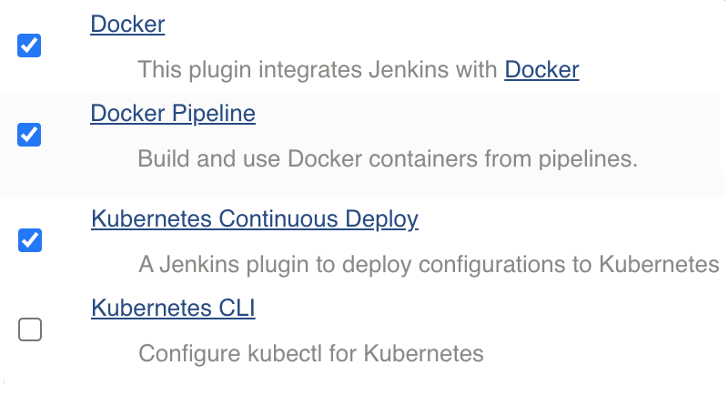

#### 2. Update Docker Hub credencials in Jenkins > Manage Credencials

#### 3. Update AKS Credencials in Jenkins

Go to C:\Users\<USER\_NAME>\.kube\config & Copy complete file contenet starting from apiVersion: v1

Go to Manage Credencilas > Add Credencials, In content – paste copied content from config file. 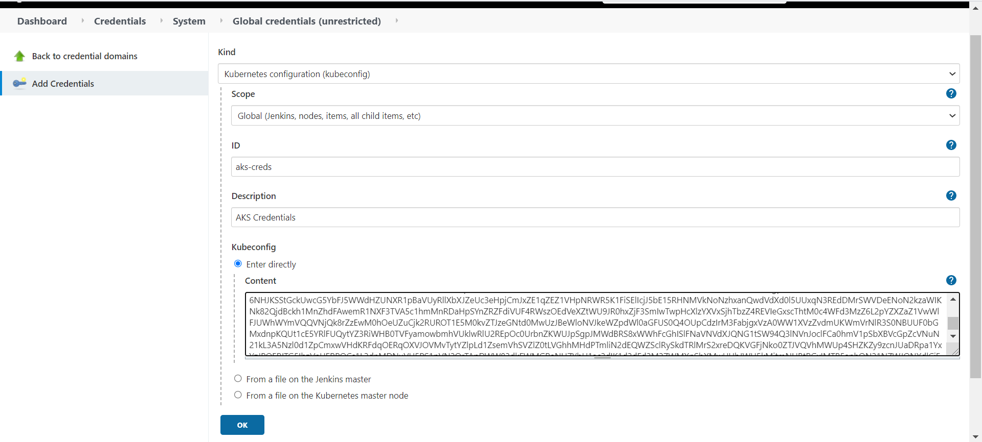

#### 4. Create Jenkins Pipeline

Create new Jenkns Item > Type as Pipleline 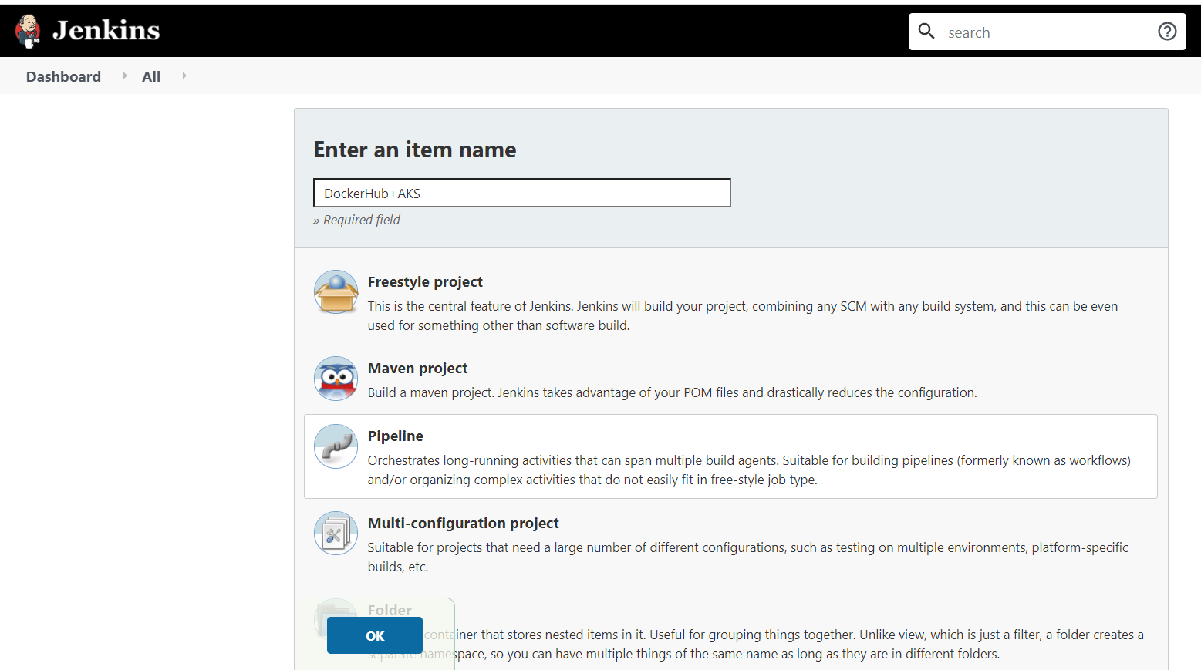

Update Pipleline Code : Jenkinsfile

**pipeline** {

**agent** *any*

**environment** {

//once you sign up for Docker hub, use that user\_id here

registry = "smlcodes/docker-employeeservices"

//- update your credentials ID after creating credentials for connecting to Docker Hub

registryCredential = 'docker-creds'

dockerImage = ''

}

**stages** {

**stage**('checkout') {

**steps** {

//github-creds are github login creds, configured in Credencial Manager

git branch: 'main',

credentialsId: 'github-creds',

url: 'https://github.com/smlcodes/docker-springboot-employeeservices.git'

}

}

**stage**('Artifactory Configuration') {

**steps** {

rtServer(

*id*: 'Artifactory-1',

url: "https://satyajohnny.jfrog.io/artifactory",

credentialsId: "jfrog-creds"

)

rtMavenResolver(

*id*: 'maven-resolver',

serverId: 'Artifactory-1',

releaseRepo: 'libs-release-libs-release',

snapshotRepo: 'libs-release-libs-snapshot'

)

rtMavenDeployer(

*id*: 'maven-deployer',

serverId: 'Artifactory-1',

releaseRepo: 'libs-release-libs-release-local',

snapshotRepo: 'libs-release-libs-snapshot-local',

threads: 6

)

}

}

**stage**('Build Maven Project') {

**steps** {

rtMavenRun(

tool: 'Maven',

pom: 'pom.xml',

goals: '-U clean install',

deployerId: "maven-deployer",

resolverId: "maven-resolver"

)

}

}

**stage**('Build Docker image') {

**steps** {

**script** {

dockerImage = **docker**.build registry + ":$BUILD\_NUMBER"

}

}

}

// Uploading Docker images into Docker Hub

**stage**('Upload Image to Docker HUB') {

**steps** {

**script** {

**docker**.withRegistry('', registryCredential) {

dockerImage.push()

dockerImage.push('latest')

}

}

}

}

**stage**('Remove Unused docker image') {

**steps** {

*bat* "docker rmi $registry:$BUILD\_NUMBER"

}

}

**stage**('K8S Deploy') {

**steps** {

**script** {

kubernetesDeploy(

configs: 'Kubernetes.yaml',

kubeconfigId: 'aks-creds',

enableConfigSubstitution: **true**

)

}

}

}

}

}

**always** {

// remove built docker image and prune system

print 'Cleaning up the Docker system.'

*bat* 'docker system prune -f'

}

Kubernetes.yaml

apiVersion: apps/v1

kind: Deployment

metadata:

name: docker-employeeservices-manual

spec:

replicas: 2

selector:

matchLabels:

app: docker-employeeservices-manual

template:

metadata:

labels:

app: docker-employeeservices-manual

spec:

containers:

- name: docker-employeeservices-manual

image: smlcodes/docker-employeeservices

# image: wingtiptoysregistry.azurecr.io/gs-spring-boot-docker:latest

---

apiVersion: v1

kind: Service

metadata:

name: docker-employeeservices-manual-service

spec:

type: LoadBalancer

ports:

- port: 80

targetPort: 8080

selector:

app: docker-employeeservices-manual

#### 5. Run Pipleline

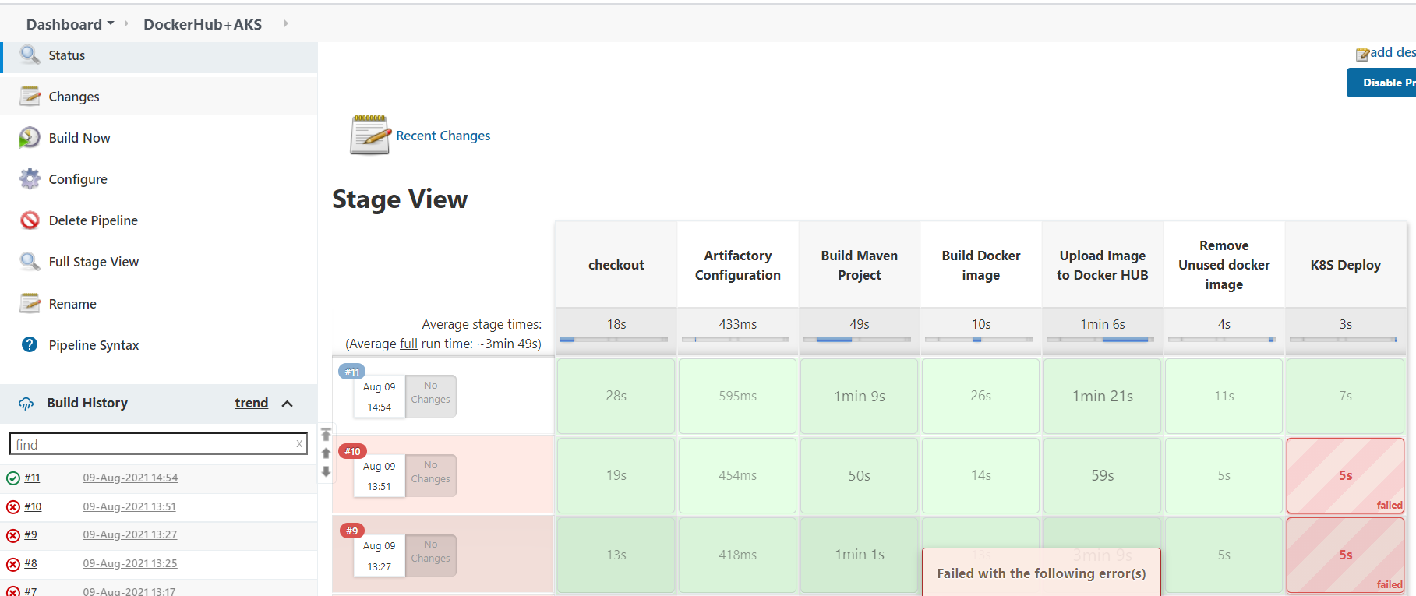

#### 6.Validate UI

We need Public IP of AKS cluster. Go to AKS Portal in below Image



Check Pods are Running

open public IP **without port**



## SpringBoot – Manually Deploy SpringBoot Image in AKS

1. Select **Add** from any of the resource views (Namespace, Workloads, Services and ingresses, Storage, or Configuration).

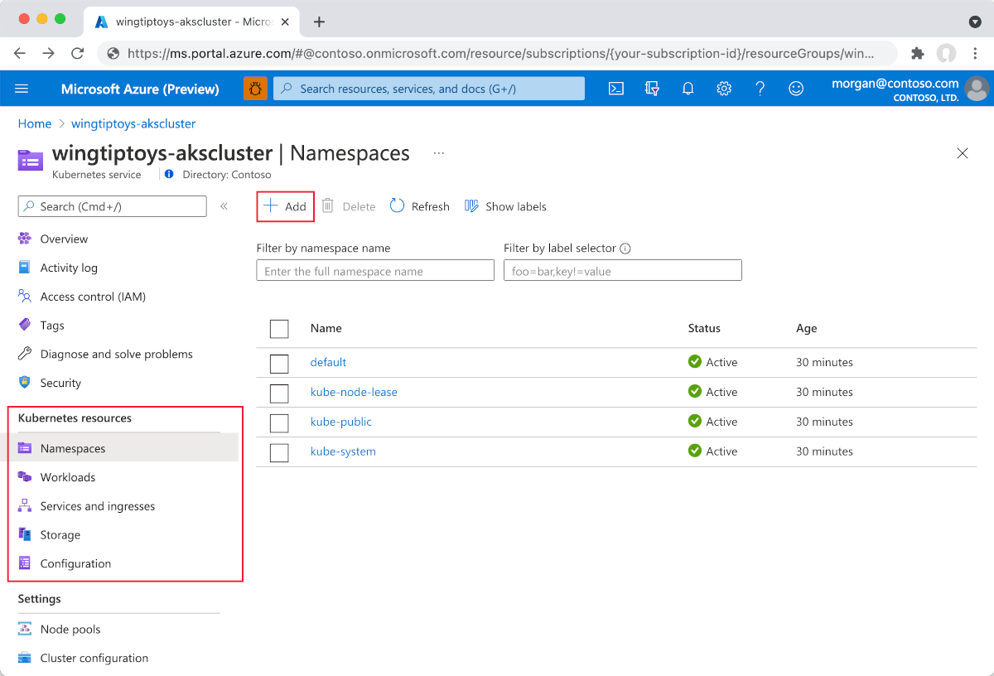

1. Paste in the following YAML:

apiVersion: apps/v1

kind: Deployment

metadata:

name: docker-employeeservices-manual

spec:

replicas: 1

selector:

matchLabels:

app: docker-employeeservices-manual

template:

metadata:

labels:

app: docker-employeeservices-manual

spec:

containers:

- name: docker-employeeservices-manual

image: smlcodes/docker-employeeservices

# image: wingtiptoysregistry.azurecr.io/gs-spring-boot-docker:latest

---

apiVersion: v1

kind: Service

metadata:

name: docker-employeeservices-manual-service

spec:

type: LoadBalancer

ports:

- port: 80

targetPort: 8080

selector:

app: docker-employeeservices-manual

1. Select **Add** at the bottom of the YAML editor to deploy the application.

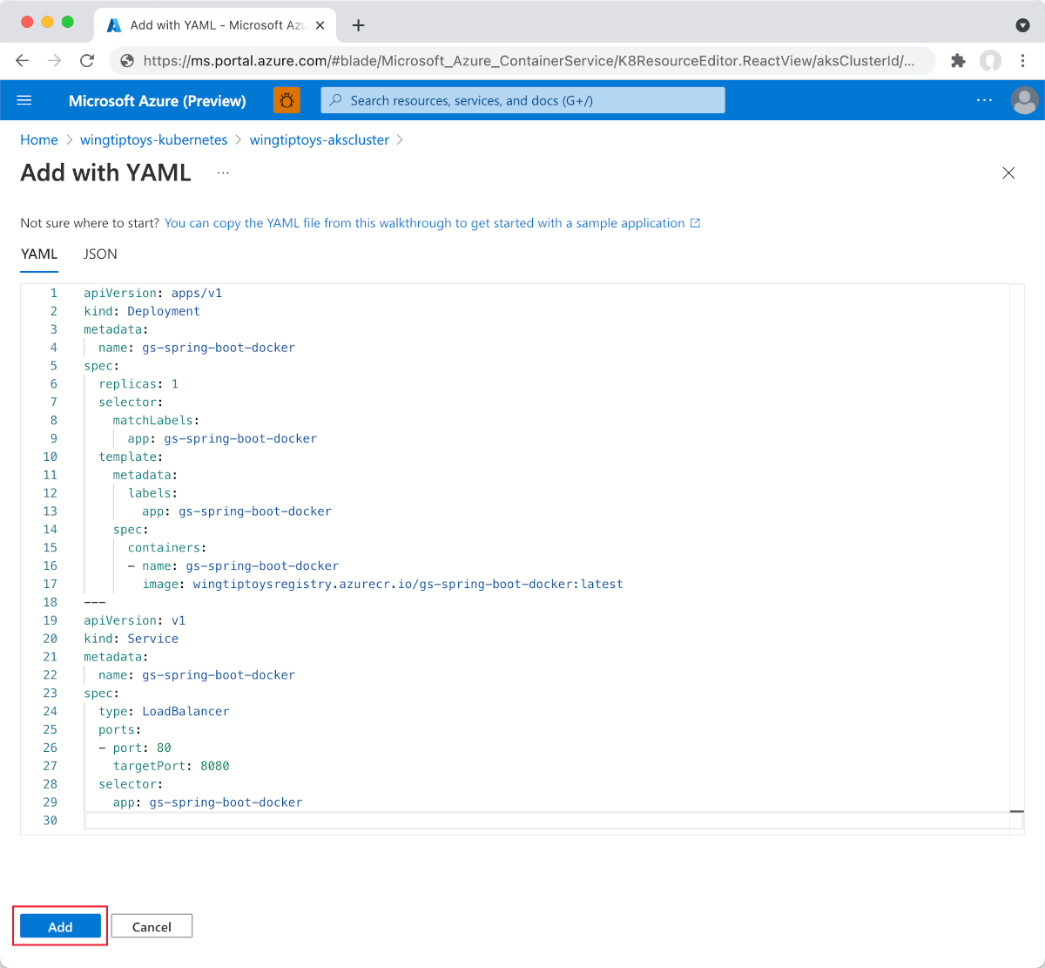

1. Once the YAML file is added, the resource viewer shows your Spring Boot application. The external service includes a linked external IP address so you can easily view the application in your browser.

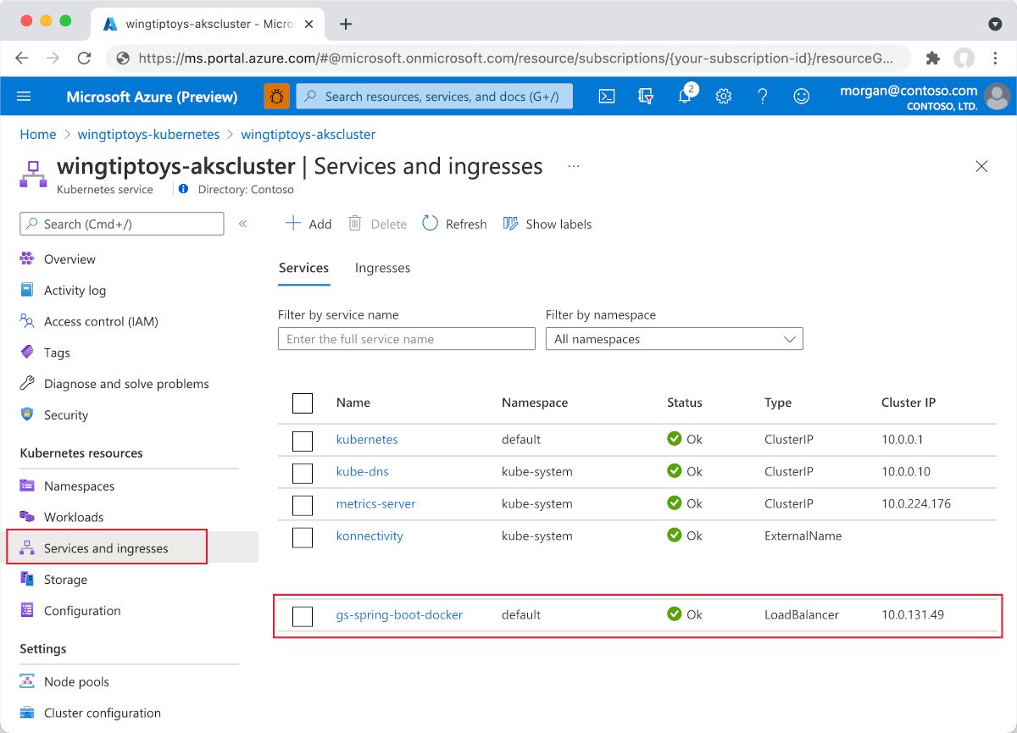

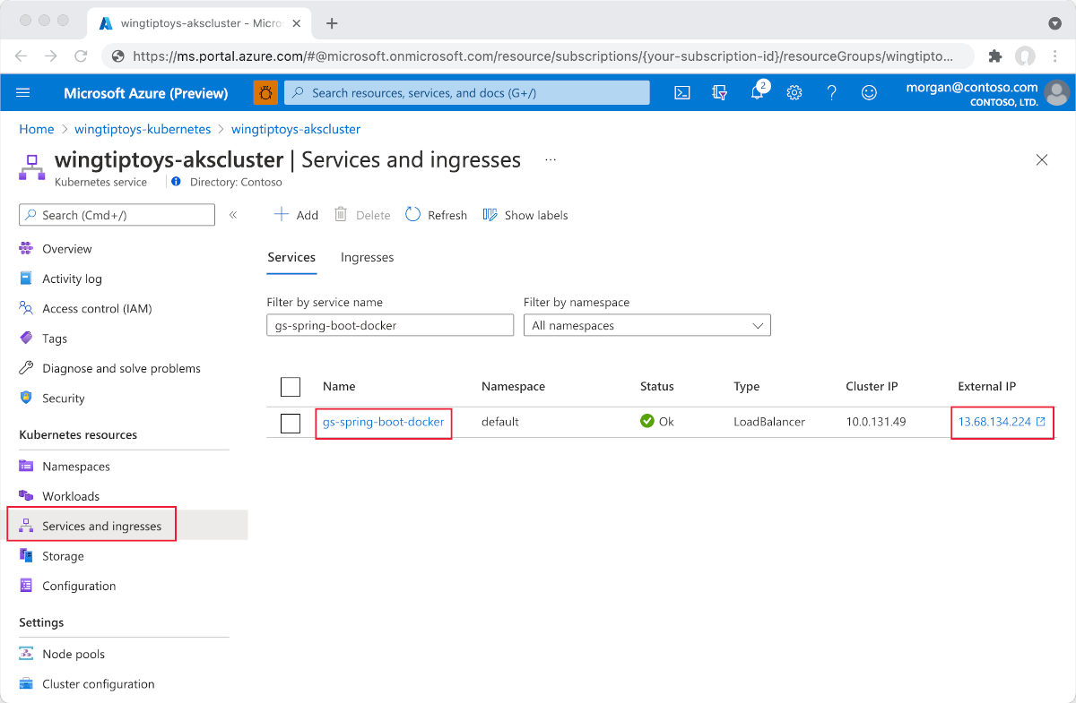

1. Select **External IP**. You will then see your Spring Boot application running on Azure.

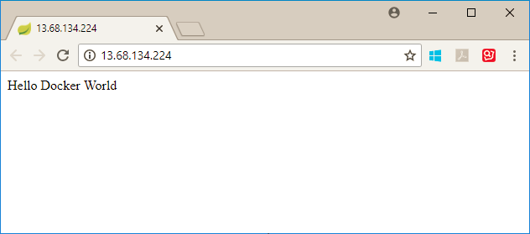

Ref. <https://docs.microsoft.com/en-us/azure/developer/java/spring-framework/deploy-spring-boot-java-app-on-kubernetes>

<https://www.cloudiqtech.com/deploy-spring-boot-application-in-kubernetes-pod/>

<https://piotrminkowski.com/2020/11/10/continuous-integration-with-jenkins-on-kubernetes/>

<https://katharharshal1.medium.com/deploy-spring-boot-application-into-aws-eks-using-jenkins-cicd-2ced0e0d894c>

<https://www.youtube.com/watch?v=5C6kzqeO4Ew> (BEST)

<https://www.coachdevops.com/2020/06/deploy-python-app-into-kubernetes.html>

<https://www.youtube.com/watch?v=Dxmmh1lW-rA>

<https://www.youtube.com/watch?v=3UaqJGXMp8w>

<https://dzone.com/articles/dockerizing-jenkins-2-setup-and-using-it-along-wit>

<https://jfrog.com/blog/ci-cd-side-by-side-jenkins-and-jfrog-pipelines/>

# References

* <http://sivalabs.in/2016/03/springboot-working-with-jdbctemplate/>
* <https://www.javatpoint.com/spring-boot-jpa>
* <https://www.petrikainulainen.net/programming/spring-framework/spring-data-jpa-tutorial-part-two-crud/>
* <https://www.dineshonjava.com/spring-boot-and-mongodb-in-rest-application/>
* <https://spring.io/guides/gs/spring-boot/#scratch>
* <http://docs.spring.io/autorepo/docs/spring-boot/current/reference/html/>(best)
* <http://www.dineshonjava.com/2016/06/introduction-to-spring-boot-a-spring-boot-complete-guide.html#.WI7wB1N965t>
* <http://websystique.com/spring-boot-tutorial/>
* <https://www.mkyong.com/tag/spring-boot/>
* (Best)Helloworld : <http://www.shristitechlabs.com/introduction-to-spring-boot/>
* <https://www.mkyong.com/spring-boot/spring-boot-spring-data-mongodb-example/>
* <https://tests4geeks.com/spring-data-boot-mongodb-example/>
* <https://avaldes.com/building-a-realtime-angularjs-dashboard-using-spring-rest-and-mongodb-part-1/>
* Final:<https://www.callicoder.com/spring-boot-mongodb-angular-js-rest-api-tutorial/>

https://www.coachdevops.com/2020/06/deploy-python-app-into-kubernetes.html

OnlineHTML - <https://www.froala.com/online-html-editor>

# Errors & Solutions

##### Error response from daemon: open \\.\pipe\docker\_engine\_linux: The system cannot find the file specified.

Restarting Docker Desktop for Windows helped me. You can do that by right-click on tray icon and selecting restart.

##### ERROR: ERROR: Can't construct a java object for tag:yaml.org,2002:io.kubernetes.client.openapi.models.V1Deployment; exception=Class not found: io.kubernetes.client.openapi.models.V1Deployment

I found the root cause of this behaviour. Jackson 2 API plugin version 2.11.1 is breaking kube deployments; you can find more info by the link below:  
<https://issues.jenkins-ci.org/browse/JENKINS-62995>

Downgrading the following plugins worked for me:

* Jackson 2 API v2.10.0,
* Kubernetes v1.21.3,
* Kubernetes Client API v4.6.3-1,
* Kubernetes Continuous Deploy v2.1.2,
* Kubernetes Credentials v0.5.0

As those plugins are default, you would need to find the relevant version source files in <https://plugins.jenkins.io/>, and upload them to your Jenkins server by going  
Manage Jenkins --> Manage Plugins --> Advanced --> Upload Plugin section

To manually downgrade the Jenkins plugin:

1. Shut down Jenkins
2. Delete the plugin.jpi file and the plugin folder from ${user\_home}/.jenkins/plugins
3. Place the older plugin.hpi file
4. Start Jenkins.